

Annual Work Plan

2024–25

© Commonwealth of Australia 2025

Ownership of intellectual property rights

Unless otherwise noted, copyright (and any other intellectual property rights) in this publication is owned by the Commonwealth of Australia (referred to as the Commonwealth).

Creative Commons licence

All material in this publication is licensed under a Creative Commons Attribution 4.0 International Licence, except for content supplied by third parties, logos and the Commonwealth Coat of Arms.

Inquiries about the licence and any use of this document should be emailed to [copyright@dcceew.gov.au](mailto:copyright@dcceew.gov.au).

Creative Commons icon

Cataloguing data

This publication (and any material sourced from it) should be attributed as: Inspector-General of Water Compliance 2024, Inspector-General of Water Compliance, Annual Work Plan 2024-25, the Australian Government, Canberra, August. CC BY 4.0.

This publication is available at https://www.igwc.gov.au/publications/annual-work-plans  
Inspector-General of Water Compliance  
GPO Box 3090 Canberra ACT 2601

Disclaimer

The Australian Government represented by the Inspector-General of Water Compliance, has exercised due care and skill in preparing and compiling the information and data in this publication. Notwithstanding, the Inspector-General of Water Compliance, the Australian Government’s employees disclaim all liability, including liability for negligence and for any loss, damage, injury, expense or cost incurred by any person as a result of accessing, using or relying on any of the information or data in this publication to the maximum extent permitted by law.

**Acknowledgement of all Traditional Owners**

The Author pays respect to the Traditional Owners and their Nations of the Murray−Darling Basin. We acknowledge their deep cultural, social, environmental, spiritual and economic connection to their lands and waters.

The guidance and support received from the Murray Lower Darling Rivers Indigenous Nations, the Northern Basin Aboriginal Nations and our many Traditional Owner friends and colleagues is very much valued and appreciated.

Aboriginal people should be aware that this publication may contain images, names or quotations of deceased persons.

**Accessibility**

The document and information is available in accessible formats. On some occasions the highly technical nature of the document means that we cannot make some sections fully accessible. If you encounter accessibility problems or the document is in a format that you cannot access, please contact us.

|  |  |  |
| --- | --- | --- |
| **Version** | **Notes** | **Date** |
| Version 1 |  | July 2024 |
| Version 2 | Varied | February 2025 |

## Foreword by the Inspector-General

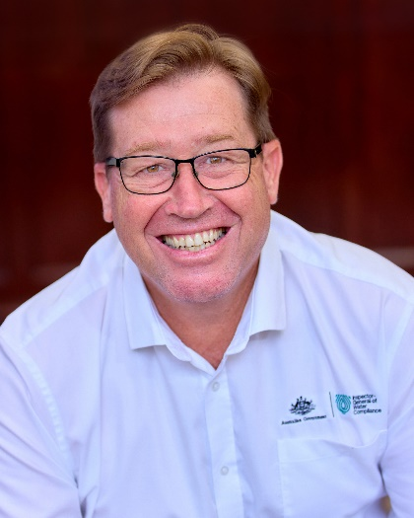

When I’m on the ground engaging with people across the Basin as Inspector-General of Water Compliance (IGWC), one of the most common concerns about government and government agencies raised with me face-to-face by the community is, “you are listening, but none of you are hearing us!”

In the May 2024 Budget, the Australian Government announced an additional $28.6 million for the IGWC over four consecutive years’ operation. This additional funding affords my office the ability to get on with critical work to support my powers as the independent Inspector-General across the Murray-Darling Basin. Of note, support from the Australian Government to ensure greater independence for the IGWC is captured in the findings and recommendations of the review of the Inspector-General of Water Compliance, completed by Mr Peter Harris AO. The government has agreed, or agreed in principle, to eight of the eleven recommendations, with a number of these recommendations implemented as part of the 2024-25 Budget.

This is not only a multi-million-dollar boost for my office’s compliance, oversight, and integrity work across the Basin, it is a clear message to Basin communities that their concerns and sentiment around issues that directly affect them are being listened and responded to. We are listening and we heard you.

My annual work plan is developed based on my commitment to always act with integrity, accountability, and transparency. This complements my use of the following powers to do my job: inquiry, audit, investigation, and enforcement. The 2024 Budget announcement of additional funding for the IGWC now means that my office is funded to exercise those powers.

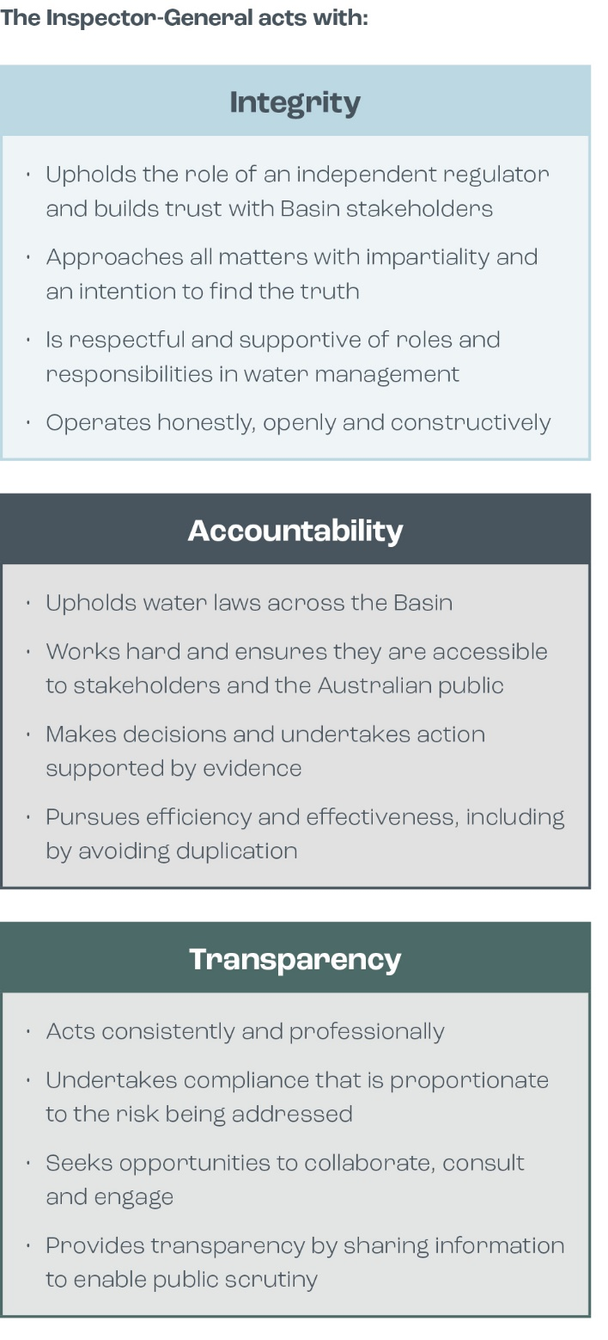

The work my office undertakes has grown in demand. The more light we shine on areas of integrity or areas of improvement across the Basin, the more work comes our way. For me, this is both a positive and a concern. Previously my inquiry capability was unfunded. New funding means this power is now very much an accountability tool that can be applied. Basin communities can be assured that a funded IGWC inquiry capability will support me to gather an evidence base, call out serious matters and fully use my powers, where and when required.

As you go through the work plan, you will see the influences and considerations that went into developing this body of work. From amendments made to the Water Act and the Basin Plan through the Water Amendment (Restoring Our Rivers) Bill 2023; the review of the Murray-Darling Basin Plan undertaken by the Productivity Commission; the Australian National Audit Office’s (ANAO) draft 2024-25 Annual Audit Work Program; through to the ability to now deliver unfunded projects and work, thanks to a $28.6 million budget injection. And critically, the communities voice.

I thank the office supporting me for their efforts to develop and execute this plan over the coming year. I take great delight in being able to provide to you the Inspector-General of Water Compliance Annual Work Plan 2024-25.

**The Hon. Troy Grant**

Inspector-General of Water Compliance

# Troy Grant, Inspector-General of Water Compliance, sites on a bench in front of a body of water.The Work Plan

## As an independent integrity agency and regulator, the Inspector-General has discretion in performing oversight, compliance, and enforcement functions. At any time, the Inspector-General may use their powers and choose to change the priorities beyond those published in the work plan.

This work plan fulfils the statutory obligation of the *Water Act 2007 (Cth)* (the Water Act) section 215E.

## Developing the 2024-25 Work Plan

## The work plan is designed to work towards strategic outcomes by responding to current and emerging risks and challenges affecting water management and compliance in the Murray-Darling Basin (the Basin). A range of factors are considered to set the work program, including:

* the Inspector-General’s Strategic Plan 2023-26
* macro trends affecting water management and compliance
* what community groups and stakeholders have told the Inspector-General and their office
* analysis of the obligations, functions, powers and commitments within the Water Act, the Basin Plan 2012 (the Basin Plan), Water Resource Plans (WRPs), and intergovernmental agreements
* risk assessments
* analysis of data and information demonstrating the level of compliance with the Basin Plan and water management arrangements in each state and territory
* monitoring and oversight of governments meeting their commitments to the public and each other
* projects and activities currently underway within the Inspector-General
* the current state of water reforms and potential future scenarios and likely challenges.

The Operating Context in 2024-25

The Inspector-General recognises there are challenges that affect the Basin’s communities and resources. Climate, changing demographics, new technologies and changing social values all influence and shape the environment, industries and communities in the Basin.

Considerations in developing this work plan included:

* Recent years have clearly demonstrated the speed at which environmental factors can change, affecting the availability of water across the Murray-Darling Basin. Research conducted by the Inspector-General in 2022 and 2023 found the importance of compliance and enforcement of water rules and regulations for the Basin community is understandably heightened when water becomes scarce. Naturally, water scarcity negatively impacts the condition of the Basin including social, economic and environmental outcomes.
* Amendments made to the Water Act and the Basin Plan through the Water Amendment (Restoring Our Rivers) Bill 2023 (Restoring Our Rivers Bill)[1], including:
  + Expanding the type of projects that can deliver the Basin Plan target of 450 GL of additional environmental water
  + Repealing the 1,500 GL cap on Commonwealth water purchases
  + Enabling funds from the Water for the Environment Special Account (WESA) to be used to enhance environmental outcomes in the Basin
  + Providing additional time for Basin States to deliver Sustainable Diversion Limit (SDL) Adjustment Mechanism projects
  + Delaying the review of the Water Act from 2024 until 2027
  + Implementing recommendations of the Water market reform: final roadmap report in relation to water markets and water management in the Basin
  + Enabling the Inspector-General of Water Compliance to determine sustainable Diversion Limit (SDL) compliance and require action plans.
* A review of the Inspector-General of Water Compliance was finalised in January 2024. The final report identified matters relating to the Inspector-General’s regulatory environment, governance arrangements, relationships with relevant agencies and regulatory powers that will be progressed through the implementation of the Australian Government’s response to the review. The Inspector-General anticipates supporting the Department of Climate Change, Energy, the Environment and Water, as lead policy agency, and other agencies in implementing the Government’s response. In addition, findings from the final report relating to communication around the Inspector-General’s roles, responsibilities and approach to regulation will be considered by the Inspector-General and, where supported and relevant, reflected in future publications and communications.
* The 2023 review of the Murray–Darling Basin Plan conducted by the Productivity Commission highlighted significant challenges in meeting water recovery targets and implementing key elements of the Plan like the Northern Basin Toolkit and the Sustainable Diversion Limit Adjustment Mechanism. The review highlighted the need for better collaboration among Basin governments, reforms in water markets, and greater recognition of First Nations' interests[2].
* The Murray-Darling Basin Authority (MDBA) will conduct its 5-yearly evaluation of the Basin Plan during this work plan period. It is the intention of the Inspector-General to have input into the evaluation by providing relevant material. The Inspector-General does not intend to duplicate work being undertaken by the MDBA as part of the evaluation, which aims to assess progress towards achieving the intended outcomes of the Basin Plan[3].
* The MDBA’s Basin Plan review will occur in 2026, focusing on climate change, sustainable water limits, First Nations, and regulatory design, considering any changes required to ensure a sustainable and healthy Basin[4]. The Inspector-General will provide input into the review as appropriate.
* The Australian National Audit Office’s (ANAO) draft 2024-25 Annual Audit Work Program which identified proposed audits for Commonwealth water management, including:
  + Accreditation of Water Resource Plans
  + Implementation and management of strategic water purchasing (Strategic water purchasing – Bridging the Gap 2023).
* The 2024-25 Budget allocated $28.6 million to the Inspector-General over 4 years. For 2024-25, $7.3m has been provided to the Inspector-General, which will be used to build the previously unfunded oversight function. This funding will allow the Inspector-General to deliver on key oversight activities identified in the priorities.

## Delivering against the Work Plan

The Inspector-General will undertake investigations, taking enforcement action where necessary, utilise inquiries in the performance of their oversight function (if planned or required), and publish reviews and audits to keep the community informed. The Inspector-General will publish the outcomes of key areas of work to support transparency and ensure compliance with legislation.

The Inspector-General's approach is detailed in the IGWC Regulatory Policy.

Please consult the website at: www.igwc.gov.au for all publications.

## Review of the Work Plan

## Section 215F of the Water Act 2007 requires the Inspector-General to undertake a mid-year review of the work plan.

The work plan was reviewed in November and December 2024. In accordance with sections 215F and 215G of the Water Act, the variation balances the Inspector-General's priorities and operational resources.

# 2024-25 Priorities

## 1. Environmental Outcomes

### Why it's a priority

The Inspector-General is responsible for oversight of Commonwealth and Basin State water management agencies' performance in relation to the Basin Plan under section 215C of the Water Act.

When the implementation of the Basin Plan nears its conclusion in coming years, public attention will shift away from implementation towards evaluating the effectiveness of the Plan in achieving environmental outcomes. The Inspector-General observes that this shift is currently evident in its very early stages.

During the Restoring Our Rivers Bill amendment process in late 2023, the Inspector-General heard concerns from stakeholders relating to environmental water outcomes throughout the Basin.

While the Inspector-General has a compliance audit power under the Water Act, the independent review of the Inspector-General noted:

*"…there will be a need for an auditor of the environmental outcomes… this should be the IGWC. But it must be allowed to grow into the role."*

By prioritising environmental outcomes, the Inspector-General aims to begin an organisational transition from a narrow focus on compliance to more comprehensive oversight.

### The Inspector-General's desired outcomes

**Ensure it's visible:** Provide the Australian community with visibility over the integrity of Basin water management.

Ensuring the Australian community can see and understand outcomes in Basin water management, understand the role of the Inspector-General, and be confident there is appropriate oversight of the integrity of Basin water management.

**Do it Better:** Raise performance and drive improvements in standards of Basin Plan delivery.

Pursuing continuous improvement in the performance of Basin water managers to embed integrity, transparency, and accountability in the delivery of Basin Plan outcomes.

### What the Inspector-General will do

* Undertake 2 compliance audits with an environmental outcome focus.
* Undertake a stocktake of all monitoring, evaluation and reporting of environmental outcomes across Basin governments.
* Undertake assurance on floodplain harvesting measurement and advocate for improved accuracy in reporting of annual actual take.
* Establish a Sustainable Diversion Limit Advisory Panel to provide advice on reporting, accounting and compliance assurance.
* Develop and publish an IGWC Audit Framework.
* Develop fit-for-purpose reporting guidelines for WRP compliance, including environmental obligations In WRPs.

## 2. Inquiry into the Northern Basin Toolkit

### Why it's a priority

The Northern Basin Toolkit is an important Government program aimed at maximising environmental outcomes in the northern Murray-Darling Basin. The original deadline for completion of all Toolkit measures was 30 June 2024, which was extended to 31 December 2026.

In late 2023, the Productivity Commission's report on Basin Plan implementation noted their concerns with the slow delivery of the Toolkit and made the observation that this lack of progress was a reflection of inadequate accountability for delivery. They also pointed to the Inspector-General as the appropriate agency who should be providing independent oversight of Toolkit progress.

By conducting an inquiry into the implementation of the Northern Basin Toolkit, the Inspector-General is ensuring accountability in the management of Basin water resources. The Australian, New South Wales and Queensland governments committed to implementing the Toolkit as enshrined in Schedule 3 to the Intergovernmental Agreement on Implementing Water Reform in the Murray-Darling Basin in 2019. These governments must be accountable for the commitment they made to deliver on these environmental measures.

### The Inspector-General's desired outcomes

**Ensure it's visible:** Provide the Australian community with visibility over the integrity of Basin water management.

Ensuring the Australian community can see and understand outcomes in Basin water management, understand the role of the Inspector-General, and be confident there is appropriate oversight of the integrity of Basin water management.

**Do it Better:** Raise performance and drive improvements in standards of Basin Plan delivery.

Pursuing continuous improvement in the performance of Basin water managers to embed integrity, transparency, and accountability in the delivery of Basin Plan outcomes.

### What the Inspector-General will do

* Undertake an Inquiry into the implementation of the Northern Basin Toolkit to inquire into and making findings and recommendations in relation to:
* The extent to which the Northern Basin Toolkit has been implemented
* The extent to which outcomes sought have been attained
* The extent to which program governance arrangements have been effective
* Reasons for the non-delivery of all measures by the originally agreed date of June 2024
* Work left to do to implement the Northern Basin Toolkit.

1. [Water Amendment (Restoring Our Rivers) Bill 2023 – Parliament of Australia (aph.gov.au)](https://www.aph.gov.au/Parliamentary_Business/Bills_Legislation/Bills_Search_Results/Result?bId=r7076)
2. [Inquiry Report - Murray-Darling Basin Plan: Implementation review 2023 - Productivity Commission (pc.gov.au)](https://www.pc.gov.au/inquiries/completed/basin-plan-2023/report)
3. [Framework for the 2025 Basin Plan Evaluation (mdba.gov.au)](https://www.mdba.gov.au/sites/default/files/publications/framework-for-the-2025-basin-plan-evaluation.pdf)
4. [Roadmap to the 2026 Basin Plan Review (mdba.gov.au)](https://www.mdba.gov.au/sites/default/files/publications/bpr-review-roadmap.pdf)