

Sustainable Diversion Limit Compliance Statement

for 2022-2023

Inspector-General of Water Compliance

**July 2024**

© Commonwealth of Australia 2023

**Ownership of intellectual property rights**

Unless otherwise noted, copyright (and any other intellectual property rights) in this publication is owned by the Commonwealth of Australia (referred to as the Commonwealth).

**Creative Commons licence**

All material in this publication is licensed under a Creative Commons Attribution 4.0 International Licence, except for content supplied by third parties, logos and the Commonwealth Coat of Arms.

Inquiries about the licence and any use of this document should be emailed to [copyright@dcceew.gov.au](mailto:copyright@dcceew.gov.au).



**Cataloguing data**

This publication (and any material sourced from it) should be attributed as: Inspector-General of Water Compliance 2024, Sustainable Diversion Limit Compliance Statement 2022-2023, the Australian Government, Canberra, July 2024. CC BY 4.0.

This publication is available at <https://www.igwc.gov.au/publications/reviews-reports>

Inspector-General of Water Compliance  
GPO Box 3090 Canberra ACT 2601

**Disclaimer**

The Australian Government represented by the Inspector-General of Water Compliance, has exercised due care and skill in preparing and compiling the information and data in this publication. Notwithstanding, the Inspector-General of Water Compliance, the Australian Government’s employees disclaim all liability, including liability for negligence and for any loss, damage, injury, expense or cost incurred by any person as a result of accessing, using or relying on any of the information or data in this publication to the maximum extent permitted by law.

**Acknowledgement of the Traditional Owners of the Murray–Darling Basin**

We pay our respects to the Traditional Owners and their Nations of the Murray-Darling Basin. We acknowledge their deep cultural, social, environmental, spiritual and economic connection to their lands and waters.

Aboriginal people should be aware that this publication may contain images, names or quotations of deceased persons.

**Accessibility**

The document and information is available in accessible formats. On some occasions the highly technical nature of the document means that we cannot make some sections fully accessible. If you encounter accessibility problems or the document is in a format that you cannot access, please contact us at [contact@igwc.gov.au](mailto:contact@igwc.gov.au).

# Table of Contents

Table of Contents 3

Foreword 4

Part A - Compliance with the Sustainable Diversion Limits 6

Ensure it’s lawful 6

Ensure it’s visible 6

Assessment Process 7

Assessment Findings 8

Part B – NSW Management of SDLs 16

Appendix 1 – Compliance year for NSW 17

Appendix 2 – Barwon-Darling and Gwydir adjustments 19

Appendix 3 – Receival of data 20

Glossary 22

# Foreword

The Sustainable Diversion Limit Compliance Statement for this year is my third and reflects my ongoing commitment to upholding the principles of the Basin Plan. I was appointed to provide independent assessment of compliance, and enforcement if necessary. My vision remains to ensure water management and use within the Murray-Darling Basin is lawful, transparent and accountable, and the Australian public is confident in the integrity of Basin Plan delivery.

I am pleased to report that the Water Amendment (Restoring our Rivers) Act 2023 has provided further clarity to my role in relation to SDL compliance and strengthened accountability, through the content and reporting provisions for action plans. Action plans will be required by Basin States if any SDL excesses are identified. In addition to this I now have the power to develop guidelines to ensure actions plans and reporting on progress are fit-for-purpose.

In October 2023, I published a [Sustainable Diversion Limit Compliance Framework](https://www.igwc.gov.au/sites/default/files/2023-10/sdl-compliance-framework.pdf), to make my expectations in this task clear to all. In line with the Framework, I have reviewed the 2022-23 Registers of Take report and I find that all 55 SDL resource units on the registers were found to be compliant. This covers Queensland, Victoria, South Australia and the Australian Capital Territory.

Wetter than normal climatic conditions in 2022 - 2023 has meant that water use across the Basin was generally lower than permitted levels. This notably resulted in increasing cumulative balance credits on the Registers of Take. As we experience drier conditions in future years, the increased cumulative balance credits will provide Basin States with some buffer and water security to be able to manage within SDL compliance thresholds.

SDL compliance is for Basin State agencies to manage all forms of consumptive water and not a compliance assessment of individual water users.

New South Wales surface water take accounts for 60% of the total take in 2022 - 2023.

I note New South Wales’ self-assessment of ‘compliant’, and their ongoing compliance assessments under long term average annual extraction limits and actions under New South Wales water sharing plans to manage water take.

Again, I am unable to determine SDL compliance in New South Wales for the 2022 - 2023 year. It cannot yet be assessed under the Basin Plan, due to a lack of water resource plans operating in 2022-2023. These inconsistencies in approach, mean New South Wales is not subject to the same level of accountability under the Basin Plan as Queensland, Victoria, South Australia and the Australian Capital Territory. This was a concern highlighted in my first SDL Compliance Statement in August 2022.

Whilst I cannot find compliance for the New South Wales 2022 - 2023 water accounts, I also cannot find non-compliance.

The Barwon-Darling watercourse and Gwydir surface water area cumulative balances have seen a swing from -71.1 GL and -111.8 GL debit respectively and are now 77 GL and 142.4 GL in credit. The Murrumbidgee also has significant model adjustments each year, while the SDL method is yet to be finalised through an accredited water resource plan. These major movements in the interim accounts can create mistrust in the process and I refer readers to Part B of this Statement for an explanation of these issues.

The prolonged reliance on bilateral arrangements between the Murray-Darling Basin Authority and New South Wales risks corrosion of confidence in the integrity of Basin Plan delivery. These are administrative arrangements, in lieu of legislative compliance through the Basin Plan and accredited water resource plans. A recent review of the Inspector-General of Water Compliance, conducted by Mr Peter Harris AO considered this issue and made the following statement:

*“The more that unenforceable arrangements are developed that enable the impression to be created that NSW is delivering on its commitments under the Basin Plan without having to meet the same burden of proof and reform of historical anomalies in water take as other jurisdictions, the less incentive there is to complete water resource plans at all.”*

I am pleased to see an end to this arrangement on the horizon, as 16 New South Wales water resource plans are accredited at the time of this Statement. There is however a time lag which will see several water resource plan areas not appear on the Registers of Take for a couple of years to come.

While Basin States continue to work towards ensuring all significant water extractions are metered accurately, the uncertainties associated with modelled surface water take remain a concern for the community. I am not just listening to communities, I am hearing them and independently acting on their areas of concern on their behalf. I have recently commissioned research to increase the understanding of modelled surface water values, identify levels of confidence in modelling figures, and clarify growth in use in the modelled proportion of water use. This will support in-depth understanding of the implications of these sources of uncertainty and risk when I determine compliance with the SDLs.

As the Inspector-General of Water Compliance I remain dedicated to transparency, rigorous oversight, and building confidence in SDL compliance among all stakeholders. I am committed to advocating for greater public visibility of state and commonwealth decision making, publishing our findings, conducting thorough assessments, and engaging with the community to ensure that the outcomes of the Basin Plan are met. This Compliance Statement is a testament to our ongoing efforts and the collective responsibility we share in safeguarding our water resources for future generations.

I am encouraged that we continue to make significant strides towards sustainable water management across the Murray-Darling Basin.

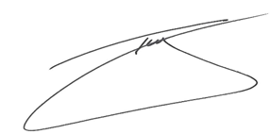

The Hon. Troy Grant

Inspector-General of Water Compliance

31 July 2024

# Part A - Compliance with the Sustainable Diversion Limits

## Ensure it’s lawful

Sustainable Diversion Limits (SDLs) and compliance with the limits are essential to the implementation and operation of the *Basin Plan 2012* (Basin Plan). Under the Commonwealth *Water Act 2007* (the Act), SDLs provide for ‘the establishment and enforcement of environmentally sustainable limits on the quantities of surface water and groundwater that may be taken from the Basin water resources.[1]

Compliance with the SDLs by Basin States has been required since 1 July 2019.[2] Only when a water resource plan is operating for a full water accounting year (1 July – 30 June)[3] can SDL compliance apply.

SDL compliance is determined from the accredited accounting methods and application of obligations within the water resource plan. It is the responsibility of the Basin States to report on and ensure compliance with the SDLs on an annual basis.

Non-compliance with SDLs considers more than one water user group taking too much water: non-compliance is when the combined water use across all consumptive uses exceeds theSDL compliance thresholdand there is no deemed reasonable excuse for the excess.

As an independent regulator, the Inspector-General of Water Compliance (Inspector-General) has a responsibility to undertake an annual assessment and respond to SDL compliance. The Inspector-General has legislative powers to conduct an inquiry, audit, and investigation.

## Ensure it’s visible

With increasing public scrutiny in relation to water management across the Murray-Darling Basin, the role of the Inspector-General was established in August 2021. Through this role, the Inspector-General has committed to:

* Deliver trust and transparency around the management of Murray-Darling Basin water resources.
* Ensure the highest standard of accountability for all involved in the use and management of Basin resources, including State and Commonwealth agencies.
* Engage with the community on management of Basin resources.

The [Sustainable Diversion Limit Compliance Framework](https://www.igwc.gov.au/sites/default/files/2023-10/sdl-compliance-framework.pdf) (the SDL Framework) has been developed to articulate the Inspector-General’s expectations and approach to exercising statutory powers and functions in relation to SDL compliance.

This annual compliance statement is published to provide the community with information on the status of SDL compliance and transparency of water management in the Murray-Darling Basin.

## Assessment Process

As described in the [SDL Framework](https://www.igwc.gov.au/sites/default/files/2023-10/sdl-compliance-framework.pdf), the SDL compliance assessment is informed by water accounts and reports provided by Basin States and the Murray-Darling Basin Authority (the Authority).

The annual SDL compliance assessments are informed by:

* Basin State reports as required by Section 71 of the Commonwealth Water Act. The Section 71 reports include detailed water accounts, including both water taken and managed during the water accounting year, and with Basin States assessment of compliance and actions to achieve compliance with SDLs.
* Registers of Take as prepared by the Authority, which includes SDL resource units managed under an accredited water resource plan.
* Prior years SDL compliance assessment information.[4]
* Other information provided to the Inspector-General, or gained publicly, for the purposes of undertaking a compliance assessment.
* Bilateral discussions and additional information provided by the Basin States.

The Registers of Take report was provided by the Authority to the Inspector-General on 5 April 2024.

The Registers of Take report collates the Section 71 reports water accounts and indicates the impact of the water taken through a cumulative balance (credits or debits) in relation to the SDL for each SDL resource unit.

Where the amount of water taken leads to an exceedance above the SDL, but the cumulative balance remains below the SDL compliance threshold, the Basin State is compliant with the SDL.

Where the amount of water taken leads to an excess above the SDL and the cumulative balance is equal to or above the SDL compliance threshold, the Basin State is non-compliant unless they have a reasonable excuse.

The SDL compliance assessment recognises that incomplete water recovery by the Commonwealth, are for reasons beyond the Basin State’s control, and are adjusted for in the Registers of Take.

The Water Amendment (Restoring our Rivers) Act 2023 clarifies the role of the Inspector-General in relation to SDL compliance. The Inspector-General must be satisfied of a Basin State’s claim of reasonable excuse, otherwise the Basin State will be non-compliant. Additionally, accountability for where there is non-compliance or compliance with a reasonable excuse has been strengthened through the requirement of the Basin States to provide action plans on how they will reduce water take to be compliant. The Basin States will also be required to report on progress against those actions in their annual reports. The Inspector-General also has new powers to make guidelines to ensure action plans and reporting on progress are fit-for-purpose and delivering intended outcomes.

## Assessment Findings

There are 55 SDL resource units (19 surface water and 36 groundwater) on the Registers of Take for the 2022-2023 water accounting year. The 55 SDL resource units are managed through the 13 water resource plans across Queensland, South Australia, Victoria, and the Australian Capital Territory.

There were no SDL exceedances in 2022-2023 from the 55 SDL resource units. All 55 SDL resource units were found to be compliant.

As there were no SDL resource units in excess of the SDL compliance threshold, there were no claims of a reasonable excuse or action plans provided by Basin States to the Inspector-General.

The 2022-2023 assessment was based on the information in the Registers of Take, as prepared by the Authority for surface water SDL resource units and for groundwater SDL resource units, at the time of the assessment.

Data from the Registers of Take is represented in Table 1 (Surface water) and Table 2 (Groundwater).

The SDL compliance assessment has observed a trend of increasing cumulative balance credits across all Basin States. This is due to less water actually being taken than the SDL methods calculated permitted take, on average across SDL resource units. Many Basin States have reported above average rainfall conditions in the previous 3 years and consistent with La Niña conditions. It is presumed the favourable conditions have contributed to a higher permitted take, particularly in the northern Basin, and lower demand for water use across the Basin.

Cumulative balance credits in the current year usually become the opening balance for the next year. The *Water Amendment (Restoring our Rivers) Act 2023* introduced a “one-off adjustment” to cumulative balances for surface water SDL resource units, to retrospectively apply the cumulative balance credits and/or debits from 2019-2020 until the year the water resource plans came into operation. This means the cumulative balance from 2022-2023 will be adjusted for most SDL resource units going forward onto the 2023-2024 Registers of Take. The SDL Compliance outcomes of the “one-off adjustment” will not be known until the 2023-2024 Registers of Take are prepared by the Authority. These changes were supported by the Inspector-General.

A final observation; information provided through Section 71 narrative reports has been consistent throughout previous years and is often a statement of water resource plan arrangements, where they exist. Basin States are encouraged to use the narrative reports to offer further relevant details, where possible, that provide clarity and disclosure to the Inspector-General and the general public on annual decision-making that contributes to enabling trade, managing allocations, water take limits and SDLs in general. This would help to explain outcomes and trends of the Registers of Take, and in turn build trust and confidence in compliance with the SDLs.

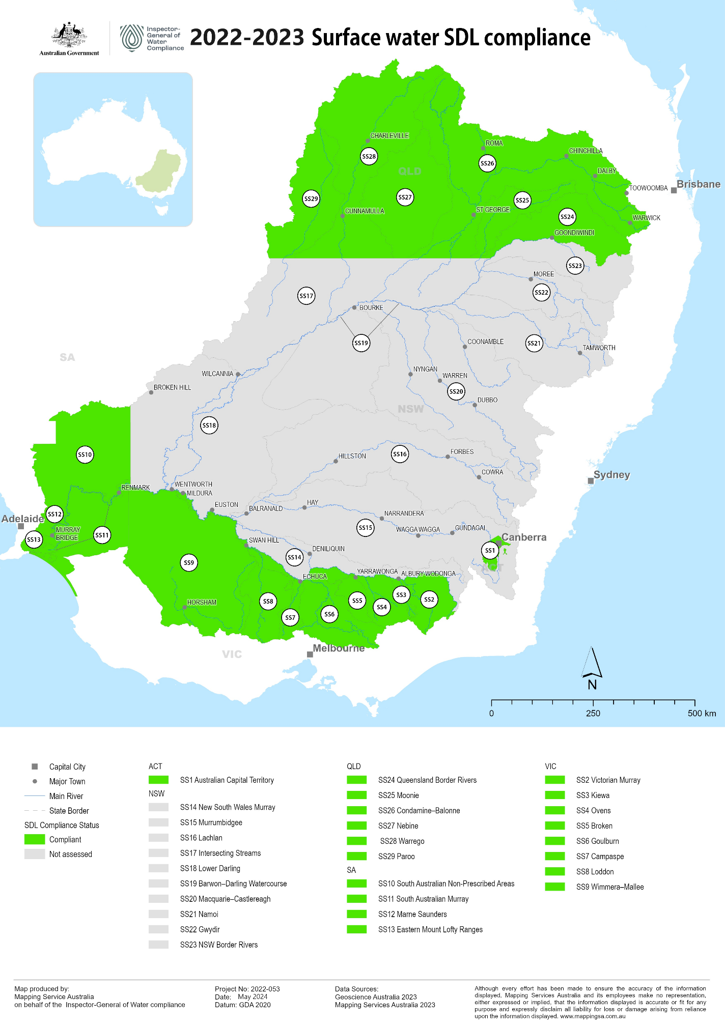

Figure 1: Map of surface water SDL compliance

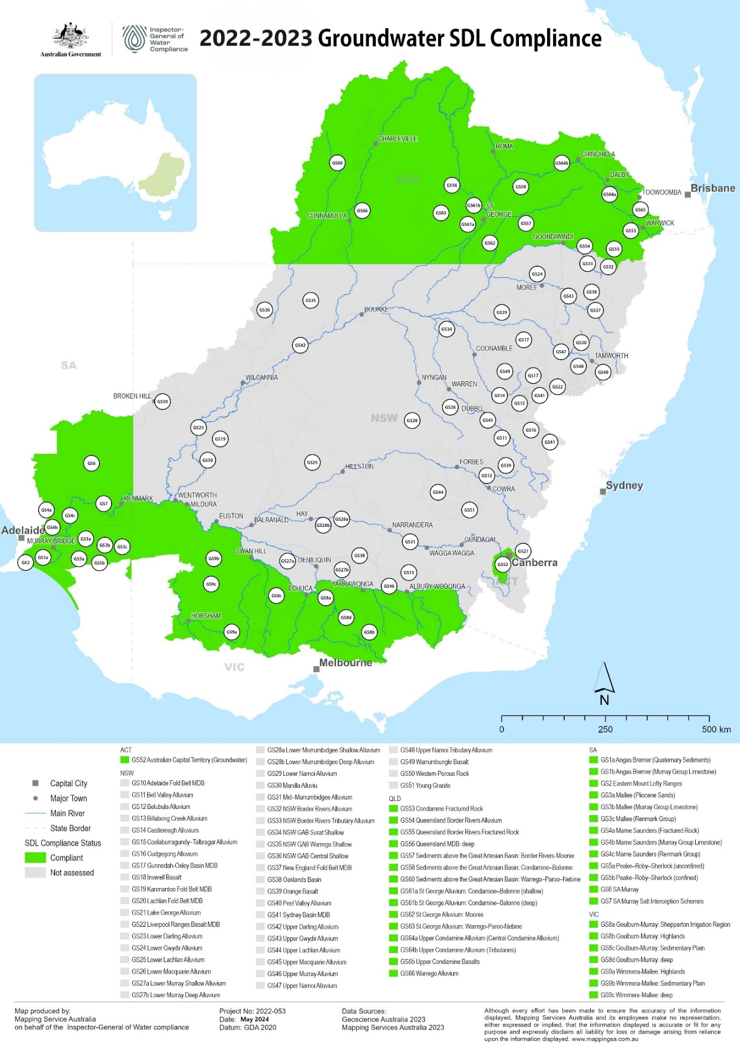

Figure 2: Map of groundwater SDL compliance

Table 1: 2022-2023 Surface water accounts from Registers of Take (Gigalitres per year)

| State | SDL resource unit | SDL resource unit code | SDL | Annual Permitted Take | Annual Actual Take | Annual Balance | Cumulative Balance, Start of year | Cumulative Balance, End of Year | HEW Adjust-ments | Adjusted Cumulative Balance, End of year | SDL Compliance Threshold  (-20% of SDL) | SDL Excess |
| --- | --- | --- | --- | --- | --- | --- | --- | --- | --- | --- | --- | --- |
| QLD | Queensland Border Rivers | SS24 | 363.6 | 424.8 | 178.9 | 245.9 | 335.2 | 581.1 | 0 | 581.1 | -72.7 | No |
| QLD | Moonie | SS25 | 89.9 | 111.5 | 51.5 | 59.9 | 125.6 | 185.5 | 0 | 185.5 | -18 | No |
| QLD | Condamine-Balonne | SS26 | 919 | 859.4 | 599.9 | 259.5 | 263.6 | 523.1 | 55.5 | 578.6 | -183.8 | No |
| QLD | Nebine | SS27 | 17.1 | 16.9 | 11.1 | 5.78 | 12.4 | 18.2 | 0 | 18.2 | -3.41 | No |
| QLD | Warrego | SS28 | 55.5 | 59.1 | 23 | 36.1 | 68 | 104 | 0 | 104 | -11.1 | No |
| QLD | Paroo | SS29 | 11.8 | 10.9 | 10.9 | 0.08 | 0.23 | 0.3 | 0 | 0.3 | -2.36 | No |
| ACT | Australian Capital Territory | SS1 | 53.4 | 29.5 | 17.6 | 11.9 | 29.7 | 41.6 | 2.13 | 43.7 | -10.7 | No |
| VIC | Victorian Murray | SS2 | 1319.8 | 1145.4 | 909.8 | 235.6 | 230 | 465.6 | 32.4 | 498 | -264 | No |
| VIC | Kiewa | SS3 | 27.7 | 25.3 | 21.8 | 3.46 | 12.4 | 15.9 | 0 | 15.9 | -5.54 | No |
| VIC | Ovens | SS4 | 85.8 | 82.9 | 71 | 11.9 | 25.2 | 37.14 | -0.09 | 37.04 | -17.2 | No |
| VIC | Broken | SS5 | 49 | 42.4 | 40.7 | 1.69 | 3.54 | 5.23 | -0.6 | 4.63 | -9.8 | No |
| VIC | Goulburn | SS6 | 1278 | 1327.6 | 800.9 | 526.7 | 598.4 | 1125 | 1142.5 | 17.4 | -255.6 | No |
| VIC | Campaspe | SS7 | 111.7 | 86.2 | 51.5 | 34.7 | 25.3 | 59.9 | 0.66 | 60.6 | -22.3 | No |
| VIC | Loddon | SS8 | 127.7 | 132 | 97.6 | 34.4 | 37.2 | 71.6 | 0 | 71.6 | -25.5 | No |
| VIC | Wimmera-Mallee | SS9 | 76.1 | 76.6 | 45.5 | 31.1 | 47.9 | 78.9 | 0 | 78.9 | -15.2 | No |
| SA | South Australian Murray | SS11 | 542.06 | 505.96 | 478.68 | 27.28 | 17.07 | 44.35 | -13.6 | 30.75 | -108.41 | No |
| SA | South Australian Non-Prescribed Areas | SS10 | 55.2 | 55.2 | 23.34 | 31.86 | 63.72 | 95.57 | 0 | 95.57 | -11.04 | No |
| SA | Marne-Saunders | SS12 | 3 | 3.7 | 2.06 | 1.65 | 1.31 | 2.96 | 0 | 2.96 | -0.6 | No |
| SA | Eastern Mount Lofty Ranges | SS13 | 28.3 | 21.38 | 12.01 | 9.37 | 24.23 | 33.6 | 0 | 33.6 | -5.66 | No |
| Total |  |  | **5214.7** | **5016.74** | **3447.8** | **1568.9** | **1921** | **3489.55** | **1218.9** | **2458.35** |  |  |
| VIC | Goulburn-Broken-Campaspe-Loddon[5] |  | 1566.4 | 1588.1 | 990.7 | 597.4 | 664.4 | 1261.8 | 17.5 | 1279.3 | -313.3 | No |
| VIC | Victorian Murray-Kiewa-Ovens |  | 1433.3 | 1253.5 | 1002.6 | 251 | 267.6 | 518.6 | 32.3 | 550.9 | -286.7 | No |

Table 2: 2022 - 2023 Groundwater accounts from the Registers of Take (Gigalitres per year)

| State | SDL resource unit code | SDL resource unit | SDL (GL/yr) | Cumulative Permitted Take at end of 2021-2022 | Cumulative Actual Take at end of 2021-2022 | Annual Permitted Take | Annual Actual Take | Cumulative Permitted Take end of 2022-2023 | Cumulative Actual Take end of 2022-2023 | 20% of SDL | SDL Compliance Threshold | SDL Excess (Yes/No) |
| --- | --- | --- | --- | --- | --- | --- | --- | --- | --- | --- | --- | --- |
| QLD | GS54 | Queensland Border Rivers Alluvium | 14.0 | 42 | 33.6 | 14 | 9.61 | 56 | 43.2 | 2.8 | 58.8 | No |
| QLD | GS55 | Queensland Border Rivers Fractured Rock | 10.5 | 31.5 | 26.6 | 10.5 | 9.5 | 42 | 36.1 | 2.1 | 44.1 | No |
| QLD | GS57 | Sediments above the Great Artesian Basin: Border Rivers-Moonie | 46.9 | 140.7 | 1.54 | 46.9 | 0.52 | 187.6 | 2.06 | 9.38 | 197 | No |
| QLD | GS62 | St George Alluvium: Moonie | 0.69 | 2.07 | 0.06 | 0.69 | 0.02 | 2.76 | 0.08 | 0.14 | 2.9 | No |
| QLD | GS53 | Condamine Fractured Rock | 1.48 | 4.44 | 1.96 | 1.48 | 0.76 | 5.92 | 2.72 | 0.3 | 6.22 | No |
| QLD | GS56 | Queensland MDB: deep | 100.0 | 300 | 0 | 100 | 0 | 400 | 0 | 20 | 420 | No |
| QLD | GS58 | Sediments above the Great Artesian Basin: Condamine–Balonne | 18.1 | 54.3 | 1.33 | 18.1 | 0.49 | 72.4 | 1.82 | 3.62 | 76 | No |
| QLD | GS61a | St George Alluvium: Condamine–Balonne (shallow) | 27.7 | 83.1 | 1.22 | 27.7 | 0.34 | 110.8 | 1.56 | 5.54 | 116.3 | No |
| QLD | GS61b | St George Alluvium: Condamine–Balonne (deep) | 12.6 | 37.8 | 34.9 | 12.6 | 11.7 | 50.4 | 46.6 | 2.52 | 52.9 | No |
| QLD | GS64a | Upper Condamine Alluvium (Central Condamine Alluvium) | 46.0 | 138 | 111.6 | 46 | 33.9 | 184 | 145.5 | 9.2 | 194.4 | No |
| QLD | GS64b | Upper Condamine Alluvium (Tributaries) | 40.5 | 121.5 | 80.4 | 40.5 | 29.9 | 162 | 110.4 | 8.1 | 179 | No |
| QLD | GS65 | Upper Condamine Basalts | 79.0 | 237 | 146.5 | 79 | 67 | 316 | 213.5 | 15.8 | 331.8 | No |
| QLD | GS60 | Sediments above the Great Artesian Basin: Warrego–Paroo–Nebine | 99.2 | 2.21 | 2.21 | 0.74 | 0.74 | 2.94 | 2.94 | 19.8 | 22.8 | No |
| QLD | GS63 | St George Alluvium: Warrego–Paroo–Nebine | 24.6 | 0.25 | 0.25 | 0.08 | 0.08 | 0.33 | 0.33 | 4.92 | 5.25 | No |
| QLD | GS66 | Warrego Alluvium | 10.2 | 2.3 | 2.3 | 0.77 | 0.77 | 3.07 | 3.07 | 2.04 | 5.11 | No |
| ACT | GS52 | Australian Capital Territory (groundwater) | 3.16 | 9.48 | 1.28 | 3.16 | 0.46 | 12.6 | 1.74 | 0.63 | 13.3 | No |
| VIC | GS8a | Goulburn-Murray: Shepparton Irrigation Region | 244.1 | 732.3 | 244.7 | 244.1 | 13.32 | 976.4 | 247.5 | 48.8 | 1025.2 | No |
| VIC | GS8b | Goulburn-Murray: Highlands | 68.7 | 206.1 | 42.7 | 68.7 | 12.9 | 274.8 | 55.6 | 13.7 | 288.5 | No |
| VIC | GS8c | Goulburn-Murray: Sedimentary Plain | 223 | 669 | 303.8 | 223 | 50.7 | 892 | 354.5 | 44.6 | 936.6 | No |
| VIC | GS8d | Goulburn-Murray: deep | 20 | 60 | 3.39 | 20 | 1.31 | 80 | 4.7 | 4 | 84 | No |
| VIC | GS9a | Wimmera-Mallee: Highlands | 2.75 | 8.25 | 3.03 | 2.76 | 0.8 | 11 | 3.83 | 0.55 | 11.6 | No |
| VIC | GS9b | Wimmera-Mallee: Sedimentary Plain | 186.9 | 560.7 | 22.2 | 186.9 | 6.46 | 747.6 | 28.7 | 37.4 | 785 | No |
| VIC | GS9c | Wimmera-Mallee: deep | 20 | 60 | 0.83 | 20 | 0.28 | 80 | 1.11 | 4 | 84 | No |
| SA | GS3a | Mallee (Pliocene Sands) | 41.4 | 124.2 | 0 | 41.4 | 0 | 165.6 | 0 | 8.28 | 173.9 | No |
| SA | GS3b | Mallee (Murray Group Limestone) | 63.6 | 190.8 | 106.9 | 63.6 | 29.7 | 254.4 | 136.5 | 12.7 | 267.1 | No |
| SA | GS3c | Mallee (Renmark Group) | 2 | 6 | 0 | 2 | 0 | 8 | 0 | 0.4 | 8.4 | No |
| SA | GS5a | Peake–Roby–Sherlock (unconfined) | 3.41 | 10.2 | 0.57 | 3.41 | 0.19 | 13.6 | 0.76 | 0.68 | 14.3 | No |
| SA | GS5b | Peake–Roby–Sherlock (confined) | 2.58 | 7.74 | 2.91 | 2.58 | 0.75 | 10.3 | 3.66 | 0.52 | 10.8 | No |
| SA | GS6 | SA Murray | 64.8 | 194.4 | 5.4 | 64.8 | 1.8 | 259.2 | 7.2 | 13 | 272.2 | No |
| SA | GS7 | SA Murray Salt Interception Schemes | 28.6 | 85.8 | 40.6 | 28.6 | 10.6 | 114.4 | 51.3 | 5.72 | 120.1 | No |
| SA | GS1a | Angas Bremer (Quaternary Sediments) | 1.09 | 0.75 | 0 | 0.25 | 0 | 1 | 0 | 0.22 | 1.22 | No |
| SA | GS1b | Angas Bremer (Murray Group Limestone) | 6.57 | 19.7 | 3.52 | 6.57 | 0.74 | 26.3 | 4.26 | 1.31 | 27.6 | No |
| SA | GS2 | Eastern Mount Lofty Ranges | 38.5 | 115.5 | 31.6 | 38.5 | 8.29 | 154 | 39.9 | 7.7 | 161.7 | No |
| SA | GS4a | Marne Saunders (Fractured Rock) | 2.09 | 6.27 | 1.53 | 2.09 | 0.32 | 8.36 | 1.84 | 0.42 | 8.78 | No |
| SA | GS4b | Marne Saunders (Murray Group Limestone) | 2.38 | 7.02 | 3.69 | 2.34 | 1.15 | 9.36 | 4.85 | 0.48 | 9.84 | No |
| SA | GS4c | Marne Saunders (Renmark Group) | 0.5 | 1.5 | 0 | 0.5 | 0 | 2 | 0 | 0.1 | 2.1 | No |

Part B – NSW Management of SDLs

The Inspector-General has not assessed the 54 SDL resource units in New South Wales for SDL compliance, as there were no water resource plans operating for the full 2022-2023 water accounting year.

There were five groundwater resource plans (including 23 SDL resource units) accredited during the 2022-2023 water year, which can be assessed for SDL compliance for the 2023-2024 water year. Refer to Appendix 1 – Compliance year for NSW for the list of accredited water resource plans and the year SDL compliance will commence.

Each year until the water resource plan is accredited, a new temporary water accounting method is agreed upon by the New South Wales Basin State agency and the Authority. The bilateral methods in 2022-2023 are retrospectively applied to previous years from 1 July 2019. The total effect is presented as a one-off adjustment to the cumulative balance (debit or credit) for each SDL resource unit, on the interim Registers of Take.

The SDL accounting and compliance methods within the Basin Plan are complex but are designed to consider long-term sustainable diversion limits which allow for variations in climate, water availability and trends in consumptive use.

The bilateral methods add another depth of complexity, as they are a blend of proposed water resource plans (even if withdrawn) and various modifications from the proposed water resource plan. The modifications can include changes to model inputs, baseline estimates, type of model, various scaling factors applied to permitted take, and other inclusions and exclusions for annual actual take.

The modifications have significantly affected the cumulative balance for the water accounts for the Barwon-Darling watercourse and Gwydir SDL resource units from previous years to the 2022-2023 interim Registers of Take. There have been “model refreshes”[6] for the previous four years, creating a cumulative effect and a one-off adjustment. Refer to Appendix 2 – Barwon-Darling and Gwydir adjustments.

The New South Wales bilateral methods change annually, unlike Queensland, Victoria, South Australia and the Australian Capital Territory which have applied the same methods from the 2019-2020 interim Registers of Take, through to the accredited water resource plans.

The bilateral methods approach and the one-off adjustments create a lack of transparency and mask trends on NSW water management, including baseline diversions, water availability, the State’s decision-making practices and annual water take by consumptive use.

New South Wales have shifted from 8 to 16 accredited water resource plans (out of 20) since the release of the [Sustainable Diversion Limit Compliance Statement for 2021-22](https://www.igwc.gov.au/sites/default/files/2023-09/igwc-2021-22-sdl-compliance-statement.pdf). This will lead to the methods for determining SDL compliance to be traceable and a constant into the future.

New South Wales are encouraged to ensure comprehensible (rather than being referred to highly technical reports) and factual details of water accounts are provided for the public to access. This could be enhanced going forward through Section 71 narrative reports, including modifications to bilateral methods, to build trust and confidence in compliance with the SDLs.

# Appendix 1 – Compliance year for NSW

|  |  |  |  |
| --- | --- | --- | --- |
| Water Resource Plan | Date accredited | SDL resource units | SDL Compliance |
| NSW Border Rivers Alluvium (GW18) | 19 September 2022 | NSW Border Rivers Alluvium (GS32)  NSW Border Rivers Tributary Alluvium (GS33) | 2023-2024 |
| NSW MDB Fractured Rock (GW11) | 15 November 2022 | Adelaide Fold Belt MDB (GS10)  Kanmantoo Fold Belt MDB (GS19)  Lachlan Fold Belt MDB (GS20)  Orange Basalt (GS39)  Young Granite (GS51)  Inverell Basalt (GS18)  Liverpool Ranges Basalt MDB (GS22)  New England Fold Belt MDB (GS37)  Warrumbungle Basalt (GS49) | 2023-2024 |
| Macquarie-Castlereagh Alluvium (GW12) | 21 December 2022 | Bell Valley Alluvium (GS11)  Castlereagh Alluvium (GS14)  Coolaburragundy–Talbragar Alluvium (GS15)  Cudgegong Alluvium (GS16)  Lower Macquarie Alluvium (GS26)  Upper Macquarie Alluvium (GS45) | 2023-2024 |
| NSW MDB Porous Rock (GW6) | 21 December 2022 | Western Porous Rock (GS50)  Gunnedah‑Oxley Basin MDB (GS17)  Sydney Basin MDB (GS41)  Oaklands Basin (GS38) | 2023-2024 |
| Darling Alluvium (GW7) | 22 June 2023 | Upper Darling Alluvium (GS42)  Lower Darling Alluvium (GS23) | 2023-2024 |

|  |  |  |  |
| --- | --- | --- | --- |
| Water Resource Plan | Date accredited | SDL resource units | SDL Compliance |
| Murray Alluvium (GW8) | 21 August 2023 | Billabong Creek Alluvium (GS13)  Lower Murray Shallow Alluvium (GS27a) | 2024-2025 |
| Lachlan Alluvium (GW10) | 22 August 2023 | Lower Lachlan Alluvium (GS25)  Upper Lachlan Alluvium (GS44)  Belubula Alluvium (GS12) | 2024-2025 |
| Murrumbidgee Alluvium (GW9) | 9 November 2023 | Lake George Alluvium (GS21)  Mid Murrumbidgee Alluvium (GS31)  Lower Murrumbidgee Shallow Alluvium (GS28a)  Lower Murrumbidgee Deep Alluvium (GS28b) | 2024-2025 |
| NSW Great Artesian Basin Shallow (GW13) | 9 December 2023 | NSW GAB Surat Shallow (GS34)  NSW GAB Warrego Shallow (GS35)  NSW GAB Central Shallow (GS36) | 2024-2025 |
| Intersecting Streams (SW13) | 9 November 2023 | Intersecting streams (S17) | 2024-2025 |
| Murrumbidgee  (SW09) | 29 February 2024 | Murrumbidgee (SS15) | 2024-2025 |
| NSW Border Rivers (SW16) | 2 May 2024 | NSW Border Rivers (SS23) | 2024-2025 |
| Lachlan (SW10) | 18 May 2024 | Lachlan (SS16) | 2024-2025 |
| NSW Murray and Lower Darling (SW08) | 18 May 2024 | NSW Murray (SS14)  Lower Darling (SS18) | 2024-2025 |
| Barwon-Darling Watercourse (SW12) | 18 June 2024 | Barwon-Darling Watercourse (SS19) | 2024-2025 |
| Macquarie-Castlereagh (SW11) | 18 June 2024 | Macquarie-Castlereagh (SS20) | 2024-2025 |

# Appendix 2 – Barwon-Darling and Gwydir adjustments

|  |
| --- |
|  |

Table: Barwon-Darling adjustments

|  |  |  |  |  |
| --- | --- | --- | --- | --- |
| **SDL Resource unit** | **2019-2020** | **2020-2021** | **2021-2022** | **2022-2023** |
| **Barwon-Darling** | **-57.7 GL**  **(-32.7%)** | **-66.9 GL**  **(-38%)** | **-71.1 GL**  **(-40%)** | **77 GL**  **(+38%)** |

*Section 71, Narrative report explanation:*

In the Barwon Darling, the 2022-2023 Annual Permitted Take (APT) was much larger than the Annual Actual Take (AAT) resulting in an annual balance of +80GL. In addition, there was a credit of 66GL due to updated modelling (correction for meter error).

Table: Gwydir adjustments

|  |  |  |  |  |
| --- | --- | --- | --- | --- |
| **SDL Resource unit** | **2019-2020** | **2020-2021** | **2021-2022** | **2022-2023** |
| **Gwydir** | **-5.19 GL**  **(-1 %)** | **-61.1 GL**  **(-12%)** | **-111.8 GL**  **(-21%)** | **142.4 GL**  **(+26%)** |

*Section 71, Narrative report explanation:*

In the Gwydir, the 2022-2023 APT was much larger than the AAT, resulting in an annual balance of +214.5GL. In addition, there was a credit of 39.7GL due to updated modelling (inclusion of floodplain harvesting licences, lead to higher estimates for regulated river permitted take).

# Appendix 3 – Receival of data

The SDL Compliance Framework states the SDL compliance assessment process is informed by the Registers of Take. The Registers of Take are informed by Basin State SDL accounts and the SDL accounts are informed by the water resource plan permitted take and actual take SDL methods.

It has become regular practice of the Basin States to provide draft SDL accounts and a subsequent corrected version provided after the legislated due date (31 October), noting the Authority is able to provide extensions if required. The SDL compliance assessment can view draft data as an early indication of compliance, although the data is not able to be assessed for compliance until the Registers of Take are finalised.

Figure 3 and Figure 4 highlights the dates when the Inspector-General receives versions of water accounts, when information is due and when the Inspector-General receives the data.

Figure 3: Timing of receival for SDL compliance information - Surface Water

A graph of surface water data receival dates for all Basin States. The graph shows that all states have submitted their final version past the granted extension date.



Figure 4: Timing of receival for SDL compliance information - Groundwater

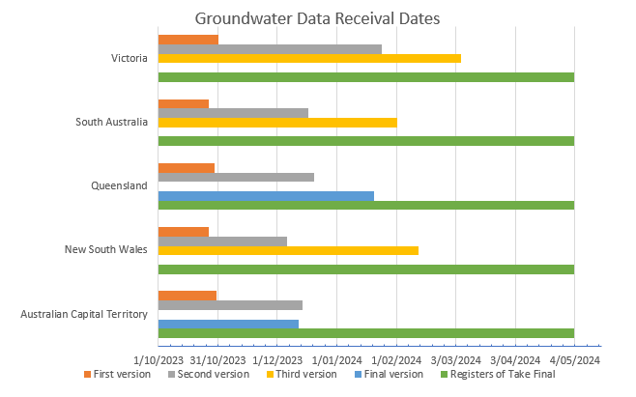

# Glossary

**Act**

*Water Act 2007* (Commonwealth)

**Basin Plan**

*Basin Plan 2012* (Commonwealth)

**Basin State**

Basin State is defined in the Water Act and means New South Wales, Victoria, Queensland, South Australia, and the Australian Capital Territory.[7] Basin States have obligations relating to SDL compliance reporting and action plans under s 71 of the Water Act and Chapter 6 of the Basin Plan.

**Cumulative balance**

For surface water SDL resource units, each year the actual take is subtracted from the permitted take to generate a debit (where actual take is more than permitted take) or a credit (where actual take is less than permitted take). Over time, these debits and credits generate a **cumulative balance**. The **surface water SDL compliance threshold** is when the cumulative balance for an SDL resource unit is a debit equal to or greater than 20% of the SDL.

**Exceedance**

The term ‘exceedance’ refers to circumstances where the Registers of Take records actual take that exceeds permitted take (cumulatively) but has not reached the SDL compliance threshold of 'excess'.

**Excess**

The term ‘excess’ has a specific meaning in the Basin Plan:[8]

For **surface water** SDL resource units, an excess occurs when the **cumulative balance** on the relevant Register is a debit amount equal to or greater than 20% of the SDL.

For **groundwater** SDL resource units, in any accounting period up to 2028, an excess occurs when the sum of actual take for all years since 2019 is greater than the sum of permitted take for those years, plus 20% of the SDL. For accounting periods after 2028, an excess occurs if the average annual take over the previous 10 years exceeds the average permitted take over that period.

**Incomplete water recovery**

The water recovery targets are for the purpose of 'bridging the gap' and recover water for the environment. Any unrecovered water (incomplete water recovery) remains in the consumptive entitlements and may be available and used as annual actual take (AAT). Therefore, the Registers of Take are adjusted to credit the surface water cumulative balance and added to the compliance trigger for groundwater, to not affect the States compliance with the SDLs due to incomplete water recovery.

**SDL compliance threshold**

The point at which the Register for an SDL resource unit records an ‘excess’ (see definition of excess above). Once the SDL compliance threshold is reached, certain obligations and actions under the Water Act and Basin Plan are triggered.[9]

1. *Water Act 2007* (Cth) s 20(b).
2. *Basin Plan 2012* (Cth) s 6.08(5).
3. *Basin Plan 2012* (Cth) s 6.08(5).
4. [Sustainable Diversion Limit compliance statement for 2020-2021 (igwc.gov.au)](https://www.igwc.gov.au/sites/default/files/2022-08/igwc-2020-21-sdl-compliance-statement_0.pdf) and [Murray–Darling Basin Sustainable Diversion Limit Compliance outcomes 2019–20 (mdba.gov.au)](https://www.mdba.gov.au/publications-and-data/publications/murray-darling-basin-sustainable-diversion-limit-compliance)
5. ‘Goulburn–Broken–Campaspe–Loddon’ and ’Victorian Murray–Kiewa–Ovens’ SDL resource units may be treated as a single SDL resource unit for the purposes of the compliance assessment (Basin Plan (s. 6.12(2) (a) & (b))).
6. Refer to Table 9, 2022-2023 Sustainable Diversion Limit Accounts – Registers of take and interim Registers of take
7. *Water Act 2007* (Cth) section 4
8. *Basin Plan 2012* section 6.12(1) (for surface water); section 6.12C(2) (for groundwater)
9. *Water Act 2007* (Cth) section 71; Basin Plan 2012 section 6.12(3), (5) (surface water); section 6.12C(3), (5) (ground water)