Management of Groundwater – Goulburn - Murray (Groundwater) Water Resource Plan Area

April 2024

Inspector-General of Water Compliance

© Commonwealth of Australia 2023

**Ownership of intellectual property rights**

Unless otherwise noted, copyright (and any other intellectual property rights) in this publication is owned by the Commonwealth of Australia (referred to as the Commonwealth).

**Creative Commons licence**

All material in this publication is licensed under a Creative Commons Attribution 4.0 International Licence, except for content supplied by third parties, logos and the Commonwealth Coat of Arms.

Inquiries about the licence and any use of this document should be emailed to [copyright@dcceew.gov.au](mailto:copyright@dcceew.gov.au).



**Cataloguing data**

This publication (and any material sourced from it) should be attributed as: Inspector-General of Water Compliance 2023, *Management of Groundwater – Goulburn-Murray (Groundwater) Water Resource Plan Area*, the Australian Government, Canberra, April 2024. CC BY 4.0.

This publication is available at <https://www.igwc.gov.au/audits>

Inspector-General of Water Compliance  
GPO Box 3090 Canberra ACT 2601

**Disclaimer**

The Australian Government represented by the Inspector-General of Water Compliance, has exercised due care and skill in preparing and compiling the information and data in this publication. Notwithstanding, the Inspector-General of Water Compliance, the Australian Government’s employees disclaim all liability, including liability for negligence and for any loss, damage, injury, expense or cost incurred by any person as a result of accessing, using or relying on any of the information or data in this publication to the maximum extent permitted by law.

**Acknowledgement of all Traditional Owners**

We pay our respect to the Traditional Owners and their Nations of the Murray-Darling Basin. We acknowledge their deep cultural, social, environmental, spiritual and economic connection to their lands and waters.

Aboriginal people should be aware that this publication may contain images, names, or quotations of deceased persons.

**Accessibility**

The document and information is available in accessible formats. On some occasions the highly technical nature of the document means that we cannot make some sections fully accessible. If you encounter accessibility problems or the document is in a format that you cannot access, please contact us at [contact@igwc.gov.au](mailto:contact@igwc.gov.au).

# Table of Contents

Table of Contents 3

Summary 4

Findings 5

Observations 5

Conclusion 5

Background 7

Audit approach 10

Requirements Tested 12

Licence Approval 12

Allocation Announcements 13

Trading Activity 13

Groundwater Level Monitoring 16

Groundwater Salinity Monitoring 17

Findings 18

Recommendations 19

Appendix A 20

Prescriptions in Katunga Groundwater Management Plan 20

Appendix B 23

Monitoring bores – Allocation assessment and water quality 23

Appendix C 24

Monitoring bores – Pumping impacts and aquifer interaction 24

# Summary

**The Inspector-General of Water Compliance (IGWC) was created to serve as a strong and independent regulator of Australia’s largest water resource, by separating compliance from the Basin Plan 2012 (Basin Plan) implementation. As the IGWC is not a government department and will not formulate or set policy, it is able to provide an independent, fair, evidence-based approach to the State’s management of water resources in the Murray-Darling Basin.**

In developing its compliance program for 2021/22, the IGWC identified the management of increased groundwater use as a key priority. Groundwater is important for the environment and communities and if increased use and demand is not appropriately managed, this can lead to declining pressure levels, permanent salinity and drawdown problems, reversal of flow direction and affect dependent ecosystems.

To provide confidence in how groundwater is being managed, the IGWC conducted an audit of groundwater rules in the Goulburn-Murray (Groundwater) Water Resource Plan Area. Within this area, the IGWC chose to focus on the Katunga Water Supply Protection Area (Katunga WSPA), as this had the highest volume of groundwater traded in Victoria during 2020-21.

The Goulburn-Murray (Groundwater) Water Resource Plan was accredited by the Minister for Resources, Water and Northern Australia in June 2020. This is a plan which sets out the rules for how water is used at a local or catchment level, limits how much water can be taken, how water quality standards are met and ensures that state water management rules meet objectives of the Basin Plan.

The audit specifically focused on the Katunga groundwater area, which forms part of the Goulburn-Murray (Groundwater) Water Resource Plan Area, and rules enshrined in the Water Act 1989 (Vic) (Victorian Water Act) and Katunga Water Supply Protection Area Groundwater Management Plan (Katunga Groundwater Management Plan) that relate to requirements covered within Chapter 10 of the Basin Plan:

* Part 4 – The sustainable use and management of water resources
* Part 5 – Interception activities
* Part 7 – Water quality objectives
* Part 8 – Trade of water access rights
* Part 9 – Approaches to addressing risks to water resources

For the trade of water access rights between two locations in the same groundwater SDL resource unit, Part 8 requires that the trade must meet each of the conditions in section 12.24 of the Basin Plan.

## Findings

1. It has been identified that sufficient hydraulic connectivity between the location of the seller and location of the buyer before the trade of water access right is approved is not transparent within the Katunga Groundwater Management Plan. The IGWC is therefore unable to provide assurance that section 12.24(a) of the Basin Plan has been met by reference to the Katunga Groundwater Management Plan.
2. The Department of Energy, Environment and Climate Action (DEECA) are not entering manual water level measurements into the groundwater database within 30 days of collection. This does not meet DEECA’s requirements set out within the Katunga Groundwater Management Plan Prescription 5.2(c).
3. Information used by Goulburn-Murray Water (GMW) to determine allocation announcements for the Katunga WSPA differs between the Katunga WSPA annual report and the Victorian Water Measurement Information System (WMIS). This may lead to requirements as set out in the Katunga Groundwater Management Plan Prescription 2(a) not being met.

## Observations

* Transparency

1. GMW should consider including information on their website to explain why no new licences have been issued in the Katunga WSPA since 2006. This would increase public knowledge on how groundwater is managed in the region and provide a greater understanding for those seeking new licences in the area.
2. The Katunga Groundwater Management Plan should be amended to identify that trade between the Shepparton Irrigation Region Groundwater Management Area (Shepparton GMA) and Katunga WSPA is not allowed.
3. Information on groundwater bore sites in WMIS could be improved by explaining the level of information available on the range of bores monitored. This includes the bores that are used for monitoring pumping impacts and aquifer interaction.

* Risk Management

1. The Katunga Groundwater Management Plan should be updated to explain why it includes monitoring bores that are in the Shepparton GMA.
2. Further discussion on the management of shared water resources between New South Wales and Victoria will be needed once the Murray Alluvium Water Resource Plan has been accredited.

## Conclusion

This audit confirmed that GMW and DEECA are meeting the requirements of the Goulburn-Murray (Groundwater) Water Resource Plan covering trade of groundwater access rights and management of risk associated with;

1. the structural integrity of the aquifers and hydraulic relationships
2. interception activity and
3. water quality

The audit report has identified 3 findings that could improve the extent of compliance.

The most significant of these findings is that sufficient hydraulic connectivity between the location of the seller and location of the buyer before the trade of water access right is approved is not transparent within the Katunga Groundwater Management Plan. While the IGWC understands that there has been an independent technical assessment to satisfy the Victorian Minister for Water that there is sufficient hydraulic connectivity between all groundwater resources in the Katunga WSPA, it is observed that there is no reference to this in the Groundwater Management Plan.

The remaining two findings relate to the delays in capturing water level measurements within the required timeframe and inconsistencies in data that can be publicly accessed. These findings may undermine public confidence in how allocation announcements are being determined.

Addressing these findings and the observations made in this report will improve the systems and processes for ensuring there is compliance with the Goulburn-Murray Water (Groundwater) Water Resource Plan and improve public confidence and knowledge in how groundwater resources are being managed.

# Background

#### Water Resource Plans

Water Resource Plans (WRPs) are the key instrument for implementing the Basin Plan. They set out how much water can be taken from the system at a local level, how water quality standards are met and ensure that state water management rules meet objectives of the Basin Plan.

Figure 1: Source of rules in the accredited Goulburn-Murray (Groundwater) Water Resource Plan

*Victorian Water Act*, then

Groundwater Management Units, then

Water Supply Protection Areas, then

Katunga Water Supply Protection Area 2006, then

*Katunga Groundwater Management Plan 2006*, then

Goulburn-Murray (Groundwater) Water Resource Plan (June 2020)

Victorian Water Act also feeds into Goulburn-Murray (Groundwater) Water Resource Plan (June 2020).

#### Victorian Groundwater Management Framework

Under the Victorian Groundwater Management Framework, Groundwater Management Units have been established as defined areas where specific rules are used to manage the sustainability of the resource according to the needs of groundwater users and the environment. They vary in size and are determined based on aquifer size, density of use and water corporation boundaries.

There are two types of Groundwater Management Units:

Water Supply Protection Areas

An area declared under the Victorian Water Act, to protect the groundwater or surface water resources through the development of a statutory management plan. These are plans drafted by a consultative committee of groundwater users and stakeholder agencies and submitted to the Victorian Minister for Water for approval.

Groundwater Management Areas

An area where groundwater has been intensively developed or has the potential to be developed. Boundaries are defined for the purposes of setting a Permissible Consumptive Volume (PCV) to cap allocations and use. In some Groundwater Management Areas a Local Management Plan is developed where local water users and the wider community are invited to comment on a draft plan before it is implemented.

#### Goulburn Murray (Groundwater) Water Resource Plan Area

The Goulburn-Murray (Groundwater) Water Resource Plan was accredited by the Minister for Resources, Water and Northern Australia in June 2020. It covers four SDL resource units in the Murray-Darling Basin – Goulburn-Murray: Shepparton Irrigation Region, Highlands, Sedimentary Plain and Deep.

In the Goulburn-Murray (Groundwater) Water Resource Plan Area, there are seventeen Groundwater Management Units – four of which are water supply protection areas with an approved statutory management plan. This includes the Katunga WSPA where a Statutory Plan was approved in 2004, then amended in 2006 and 2017.

Groundwater in the Goulburn-Murray (Groundwater) Water Resource Plan Area is found in shallow and deep aquifers that vary in character and connectivity. Fresh groundwater is extracted for urban and domestic and stock use as well as irrigation. Some shallow and saline aquifers across the floodplains are a threat to productivity and natural assets and are managed with pumping.

Figure 2 Groundwater Management Units.

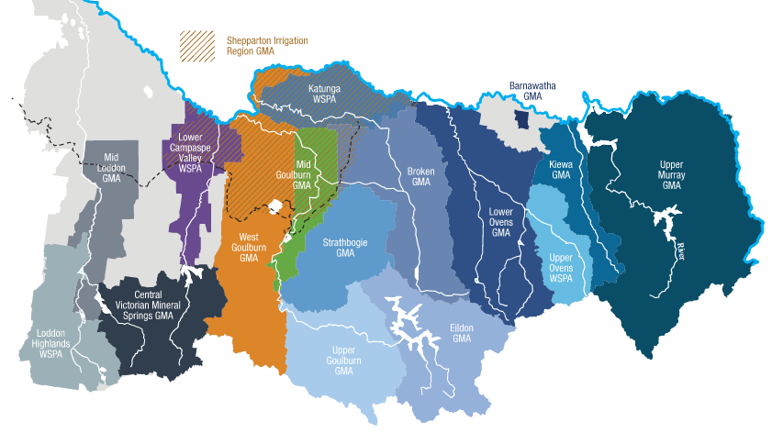

Source: [Website of GMW](https://www.g-mwater.com.au/water-resources/ground-water/management)

#### Katunga Water Supply Protection Area

The Katunga WSPA was chosen for this audit as this area had the highest volume of groundwater traded in Victoria during 2020-21.

As an area that requires intensive management due to the risks associated with groundwater extraction, Katunga was declared a water supply protection area with a statutory management plan approved by the Minister for Water in Victoria. It provides the local community, and in particular licensed groundwater users, with information about the groundwater system and rules describing management of the resource. This plan outlines management arrangements for the resource with rules that cover:

* Limits on groundwater licences
* Restrictions on taking groundwater
* Rules governing transfer of groundwater licences
* Metering licenced take
* Groundwater level monitoring
* Groundwater salinity monitoring, and
* Annual reporting

The Katunga WSPA is located to the north of the Great Dividing Range and incorporates parts of the flood plains of the River Murray, Broken Creek and the Goulburn River between Yarrawonga and Barmah. It includes the towns of Nathalia, Numurkah and Cobram and covers an area of approximately 2,100 km2.

Figure 3: Map of Katunga Water Supply Protection Area

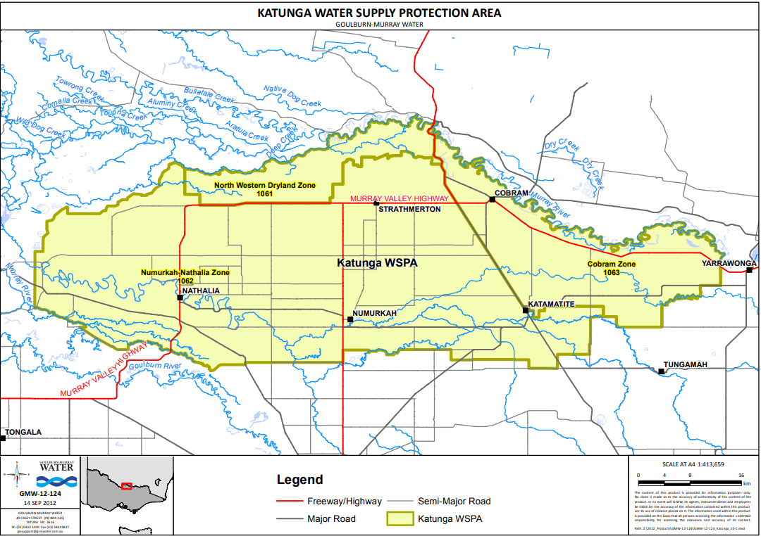

Source: [Website of GMW](https://www.g-mwater.com.au/downloads/gmw/Groundwater/Katunga_WSPA/TATDOC-_3469646-v1-MAP_-_KATUNGA_WSPA_-_FOR_WEBSITE.pdf)

A PCV of 60,577 ML has been declared for the Katunga WSPA under section 22A of the Victorian Water Act to provide certainty on the amount of groundwater that can be extracted while also protecting water for the environment.

# Audit approach

#### Audit objective and scope

To provide confidence in how groundwater is being managed in the Goulburn-Murray (Groundwater) Water Resource Plan Area.

The objective of the audit was to assess whether Goulburn-Murray Water (GMW) and DEECA) have been complying with rules in the Goulburn-Murray Water (Groundwater) Water Resource Plan in relation to *the* Katunga WSPA. Specifically in relation to the trade of groundwater access rights and management of risks associated with;

* structural integrity of the aquifers and hydraulic relationships,
* interception activity,
* water quality.

These rules are contained in the Victorian Water Act and Katunga Groundwater Management Plan (refer to Appendix A), and are linked to the accredited Goulburn-Murray (Groundwater) Water Resource Plan. They cover the following requirements in Chapter 10 of the Basin Plan

* Part 4 – The sustainable use and management of water resources
* Part 5 – Interception activities
* Part 7 – Water quality objectives
* Part 8 – Trade of water access rights
* Part 9 – Approaches to addressing risks to water resources

#### Audit methodology

The audit has been conducted in accordance with the standards issued by the *Australian Auditing and Assurance Standards Board (AUASB)*, specifically the following *Standards on Assurance Engagements (ASAE):*

* **ASAE 3000** for Assurance Engagements other than Audits or Reviews of Historical Financial Information
* **ASAE 3100** for specific Compliance Assurance Engagements.

This is a limited assurance compliance audit with the purpose to assess compliance against legislative requirements, documented policies, or procedures to identify whether or not specific requirements have been met. Due to the limited assurance nature of this audit, it is possible that some deviations in implementation from WRP provisions may not be detected and should not be relied upon to comprehensively identify all weaknesses, improvements, or areas of non-compliance.

Audit procedures included:

* interviews with representatives from GMW and DEECA
* review of documents including procedures, guidelines and manuals
* review of spreadsheets and data related to groundwater levels, water quality and water trading
* testing of GMW compliance with requirements set out in the WRP, Victorian Water Act and Katunga Groundwater Management Plan

These procedures were carried out on a test basis to provide sufficient appropriate evidence to provide a limited assurance conclusion.

# Requirements Tested

## Licence Approval

Under the Katunga Groundwater Management Plan, GMW is responsible for the approval of groundwater licenses. GMW must not approve an application if approval of the application would cause intensity or management zone limits to be exceeded (refer to Prescription 1 – Appendix A). This is in addition to the requirement in section 55(2B) of the Victorian Water Act,that an application must be refused if the allocation of water under the licence will or may result in the PCV for the area being exceeded.

During the audit, the IGWC identified that no new licences for entitlements have been issued since 1 July 2019. As no new licences for entitlements have been issued since the Water Resource Plan was accredited, testing of decisions against what’s required by the Victorian Water Act and Katunga Groundwater Management Plan were not necessary.

Information on current licence records and total licences issued are available from the Victorian Water Register. This is the register which captures water resource assessment requirements and is the accounting system through which all licence and trading applications are processed.

A review of the Victorian Water Register identified that as at 11 July 2022, the total volume under all licences issued was 60,635.7 Megalitres (ML). While this volume exceeds the PCV for the *Katunga WSPA*, it included three accounting entries for 434 ML to enable system functionality for reducing entitlement volume forfeited during trades between 2006 – 2017. Removal of this amount from total volume identified on the Victorian Water Register means that it is only 60,202 ML of water currently available to landholders.

The IGWC understands that these accounting entries have since been removed from the Victorian Water Register and are no longer included in the current volume of entitlement on issue in the Katunga WSPA.

OBSERVATION

GMW should consider including information on their website to explain why no new licences have been issued in the Katunga WSPA since 2006. This would increase public knowledge on how groundwater is managed in the region and provide a greater understanding for those seeking new licences in the area.

## Allocation Announcements

To minimize the potential impacts on the long-term sustainability of the groundwater resource for groundwater users, trigger levels for restrictions on groundwater extraction have been set (refer to Prescription 2 – Appendix A). Restrictions on licensed groundwater extraction are introduced through allocations announced at the start of each water season.

In the Katunga WSPA, allocations are determined by comparing the rolling five-year average of the maximum annual groundwater recovery levels recorded in seven key monitoring bores against set groundwater trigger levels (refer to Appendix B). These bores are listed in Schedule 1 of the Katunga Groundwater Management Plan.

Information on maximum annual groundwater recovery levels recorded and how rolling averages are calculated is captured in the annual report prepared for the Katunga WSPA. There is also public access to this information through the WMIS.

Comparison of information on maximum annual groundwater recovery levels and rolling average calculations in the annual report for 2020/21 identified discrepancies with data available from the WMIS. This was primarily the result of GMW not having access to validated telemetry data when the annual report was prepared.

While the discrepancies identified did not impact the allocations announced, the ability to accurately reconcile information published on maximum groundwater recovery levels and rolling average calculations to other public data sources is critical to providing confidence in how they were determined.

All allocations are announced by listing on the website of GMW, letters sent to all licence holders and public notices placed in local newspapers.

FINDING

Information used to determine allocation announcements for the Katunga WSPA differs between the Katunga WSPA annual report and WMIS. This may lead to requirements as set out in the Katunga Groundwater Management Plan Prescription 2(a) not being met.

## Trading Activity

Licence holders may apply to transfer their licence to another person or entity either temporarily or permanently. This encourages more efficient water use and provides buyers and sellers with choice and flexibility in business decision making and risk management to increase productivity.

Consistent with new licence applications, GMW will not approve an application for the temporary or permanent trade of a licence unless requirements of the Katunga Groundwater Management Plan and Victorian Water Act have been met. This includes intensity and management zone limits (refer to *Prescription 3* – Appendix A) and trading rules captured in the Victorian Water Register for processing of applications received. There are also water trading rules in the Basin Plan that include the requirement to assess whether there is sufficient hydraulic connectivity between the location of the seller and location of the buyer before the trade of groundwater is approved[1].

Section 1.07 of the Basin Plan defines hydraulic connectivity:

“Hydraulic connectivity means the ease with which, or the rate at which, groundwater moves:

1. within an aquifer;
2. between aquifers; or
3. between aquifers and the adjacent or overlying surface water systems.

Groundwater trade between two locations that have low or no hydraulic connectivity can lead to increased leakage between aquifers and reduced groundwater levels in other production bores in the area. This may increase the cost of, or even prevent, groundwater access for other users and affect water quality.

The relatively high reliability of some groundwater systems makes it an attractive alternative or supplement water source for surface water users. This is especially evident in drought. [Australian Water Markets Report 2019–20 (bom.gov.au)](http://www.bom.gov.au/water/market/documents/AWMR2019-20.pdf) pg 34: ‘the volume of groundwater allocation traded in 2019-20 was 291GL in the MDB. This was 9 and 36 per cent higher compared to 2018-19 and 2017-18 respectively’.

It is important that groundwater trade reflects the physical realities of water movement and supply.”

Within the three management zones established by the Katunga Groundwater Management Plan (refer to *Prescription 1* – Appendix A) there are two defined hydrogeological aquifers. The Katunga WSPA includes all formations from a depth of 25 metres, including the deeper Shepparton formation and the very deep Calivil formation.

Saline groundwater in the shallow Shepparton formation is managed under the Shepparton GMA. While it is understood that trade between this GMA and the Katunga WSPA is not allowed, this is not referred to in the Katunga Groundwater Management Plan.

Figure 4 Cross section of aquifers in the Katunga WSPA

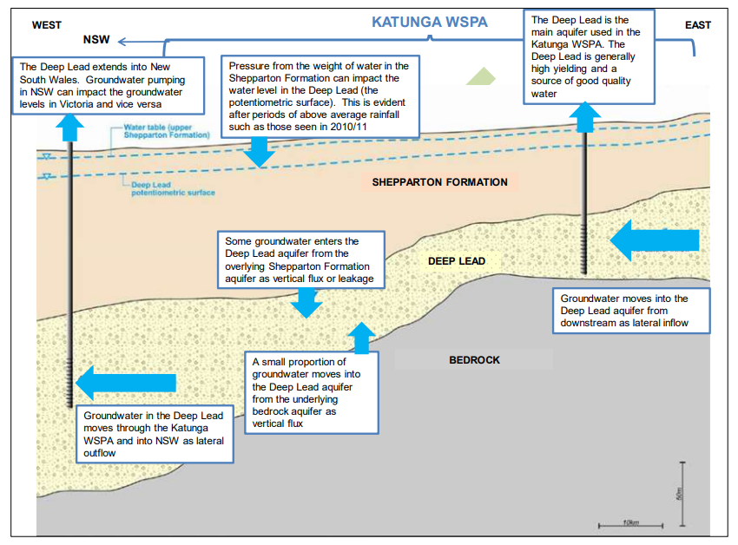

Source: [Katunga WSPA Groundwater Management Plan](https://www.g-mwater.com.au/downloads/gmw/Groundwater/Katunga_WSPA/20170901_4449443-v1-KATUNGA_WATER_SUPPLY_PROTECTION_AREA_GROUNDWATER_MANAGEMENT_PLAN_-_2017.pdf)

To meet the requirements of s12.24(a) of the Basin Plan, the Goulburn-Murray (Groundwater) Water Resource Plan identifies that trade between two locations within a single SDL resource unit is permitted where sufficient hydraulic connectivity has been demonstrated by a relevant hydrogeological resource assessment or approved Statutory Management Plan. The IGWC has been informed by DEECA and GMW that they rely upon an independent technical assessment of the resource against the requirements of s12.24(a).

In the course of auditing the Katunga Groundwater Management Plan, which is the supporting document of the Water Resource Plan, mention of the requirements to comply with s.12.24(a) was not present.

FINDING

It has been identified that sufficient hydraulic connectivity between the location of the seller and location of the buyer before the trade of a water access right is approved is not transparent within the Katunga Groundwater Management Plan. The IGWC is therefore unable to provide assurance that section 12.24(a) of the Basin Plan has been met by reference to the Katunga Groundwater Management Plan.

OBSERVATION

The Katunga Groundwater Management Plan should be amended to identify that trade between the Shepparton GMA and Katunga WSPA is not allowed.

## Groundwater Level Monitoring

Monitoring of groundwater levels provides important information that is used to:

* assess annual and long-term impacts on water levels from groundwater pumping
* monitor regional and local seasonal drawdown
* assess yearly allocations
* provide information for future resource assessments
* assess potential management issues including evaluating potential interference between bores

In the Katunga WSPA, monitoring activity is undertaken using state observation bores listed in Schedules 1 and 2 of the Katunga Groundwater Management Plan (refer to Appendices B and C). This includes the seven priority bores used for determining the allocations to be announced.

Data for monitoring activity is collected by a private supplier who also inspects bore condition and reports to DEECA if maintenance is required. All data collected is captured in the WMIS.

The IGWC was satisfied with the process by which monitoring data is collected. However, DEECA reported to the IGWC that since 1 January 2016, only 63 of the 230 manual water level measurements used for announcing allocations were entered into the groundwater database within 30 days of when they were collected. This does not meet DEECA’s requirements set out within the Katunga Groundwater Management Plan Prescription 5.2(c).

During this audit, the IGWC also explored consideration given to the need for an agreed process for the joint management of groundwater resources where there is a significant connection between the border of New South Wales (NSW) and Victoria. DEECA have acknowledged that there needs to be further discussion on the management of shared water resources which have been delayed pending the accreditation of NSW’s Murray Alluvium Water Resource Plan.

FINDING

DEECA are not entering manual water level measurements into the groundwater database within 30 days of collection. This does not meet DEECA’s requirements set out within the Katunga Groundwater Management Plan Prescription 5.2(c).

OBSERVATION

Information on groundwater bore sites in WMIS could be improved by explaining the level of information available on the range of bores monitored. This should include the bores that are used for monitoring pumping impacts and aquifer interaction.

OBSERVATION

Further discussion on the management of shared water resources between NSW and Victoria will be needed once the Murray Alluvium Water Resource Plan has been accredited.

## Groundwater Salinity Monitoring

In the Katunga WSPA, some of the groundwater pumped from the Deep Lead aquifer is sourced from the overlying Shepparton Formation aquifer which generally has a higher level of salinity. Increased salinity levels can therefore impact how groundwater is used.

To monitor potential changes in groundwater salinity, GMW sample groundwater from bores specified in the Katunga Groundwater Management Plan (refer to Appendix B) and have the results analysed by an accredited laboratory. Individual groundwater users are also encouraged to monitor salinity of their own bores by requesting a bottle from GMW for sample testing.

In the Katunga WSPA annual report for 2020/21, GMW identified that while groundwater salinity levels had remained stable over the previous six years, there was a recent increase in salinity over the last two readings collected from an observation bore in the Calivil Formation aquifer. This bore however is in the Shepparton GMA and should not have been included in this report.

The IGWC understands that error in the Katunga WSPA annual report for 2020/21 will be addressed in the annual report for 2022/23.

OBSERVATION

The Katunga Groundwater Management Plan should be updated to explain why it includes monitoring bores that are in the Shepparton GMA.

# Findings

1. It has been identified that sufficient hydraulic connectivity between the location of the seller and location of the buyer before the trade of a water access right is approved is not transparent within the Katunga Groundwater Management Plan. The IGWC is therefore unable to provide assurance that section 12.24(a) of the Basin Plan has been met by reference to the Katunga Groundwater Management Plan.

Groundwater trade between two locations that have low or no hydraulic connectivity can lead to increased leakage between aquifers and reduced groundwater levels in other production bores in the area. This may increase the cost of, or even prevent, groundwater access for other users and affect water quality.

1. DEECA are not entering manual water level measurements into the groundwater database within 30 days of collection. This does not meet DEECA’s requirements set out within the *Katunga Groundwater Management Plan Prescription 5.2(c).*

The information around non-compliance was self-reported by DEECA. Delays in capturing or reporting water level measurements within the required timeframes can cause confusion around information and undermine public confidence. The IGWC does not know how long after the 30 days the information was entered into the Groundwater database.

1. Information used by GMW to determine allocation announcements for the Katunga WSPA differs between the Katunga WSPA annual report and the Victorian WMIS. This may lead to requirements as set out in the Katunga Groundwater Management Plan Prescription 2(a*)* not being met.

Discrepancies in public data have the potential to undermine how allocation announcements are being determined.

# Recommendations

#### Recommendation 1

1. The Katunga Groundwater Management Plan should be amended to demonstrate that there is sufficient hydraulic connectivity between the location of the seller and location of the buyer before the trade of a water access right is approved. This could include reference to, and publication of, the technical assessment currently being relied on by GMW for all groundwater resources managed under the plan.
2. Victoria should identify changes made to the Katunga Groundwater Management Plan when they report to the MDBA on matters listed in Schedule 12 under section 13.14 of the Basin Plan. Matter 19 of this Schedule requires Basin States to report on whether there have been any amendments to state instruments that affect the operation of a water resource plan or are referenced in accredited text of a water resource plan.

#### Recommendation 2

1. DEECA should ensure that data collected from the state observation bore network is entered into the groundwater database, within 30 days after it has been collected.

#### Recommendation 3

1. Groundwater level monitoring processes should be reviewed to ensure that allocation announcements are based on readings that have been validated.

Appendix A

Prescriptions in Katunga Groundwater Management Plan

#### **PRESCRIPTION 1: Limit on groundwater licences**

GMW must not approve an application for a groundwater licence if the approval of the application would cause:

1. The total licenced volume within a 2km radius of the proposed extraction site exceeding 3,700 ML/year; or
2. The following zone limits to be exceeded.

|  |  |
| --- | --- |
| Management zone | Zone limit (ML/year) |
| North Western Dryland Zone (1061) | 6,500 |
| Numurkah-Nathalia Zone (1062) | No limit |
| Cobram Zone (1063) | 25,000 |

#### **PRESCRIPTION 2: Restrictions on taking groundwater**

By 15 September 2017, and by 1 July each year thereafter GMW will:

1. determine the rolling average of the maximum annual groundwater recovery levels from the preceding five irrigation seasons for bores listed in Schedule 1 and announce a corresponding allocation for the subsequent irrigation season as detailed below:

|  |  |
| --- | --- |
| Trigger level depth below natural surface (m) | Allocation |
| 21.0 and above | 100% |
| 21.1 to 24.0 | 70% |
| Below 24.1 | 70% and review undertaken by GMW in consultation with Katunga Groundwater Reference Group |

1. announce allocations by listing them on its website, sending letters to all licence holders and placing public notices in local newspapers.

#### **PRESCRIPTION 3: Transfer of a groundwater licence**

**3.1.** GMW may approve a permanent transfer of a groundwater licence provided relevant matters have been considered and:

1. zone limits in Prescription 1 will not be exceeded; and
2. the total licensed volume within 2 km of an applicant's bore will be less than 3,700 ML/year; or
3. where the total licensed volume within 2 km of an applicant's bore is equal to or greater than 3,700 ML/year, the permanent transfer is from other licence holders within a 2 km radius of the applicant's bore.

**3.2.** GMW may approve a temporary transfer of a groundwater licence provided relevant matters have been considered and:

1. zone limits in Prescription 1 will not be exceeded; and
2. the total licensed volume within 2 km of an applicant's bore will be less than 3,700 ML/year; or
3. where the total licensed volume within 2 km of an applicant's bore is equal to or greater than 3,700 ML/year –
   1. the applicant's licensed volume in one water season will not exceed 125% of their permanent licensed volume prior to any temporary trade occurring; or
   2. the temporary transfer is from other licence holders within a 2 km radius of the applicant's bore

#### **PRESCRIPTION 5: Groundwater level monitoring**

**5.1.** GMW will:

* 1. obtain groundwater levels from bores used for allocation assessments (listed in Schedule 1) on a monthly basis. If a bore used for allocation assessments becomes defective an alternative bore may be monitored and the defective bore should be decommissioned. The alternative bore will be selected by consensus between DELWP and GMW.
  2. undertake water level monitoring at appropriate locations throughout the Katunga WSPA to:
     1. assess annual and long-term impact on water levels from groundwater pumping;
     2. monitor regional and local seasonal drawdown; and
     3. monitor the impacts of groundwater pumping generally across the Katunga WSPA and in areas of high intensity groundwater pumping.

**5.2.** DELWP will manage the State observation bore network so that:

1. continuous regional baseline monitoring is maintained to provide sufficient information to identify changes in groundwater resource availability and condition;
2. State observation bores are properly maintained; and
3. data collected from the bores is entered into the groundwater database, within 30 days after it has been collected.

#### **PRESCRIPTION 6: Groundwater salinity monitoring**

GMW must:

1. sample bores specified in Schedule 1 and have the samples analysed at an accredited laboratory for salinity once a year;
2. enter salinity measured in bores referred to in Schedule 1 to the State groundwater database; and
3. provide a sample bottle to any groundwater user in the Katunga WSPA who requests one, test the salinity level of returned samples and provide the results to the groundwater user.

#### **PRESCRIPTION 7: Annual reporting**

By 30 September each year GMW will prepare an annual report on the enforcement and administration of the Plan. The report will be provided to the Minister and the Goulburn Broken Catchment Management Authority and made publicly available on GMW's website.

Appendix B

Monitoring bores – Allocation assessment and water quality

| Management Zone | Location | Bore ID | Monitoring purpose: Allocation assessment | Monitoring purpose: Groundwater quality |
| --- | --- | --- | --- | --- |
| North Western Dryland Zone - 1061 | River Road, Barmah National Park | WRK953007 | Nil | Yes |
| WRK953008 | Nil | Yes |
| Numurkah – Nathalia Zone 1062 | Allerts Road, Katunga | 69710 | Yes | Nil |
| Boards Road, Strathmerton | 92446 | Yes | Nil |
| Goulburn Valley Highway, Katunga | 48282 | Yes | Nil |
| Goulburn Valley Highway, Numurkah | 48281 | Nil | Yes |
| 48288 | Nil | Yes |
| James Bridge Road, Picola | 84016 | Nil | Yes |
| 84021 | Nil | Yes |
| Larissa Road, Naring | 83964 | Yes | Nil |
| Waaia-Bearii Road, Waaia | 97613 | Yes | Nil |
| Cobram Zone - 1063 | Grinter Road, Cobram East | 51001 | Yes | Nil |
| Langan Road, Katamatite | 69545 | Yes | Yes |
| 69547 | Nil | Yes |
| 69548 | Nil | Yes |

Appendix C

Monitoring bores – Pumping impacts and aquifer interaction

| Management Zone | Location | Bore ID | Monitoring purpose: Aquifer interaction | Monitoring purpose: Pumping impacts |
| --- | --- | --- | --- | --- |
| North Western Dryland Zone - 1061 | Browns Bridge Road, Yielima | 105928 | Yes | Nil |
| 105936 | Yes | Nil |
| 109777 | Yes | Nil |
| 109778 | Yes | Nil |
| 109779 | Yes | Nil |
| River Road, Barmah National Park | WRK953007 | Yes | Nil |
| WRK953008 | Yes | Nil |
| WRK953010 | Yes | Nil |
| Numurkah – Nathalia Zone 1062 | Benalla-Tocumwai Road, Muckatah | 109556 | Yes | Yes |
| 109557 | Yes | Yes |
| Boards Road, Strathmerton | 92446 | Yes | Nil |
| 92448 | Yes | Nil |
| Cranes Road, Yielima | 105927 | Yes | Nil |
| 105929 | Yes | Nil |
| 109780 | Yes | Nil |
| 109781 | Yes | Nil |
| Gilberts Road, Picola | 88009 | Yes | Nil |
| 88010 | Yes | Nil |
| Goulburn Valley Highway, Katunga | 48282 | Yes | Yes |
| 48289 | Yes | Yes |
| 48292 | Yes | Yes |
| Goulburn Valley Highway, Numurkah | 48281 | Yes | Nil |
| 48288 | Yes | Nil |
| James Bridge Road, Picola | 84016 | Yes | Nil |
| 84021 | Yes | Nil |
| Paynes Road, Nathalia | 97885 | Yes | Nil |
| 97886 | Yes | Nil |
| Paynes Road, Nathalia | 109757 | Yes | Nil |
| 109758 | Yes | Nil |
| Sandmount Road, Katunga | WRK953012 | Nil | Yes |
| Waaia-Bearii Road, Waaia | 97613 | Nil | Yes |
| Cobram Zone - 1063 | Grinter Road, Cobram East | 51001 | Yes | Yes |
| 51003 | Yes | Yes |
| Langan Road, Katamatite | 69545 | Yes | Yes |
| 69547 | Yes | Yes |
| 69548 | Yes | Yes |
| Tungamah Road, Burramine | 53674 | Yes | Nil |
| 53676 | Yes | Nil |
| 53678 | Yes | Nil |
| Youarang Road, Katamatite East | WRK059813 | Yes | Yes |
| WRK059814 | Yes | Yes |
| WRK059815 | Yes | Yes |

1. section 12.24 Basin Plan 2012