# Frequently Asked Questions Sustainable Diversion Limit Compliance Framework

© Commonwealth of Australia 2023

**Ownership of intellectual property rights**

Unless otherwise noted, copyright (and any other intellectual property rights) in this publication is owned by the Commonwealth of Australia (referred to as the Commonwealth).

**Creative Commons licence**

All material in this publication is licensed under a Creative Commons Attribution 4.0 International Licence, except for content supplied by third parties, logos and the Commonwealth Coat of Arms.

Inquiries about the licence and any use of this document should be emailed to copyright@dcceew.gov.au.



**Cataloguing data**

This publication (and any material sourced from it) should be attributed as: Inspector-General of Water Compliance 2023, Frequently Asked Questions - Sustainable Diversion Limit Compliance Framework, the Australian Government, Canberra, September 2023. CC BY 4.0.

This publication is available at https://www.igwc.gov.au/about

Inspector-General of Water Compliance  
GPO Box 3090 Canberra ACT 2601

**Disclaimer**

The Australian Government represented by the Inspector-General of Water Compliance, has exercised due care and skill in preparing and compiling the information and data in this publication. Notwithstanding, the Inspector-General of Water Compliance, the Australian Government’s employees disclaim all liability, including liability for negligence and for any loss, damage, injury, expense or cost incurred by any person as a result of accessing, using or relying on any of the information or data in this publication to the maximum extent permitted by law.

**Acknowledgement of all Traditional Owners**

We pay our respect to the Traditional Owners and their Nations of the Murray-Darling Basin. We acknowledge their deep cultural, social, environmental, spiritual and economic connection to their lands and waters.

Aboriginal people should be aware that this publication may contain images, names, or quotations of deceased persons.

**Accessibility**

The document and information is available in accessible formats. On some occasions the highly technical nature of the document means that we cannot make some sections fully accessible. If you encounter accessibility problems or the document is in a format that you cannot access, please contact us.

# SDL Compliance Framework – Frequently Asked Questions

## Roles and responsibilities

### Why was the Inspector-General of Water Compliance established?

The Inspector-General of Water Compliance was created on 5 August 2021 to serve as a strong and independent regulator of Australia’s largest water resource – the Murray–Darling Basin (the Basin). The Inspector-General’s role was established under the *Water Act 2007* (Cth) (Water Act) to strengthen compliance, increase transparency, and improve trust. The Inspector-General has powers to scrutinise, provide oversight of and monitor compliance with the *Basin Plan 2012* (Basin Plan), water resource plans and intergovernmental agreements and arrangements relating to water resource management in the Basin.

### What is the role of the Inspector-General of Water Compliance

The independent Inspector–General of Water Compliance was established to enforce compliance with the national laws and to hold Commonwealth and Basin State governments to account in their management of Basin water resources.

In this context, the Inspector–General broadly has the roles of:

* Monitoring and overseeing the performance of functions and exercise of powers by agencies of the Commonwealth, as described in the Water Act, Basin Plan and water resource plans, for the management of Basin water resources.
* Monitoring and overseeing Basin State and Territory government agencies’ performance in meeting legislative obligations for the management of Basin water resources.
* Enforcing compliance with Commonwealth laws that regulate the management of Basin water resources.
* Engaging with the Australian community about the management of Basin water resources.

### What is the role of the Inspector-General compared to the Murray Darling Basin Authority?

In relation to the assessment of compliance with Sustainable Diversion Limits (SDLs), it is the role of the Murray Darling Basin Authority (MDBA) to:

* Maintain a Register of Take for each SDL resource unit (Basin Plan, Chapter 6)
* Provide information submitted by Basin States (reports under section 71 of the *Water Act 2007* (Cth)) to the Inspector-General
* Identify concerns with information provided and advise the Inspector-General.

The Inspector-General’s role is to undertake assessment of SDL compliance using information provided by the MDBA and other lines of evidence.

## Purpose

### What is the purpose of the SDL Compliance Framework?

The purpose of the Framework is to:

* Set out the Inspector-General’s role and objectives in relation to SDL compliance.
* Articulate the Inspector-General’s expectations, requirements and approach.
* Provide transparency and confidence about this essential function to the community.

SDL compliance assessments consider the overall management of take of water from both surface water and groundwater at an SDL resource unit level. They do not assess an individual water users’ compliance.

### What is in scope of the SDL Compliance Framework?

The SDL Compliance Framework sets out the Inspector-General’s role and objectives in relation to ensuring compliance with the SDLs. The Framework outlines the Inspector-General’s expectations and approach.

The Inspector-General relies on the data and information provided by the MDBA and Basin States. The method for collecting this data is documented in the [Sustainable Diversion Limit Accounting and Reporting Framework (mdba.gov.au)](https://www.mdba.gov.au/publications-and-data/publications/sustainable-diversion-limit-accounting-and-reporting-framework) and the relevant water resource plan for each SDL resource unit and is outside of the scope of this Framework.

Similarly, the amount of water available to be taken each year, is determined using the method set out in the relevant water resource plan and is outside of the scope of this Framework.

## Sustainable Diversion Limit (SDL)

### What is an SDL?

Sustainable diversion limits (SDLs) are how much water, on average, can be used in the Murray-Darling Basin, while keeping the rivers and environment healthy. SDLs are in place for 29 surface water and 80 groundwater areas called SDL resource units. The SDLs regulate the total long-term average water use in an SDL resource unit, they do not regulate the water taken by individual entitlement holders. Individual water take is limited by state allocation frameworks and legislation. The SDLs came into effect in 2019 and are binding on all States and Territory in the Basin. Further details regarding information on SDLs can be found at [Sustainable diversion limits | Murray–Darling Basin Authority (mdba.gov.au)](https://www.mdba.gov.au/water-use/water-limits/sustainable-diversion-limits)

## Data

### Where does the water accounting data come from?

Water account data is submitted by the Basin States as required under section 71 of the WaterAct. This information is due within four months after the end of the water accounting year i.e., 30 June, which means submission is due on 31 October annually. Basin States can seek an extension from the MDBA.

Basin States source the section 71 data from several different resources including water licensing systems, water resource monitoring and gauging stations, hydrological models, and other methods as necessary.

When submitting the section 71 data, Basin States provide a declaration of accuracy of the data. The MDBA then undertakes a quality assurance check on the data and collates the information into the Registers of Take.

### What information is used to assess compliance?

Given the complexity of managing SDLs, the Inspector-General will use multiple lines of evidence to assess SDL compliance. A number of lines of evidence are established in the Water Act and Basin Plan, and the Inspector-General may also seek additional lines of evidence. The Framework provides an indicative list of possible lines of evidence that the Inspector-General will use to assess compliance, however it is the responsibility of the Basin States to provide enough evidence to support their claims.

## Compliance

### How is SDL compliance assessed?

The Inspector-General’s assessment of SDL compliance is based on information provided by the MDBA and the Basin States.

The Basin States must report on permitted and actual take for each SDL resource unit to the MDBA within 4 months after the end of a water accounting period (30 June). The MDBA then reviews and checks the information received and meets with the relevant State agencies to confirm their findings. The MDBA collates the Registers of Take and provides the compliance data and documentation to the Inspector-General in March each year.

The Inspector-General will then assess SDL compliance, including claims of reasonable excuse and action plans, by applying the approach laid out in the Framework.

The Inspector-General will publish the outcomes of each annual compliance assessment, through the SDL Compliance Statement on their website.

### What is the difference between excess and exceedance?

The term ‘excess’ has a specific meaning in the Basin Plan.

For surface water SDL resource units, each year the actual take is subtracted from the permitted take to generate a debit (where actual take is more than permitted take) or a credit (where actual take is less than permitted take). Over time, these debits and credits generate a cumulative balance. An excess occurs when the cumulative balance on the relevant Register of Take is a debit amount equal to or greater than 20% of the SDL (the SDL compliance threshold).

An example cumulative balance showing exceedance and excess is shown in Figure 1.

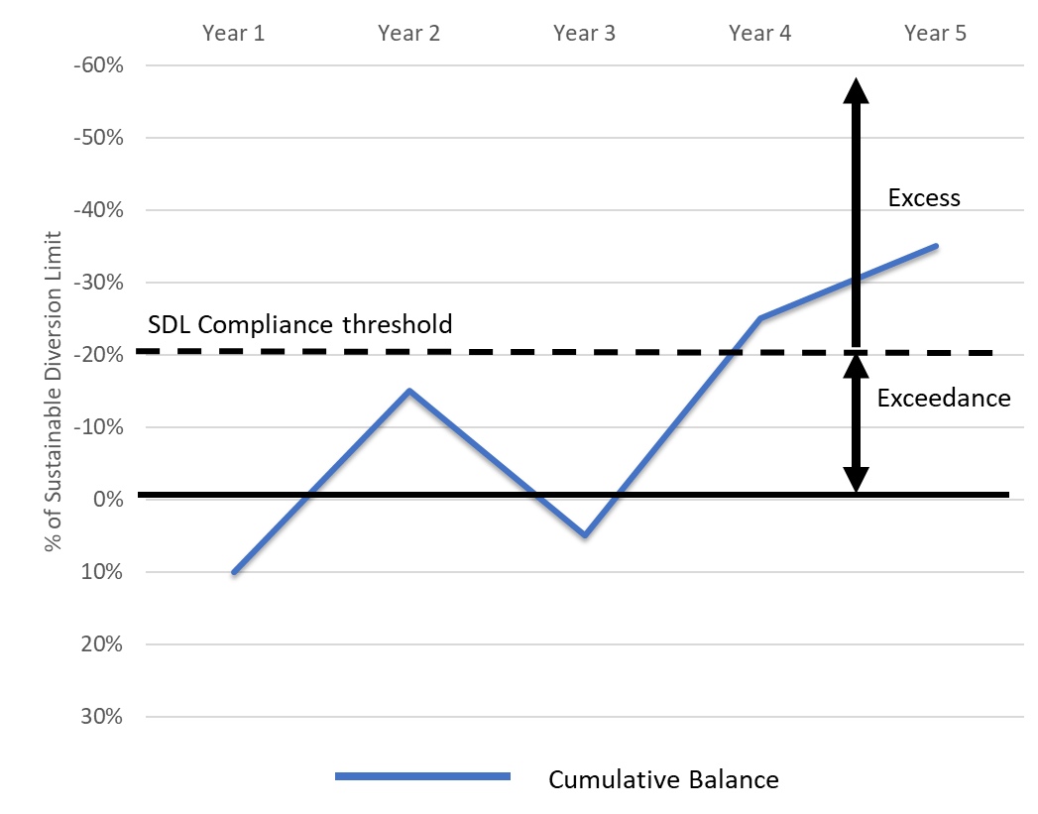

Figure 1 A hypothetical example cumulative balance for a surface water SDL resource unit (the blue solid line represents cumulative balance)

For groundwater SDL resource units, in any accounting period up to 2028, an excess occurs when the sum of actual take for all years since 2019 is greater than the sum of permitted take for those years, plus 20%. This method will change in 2028, after which an excess occurs when the average annual take over the previous 10 years exceeds the average permitted take over the previous 10 years. *Figure 2* shows an example of a groundwater SDL resource unit in exceedance and excess prior to 2028.

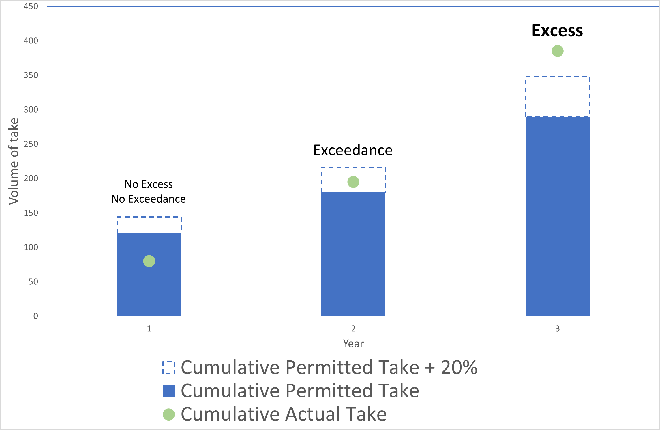

*Figure 2 A hypothetical example of a groundwater exceedance and excess prior to 2028.*

The Framework uses the term ‘exceedance’ to refer to circumstances where actual take is higher than permitted take (cumulatively) but has not reached the SDL compliance threshold of ‘excess’.

### What is a reasonable excuse and why is it provided?

When the water taken is in excess of the SDL compliance threshold, a Basin State may choose to provide a ‘reasonable excuse’ explaining the reasons for the excess.

The concept of ‘reasonable excuse’ was introduced in the Basin Plan because the SDL compliance threshold may be breached even if a Basin State did everything within its power to try to prevent it. Circumstances where a reasonable excuse may be appropriate include times when the SDL compliance threshold is breached even though all the rules in the relevant water resource plan have been complied with, or where the circumstances that caused the excess are outside of the control of the Basin State.

The Inspector-General assesses reasonable excuse reports from Basin States. If the ‘reasonable excuse’ is assessed by the Inspector-General to be acceptable, then the SDL resource unit is considered ‘compliant with a reasonable excuse’.

It is the responsibility of the Basin State making the claim to provide appropriate information to demonstrate the reasonable excuse.

### What will occur if there is non-compliance?

If the Inspector-General assesses a Basin State as non-compliant in a particular SDL resource unit, the Inspector-General will work with that Basin State to understand how the Basin State will ensure that the non-compliance does not occur again. This will involve the Basin State proposing an ‘action plan’ that outlines the steps it will take to bring the SDL resource unit back to being compliant. The Inspector-General will review this action plan and make a public statement regarding the facts of the non-compliance and the Basin State’s response.

If the Inspector-General assessment indicates non-compliance, the Inspector-General will provide the responsible Basin State with an opportunity to respond to the assessment before it is finalised.

The Inspector-General may also choose to undertake an audit or investigation of the Basin State’s data and actions.

An SDL non-compliance is not in itself a direct contravention of the Water Act, or the Basin Plan or a water resource plan. However, acting inconsistently with the Basin Plan or a water resource plan is a contravention of the Water Act.

If the Inspector-General has evidence of a contravention of the Water Act, the Inspector-General may take appropriate enforcement action. Enforcement action may include:[1]

* Requesting a person (including a Basin State agency) to provide an enforceable undertaking that the person will take specified action to prevent the contravention; or
* Applying to the court for a declaration that there has been a contravention, and/or an injunction to prevent the contravention.

## Actions

### What must the Basin State do if they are in excess?

If an SDL resource unit is in excess of the SDL compliance threshold, the Basin State must take steps to ensure that the SDL is complied with in the future.

If a surface water SDL resource unit is in excess, but the Basin State has a claim of reasonable excuse, the Basin State must provide an action plan and indicate the steps that will be taken to reduce the cumulative balance to zero or less.

If a groundwater SDL resource unit is in excess, but the Basin State has a claim of reasonable excuse, the Basin State must provide an action plan and indicate the steps that will be taken to reach the point where there is no excess.

### What is an Action Plan?

This Framework uses the term ‘Action Plan’ to refer to the steps a Basin State will take to address the cause and reduce the excess.

## Timing

### How long will the SDL compliance assessment take?

The Inspector-General’s assessment of SDL compliance will commence when they have received the Registers of Take and supporting data from the MDBA. Where there are no compliance issues, the Inspector-General will aim to complete the SDL Compliance Statement in two months. Where there are one or more cases of SDL excess, the Inspector-General will aim to complete assessments within three months.

## Public Information

### Will the SDL Compliance Statement be publicly reported?

The Inspector-General will publish a Sustainable Diversion Limit Compliance Statement on its website, for each water accounting year.

### How have stakeholders been consulted?

The Inspector-General developed a draft SDL Compliance Framework and consulted the Basin States and MDBA through a workshop and bilateral meetings over June to July 2023. The Basin States and MDBA were asked to review the Framework and provide feedback on

i) Any errors or omissions from the Framework; and

ii) Matters related to the implementation of the Framework.

**Where can I find the Sustainable Diversion Limit Compliance Framework?**

The Framework is published on the Inspector-Generals website, [Reviews and reports | Inspector General of Water Compliance (igwc.gov.au)](https://www.igwc.gov.au/publications/reviews-reports).

1. Water Act Part 8