Fact Sheet – Sustainable Diversion Limit Compliance Framework

What is Sustainable Diversion Limit (SDL) compliance?
Sustainable diversion limits (SDLs) are how much water, on average, can be used in the Murray-Darling Basin, while keeping the rivers and environment healthy. It is the role of the Inspector-General to assess the compliance of each Basin State with the SDL.
The Inspector-General uses information provided by the Basin States and the Murray-Darling Basin Authority to assess compliance. This includes information on:
- how much water was available to be taken (permitted take)
- how much water was taken (actual take)
- if the SDL compliance threshold has been exceeded, the reasons why
more water was taken

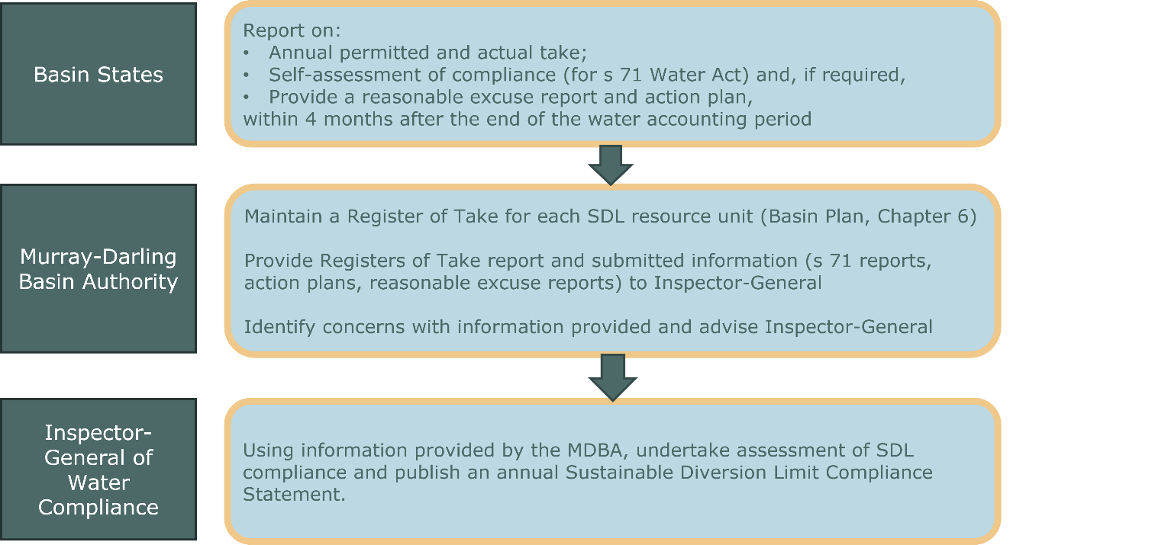
Roles & responsibilities

Why is there a Framework?
The SDL Compliance Framework sets out the Inspector-General’s role and objectives in relation to ensuring compliance with the SDLs. The Framework:
- articulates the Inspector-General’s expectations, requirements and approach
- provides transparency and confidence about this essential function to the community.

Where can I learn more?
More information on the assessment of SDL compliance can be found in the SDL Compliance Framework - Frequently Asked Questions.

