

Annual Report 2022–23

© Commonwealth of Australia 2023
Ownership of intellectual property rights
Unless otherwise noted, copyright (and any other intellectual property rights) in this publication is owned by the Commonwealth of Australia (referred to as the Commonwealth).
Creative Commons licence
All material in this publication is licensed under a Creative Commons Attribution 4.0 International Licence, except for content supplied by third parties, logos and the Commonwealth Coat of Arms.
Inquiries about the licence and any use of this document should be emailed to copyright@dcceew.gov.au

Cataloguing data
This publication (and any material sourced from it) should be attributed as: Inspector-General of Water Compliance 2023, Annual Report, Australian Government, Canberra. CC BY 4.0.
This publication is available at www.igwc.gov.au/publications
Inspector-General of Water Compliance
GPO Box 3090 Canberra ACT 2601
Web www.igwc.gov.au
Disclaimer
The Australian Government, represented by the Inspector-General of Water Compliance, has exercised due care and skill in preparing and compiling the information and data in this publication. Notwithstanding, the Inspector-General of Water Compliance, the Australian Government’s employees and advisers disclaim all liability, including liability for negligence and for any loss, damage, injury, expense or cost incurred by any person as a result of accessing, using or relying on any of the information or data in this publication to the maximum extent permitted by law.
Acknowledgement of all Traditional Owners
We pay our respect to the Traditional Owners and their Nations of the Murray−Darling Basin. We acknowledge their deep cultural, social, environmental, spiritual and economic connection to their lands and waters.
Aboriginal people should be aware that this publication may contain images, names or quotations of deceased persons.
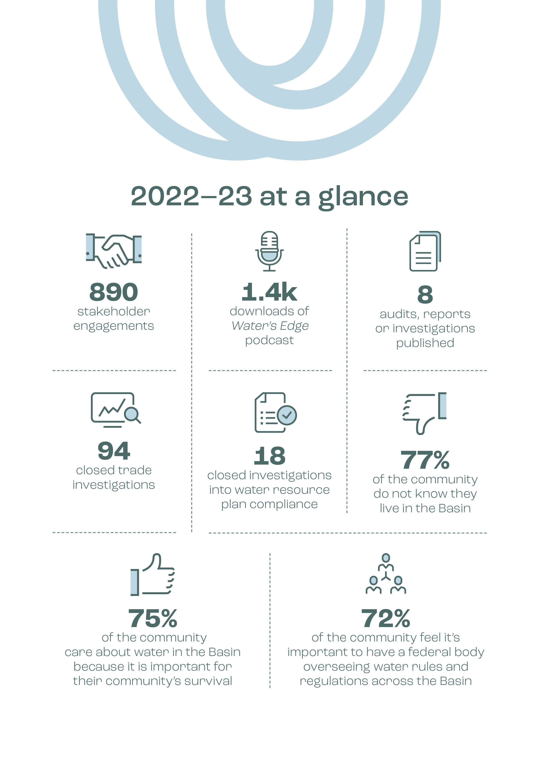

Foreword by the Inspector-General


Once again, I have great pleasure in commending to you the annual report for the Inspector-General of Water Compliance (IGWC).
At the end of our second year of being established, I am pleased to report it has been another busy year and continues to get busier as the office addresses concerns and issues raised by the community and industry, and those who regulate it. In establishing the role of the independent Inspector-General of Water Compliance there was a clear mandate to restore trust and confidence in water management across the Murray-Darling Basin. Supporting that mandate, my commitment – and obligation – to hold those charged with managing our most precious natural resource to account, something I have continued to do with the staff who support me in this role.
The year 2022 provided us with the opportunity to hear from the community through survey research undertaken on our behalf by ORIMA Research. This survey was to measure community sentiment relating to the Basin Plan and water management across the Basin. We heard from water licence-holders, water users, First Nations and the community at large. It was an interesting result, the breakdowns of which can be found on our website under the ‘publications’ tab on our homepage (select: ‘annual community sentiment survey’). Not surprisingly, it demonstrated a real desire by all community groups for an independent body to oversee water management in the Basin, exactly the role with which I have been tasked. It also saw respondents indicating they get angry with those who flout the law, with many believing people take more water than they are permitted. Through cooperation with state governments, I am committed to undertaking and publicly reporting on the annual community sentiment survey to provide transparency of trends and drivers of confidence in water management and the Basin Plan.
During the reporting period, we undertook several key audits and reports on matters that you, the community, wanted me to investigate, or that I felt needed closer scrutiny based on my own observations and findings. These included, but were not limited to:
- Audit of Goulburn–Murray Water disclosure obligations under the Basin Plan
- Sustainable Diversion Limit Compliance Statement
- ‘Steady as it flows’ – an assessment of River Murray operations and environmental water management
- An audit on “Accounting for Interstate Trade in the Northern Basin”
- The inaugural Metering Report Card.
- Audit of the management of overland flow harvesting in the Lower Balonne.
Both the comprehensive summaries, and copies of the final products/audits and reports can be found on our website. Go to the ‘publications’ tab on the home page of our website and visit ‘reviews and reports’.
Complementing this critical work is the ongoing communications and engagement by myself and the staff that support me in my role. This has included rolling ‘on the ground’ visits across the Basin to see and hear firsthand from people. I have continued to invest in the network of our field officers and staff based in Goondiwindi, Dubbo, Albury, Mildura and Loxton – ensuring we have authentic and accessible staff on the ground to cover the 1 million square kilometres of the Murray-Darling Basin. Our communications products are ever evolving and are designed to be engaging, accessible, relevant, informative, and timely. ‘Water’s Edge’, our in-house produced podcast continues to grow in reach and popularity among its audience. We have committed to producing simplified ‘explainer’ and ‘myth busting’ content, in particular short-form videos, that share key information in easy to consume and digest ways. Our on-the-ground engagement activities at some of the Basin’s biggest agricultural field days ensure we’re front and centre, and accessible to a range of individuals living in these areas. We continue to visit and have face-to-face conversations with people from towns and villages throughout the Basin, with ‘farm gate’ conversations continuing to play a role in how we communicate with and listen to people. In turn, the information we gather from these conversations provides for part of an evidence base that informs priority areas that I might need to look into further.
The community can also contact us via our dedicated 13 IGWC (13 44 92) phone number – connecting the community with their nearest field officer or ensuring someone from the Inspector-General of Water Compliance responds to their enquiry. I have been told, and listened to, the feedback from the community that often, ‘government agencies are too hard to reach, or don’t care about my enquiry’. As an independent statutory authority, I want the Inspector-General of Water Compliance to be accessible and responsive to anyone in the Basin who has a concern about water management.
On 5 August 2023, the Inspector-General of Water Compliance observed its second year of operation. In that time, the environment in which we operate continues to change, physically and metaphorically. The legislative environment designed to deliver and support the Basin Plan is changing. We’re transitioning from consecutive years’ above average rainfall and floods due to La Niña, to drought inducing drier conditions brought about by the return of El Niño. The many lessons learned from the recent worst drought in recorded European settlement compels us to be more resilient and prepared, never more so critical than in water resource management, operations, and compliance.
As the independent Inspector-General of Water Compliance, I have certain provisions and powers, including powers of inquiry, to hold those who manage and use our finite water resource to account. Community sentiment research tells us the Australian public expects this from regulators. Our own face-to-face engagement shows us that people and industry want greater action and penalties in the water compliance space. Our own investigations and audits are showing us, in the main, levels of compliance, and need for improvement in key areas by government agencies and water operators. And the more things I am asked to look into, or that I look into, the more confident I am that those powers afforded to me, will and can be used to find answers, hold people and entities to account, or prosecute.
2021 to 2022, and 2022 to 2023 were foundational and busy years for the Inspector-General of Water Compliance. Most recently I published a Strategic Plan, setting out my priority areas for the coming three years. Supporting this is a Regulatory Policy that communicates when, how, and why I use my powers in order to deliver on the abovementioned mandate. 2023 to 2024 (next year’s annual report) will be an equally important year as we mature to focus on more acute priorities and prepare for the busy water reform agenda that will centre around Basin Plan deliverables and maturing compliance regimes, both of which I intend to watch closely and act upon when, and if, necessary.

The Honourable Troy Grant
Inspector-General of Water Compliance

Contents
Foreword by the Inspector-General i
01 Introduction 1
About the Inspector-General 1
Purpose of the Inspector-General 4
Values and approach 4
Vision of integrity for the Basin 4
Office locations and contact information 5
Field Officers in Basin communities 5
About the Murray–Darling Basin 6
A plan for the Basin 6
Roles and responsibilities of other agencies 7
A dynamic Basin: 2022–23 in review 8
02 Compliance and performance 9
Enforcing trade rules: the water market 9
Border Rivers trade Audit of Accounting for Interstate Trade in the Northern Basin 11
Water resource plans 12
New South Wales water resource plans 16
Lower Balonne water resource plan audit 17
Measuring water take 18
Compliance with sustainable diversion limits 20
03 Oversight and confidence 23
Regulatory Leaders Forum 23
Acting on the Des Pearson review: consistency of reporting 24
Acting on community questions: operation of irrigation infrastructure operators 26
Transparency review: $13 billion Basin funding 27
Measuring community confidence 30
Engaging across the Basin 33
The Water’s Edge podcast 35
Looking forward 36

01 Introduction

Each year, the Inspector-General of Water Compliance (the Inspector-General) reports on the activities undertaken in the previous financial year by preparing an annual report in accordance with s. 215Y of the Water Act 2007 (Cth) (the Water Act). This report fulfils that legislative obligation and allows the Inspector-General to be transparent by sharing findings, reporting on commitments and communicating with the public.
The Inspector-General’s financial statements and other information required by the Public Governance, Performance and Accountability Act 2013 (Cth) are reported each year in the annual report of the Australian Government Department of Climate Change, Energy, the Environment and Water.

About the Inspector-General
The Inspector-General is an independent statutory office holder and integrity agency with oversight, monitoring and enforcement functions and powers in relation to the Water Act and the Basin Plan 2012 (Cth) (the Basin Plan).
The Inspector-General role was established by the Water Legislation Amendment (Inspector-General of Water Compliance and Other Measures) Act 2021 (Cth).
This means:
- the functions of the Inspector-General are set out in the legislation
- the Inspector-General is appointed by the Governor-General
- the Inspector-General is appointed for a set term (4 years)
The Inspector-General is a public-facing role and reports to the Australian Parliament while engaging directly with the public across the Basin.

What the Inspector-General does
The Inspector-General provides strong and independent regulation of water compliance. This includes:
- enforcing compliance with the Water Act and the Basin Plan, including water trading rules
- conducting inquiries into how government agencies perform their obligations under the Water Act
- engaging with the Australian public on the management of Murray–Darling Basin water resources
- monitoring the performance of Commonwealth and Basin State government agencies in meeting their water management responsibilities under the Water Act including overseeing 11 intergovernmental agreements which implement various elements of the Basin Plan

Independence

A critical factor in the way the Inspector-General works is that the role is independent. The Inspector-General’s independence comes from:
- Self-determination: there are very limited circumstances in which the Inspector-General can be directed by others
- Security of tenure: there are statutory provisions regarding things such as the appointment and dismissal of the Inspector‑General
- Access to resources: the Inspector-General has a dedicated budget and staffing
- Lines of accountability: as the Inspector-General is a statutory officer, the performance of the Inspector-General is overseen by the Australian Parliament, not by a departmental secretary
This means that when making decisions, the Inspector-General is not driven or influenced by, or involved in, politics.
The Inspector-General’s decisions on where, when and how to act are evidence and risk based.
The Inspector-General’s independence enables agile decision-making in order to respond effectively to changing priorities or emerging issues.
The Inspector-General has published a Regulatory Policy that sets out the principles applied to decision-making when prioritising where, when and how to apply the functions and powers of the role.
The Regulatory Policy may be updated from time to time, as the Inspector-General identifies opportunities for continuous improvement. It can be found on the website at: Inspector-General of Water Compliance (igwc.gov.au)
With independence comes a greater need to be transparent and accountable.
This is achieved through:
- engaging transparently with the community
- public reporting
- accountability of the Inspector-General to the Australian Parliament

The Inspector-General
The Hon Troy Grant, Inspector-General of Water Compliance
Troy has a 32-year career of public service in government, law enforcement, emergency service, social justice, community and charity. He was an elected member of the New South Wales Parliament from 2011 to 2019. Troy has lived and worked in the northern and southern Murray–Darling Basin for over 40 years. He maintains a sound understanding of, and connection to, the communities in the Basin.

Deputy Inspectors-General
The Inspector-General is supported by 2 deputies, who provide day-to-day operational executive management, and strategic advice and support.
Daniel Blacker: Deputy Inspector-General of Water Compliance – Regulation
Bridgett Leopold: Deputy Inspector-General of Water Compliance – Capability

The division of responsibilities between the Deputy Inspectors-General is outlined in the organisation chart (Figure 1.1).

Inspector-General staff
The Inspector-General is assisted by employees from the Department of Climate Change, Energy, the Environment and Water (DCCEEW).
Interactions between Inspector-General staff and the broader department are managed in a way that enables the department and staff to comply with their legal obligations while respecting and supporting the integrity and independence of the Inspector-General.
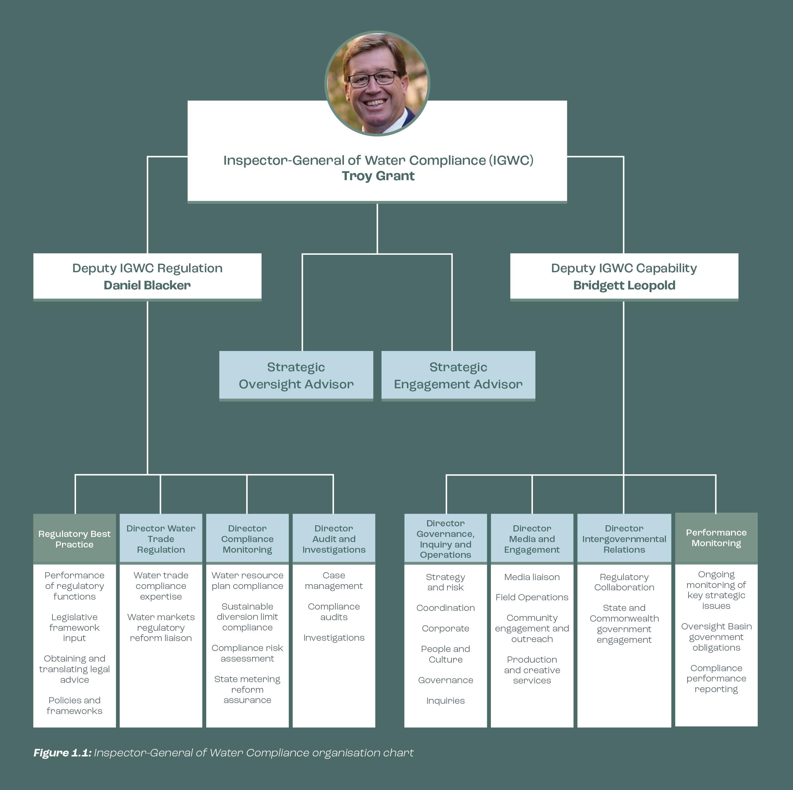
Figure 1.1: Inspector-General of Water Compliance organisation chart

Purpose of the Inspector-General
The purpose of the Inspector-General of Water Compliance is to ensure various government bodies, water managers and water users in the Murray–Darling Basin comply with their obligations under the Water Act 2007 and the Basin Plan 2012 and drive governments and water managers to uphold high standards of integrity and performance.
This purpose reflects the functions described in the Water Act, which include both oversight powers and specific compliance powers relating to areas of water management.

Values and approach
At all times, the Inspector-General and their staff act with the same values they seek to embed into the fabric of Basin water management. The core values of the Inspector-General are transparency, accountability and integrity (Figure 1.2).
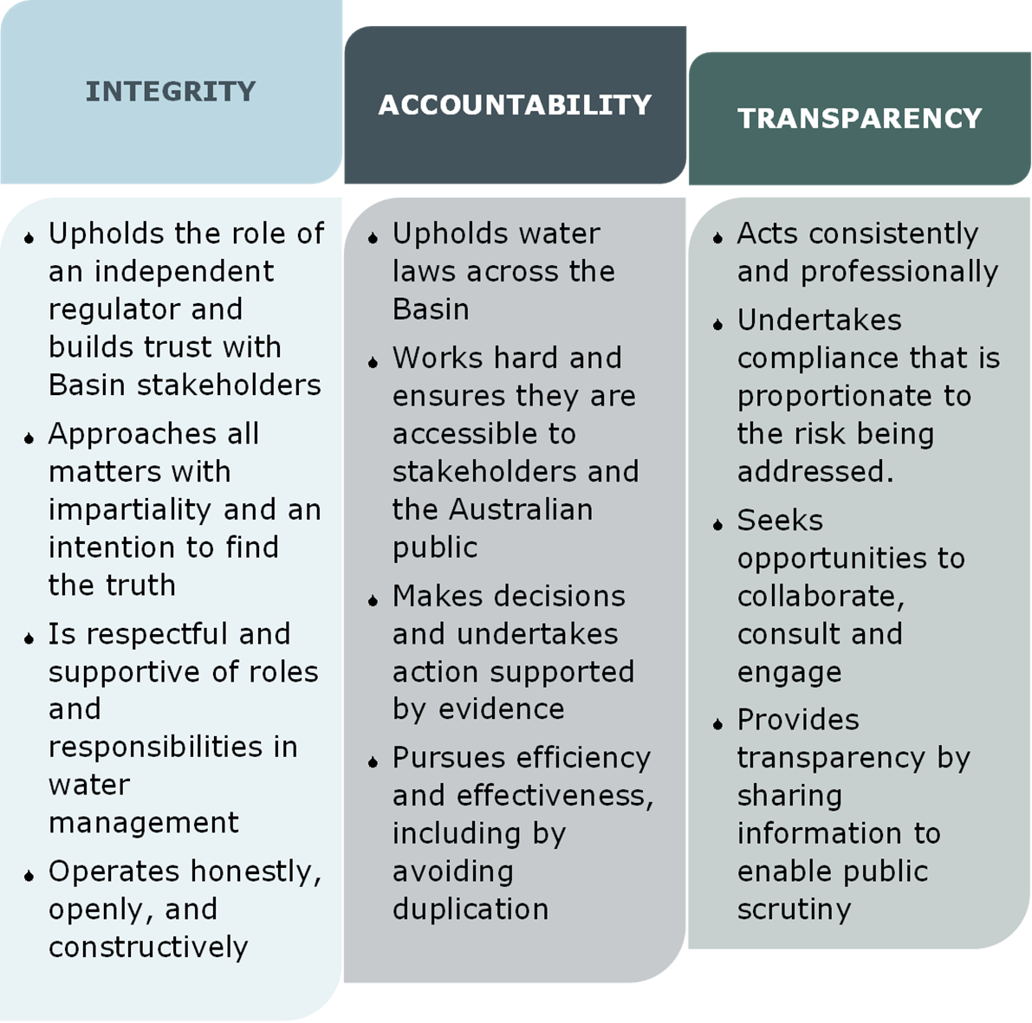
Figure 1.2: The Inspector-General’s values

Vision of integrity for the Basin
The Inspector-General’s vision is that water management and use within the Basin is lawful, transparent, and accountable, and the Australian public is confident in the integrity of Basin Plan delivery.
The Inspector-General has established 4 long-term goals that enable the agency to work strategically towards the achievement of this vision (Figure 1.3).
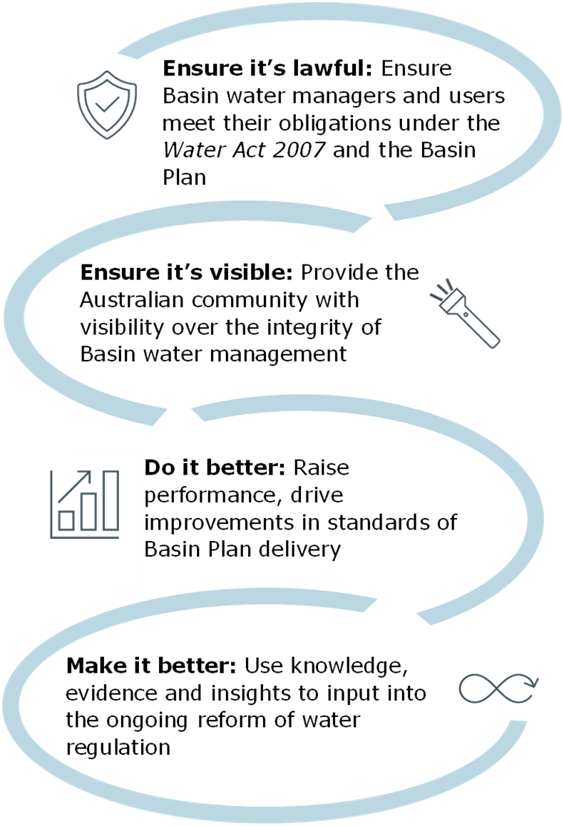
Figure 1.3: Strategic objectives of the Inspector-General 2023–26
Further information can be found at: About | Inspector-General of Water Compliance (igwc.gov.au)

Office locations and contact information
The Inspector-General has offices located throughout the Basin.
In addition to an office in Canberra, there are 5 regional offices in the Basin:
- Goondiwindi
- Dubbo
- Albury
- Mildura
- Loxton
Office contact details are on the website: Contact us | Inspector-General of Water Compliance (igwc.gov.au)
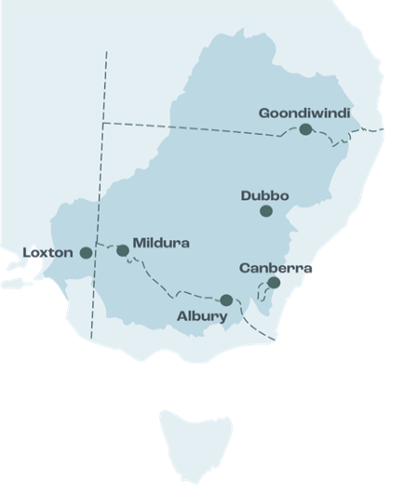
Figure 1.4: Map of Inspector-General of Water Compliance office locations

Field Officers in Basin communities
The Inspector-General maintains a team of Field Officers who live and work in the Basin and understand the diversity of interests in water management across Basin communities.
Field Officers speak directly with the public and stakeholders to identify areas of interest and/or concern. They also provide the community with information about what the Inspector-General is doing. This gives assurance to the community that their questions and matters of concern are being looked into and that outcomes will be reported back to the public.
Field Officers’ work is part of an effort to build and maintain community confidence in the transparency, accountability and integrity of Basin water management.

What Field Officers do
Field Officers act as a conduit between the Basin community and the Inspector-General. Their responsibilities include:
- providing support to the Inspector-General during engagement activities
- assessing stakeholder concerns and directing them to the relevant agency
- gathering ‘on-ground’ intelligence to inform the Inspector-General of concerns relating to confidence in water management
- assisting stakeholders in navigating complex water information
- working with and liaising across Australian Government and state agencies on matters relating to the Inspector-General
Key stakeholders include:
- communities
- First Nations peoples
- peak bodies (including environmental)
- irrigators and farmers
- industry representatives
- Australian Government, state government and local government agencies and representatives
- infrastructure and river operators

About the Murray–Darling Basin
The Murray–Darling Basin is significant for its environmental, social and economic contribution to the nation.
It is the country’s largest river system – home to more than 2.3 million people, including over 40 First Nations, who rely on its groundwater and rivers for their drinking water and water for livestock.
The Basin is made up of more than 20 major rivers and extends over 1 million km², covering three-quarters of New South Wales, more than half of Victoria, significant portions of Queensland and South Australia, and all of the Australian Capital Territory. It is known as ‘the food bowl of Australia’.
The Basin contains more than 77,000 km² of rivers, including Australia’s 3 longest rivers: the Darling (Baaka), the Murray and the Murrumbidgee.
It includes an estimated 30,000 wetlands, of which 16 are listed as internationally significant. Its rivers, lakes, creeks and watercourses are home to 35 endangered species and 120 species of waterbirds.
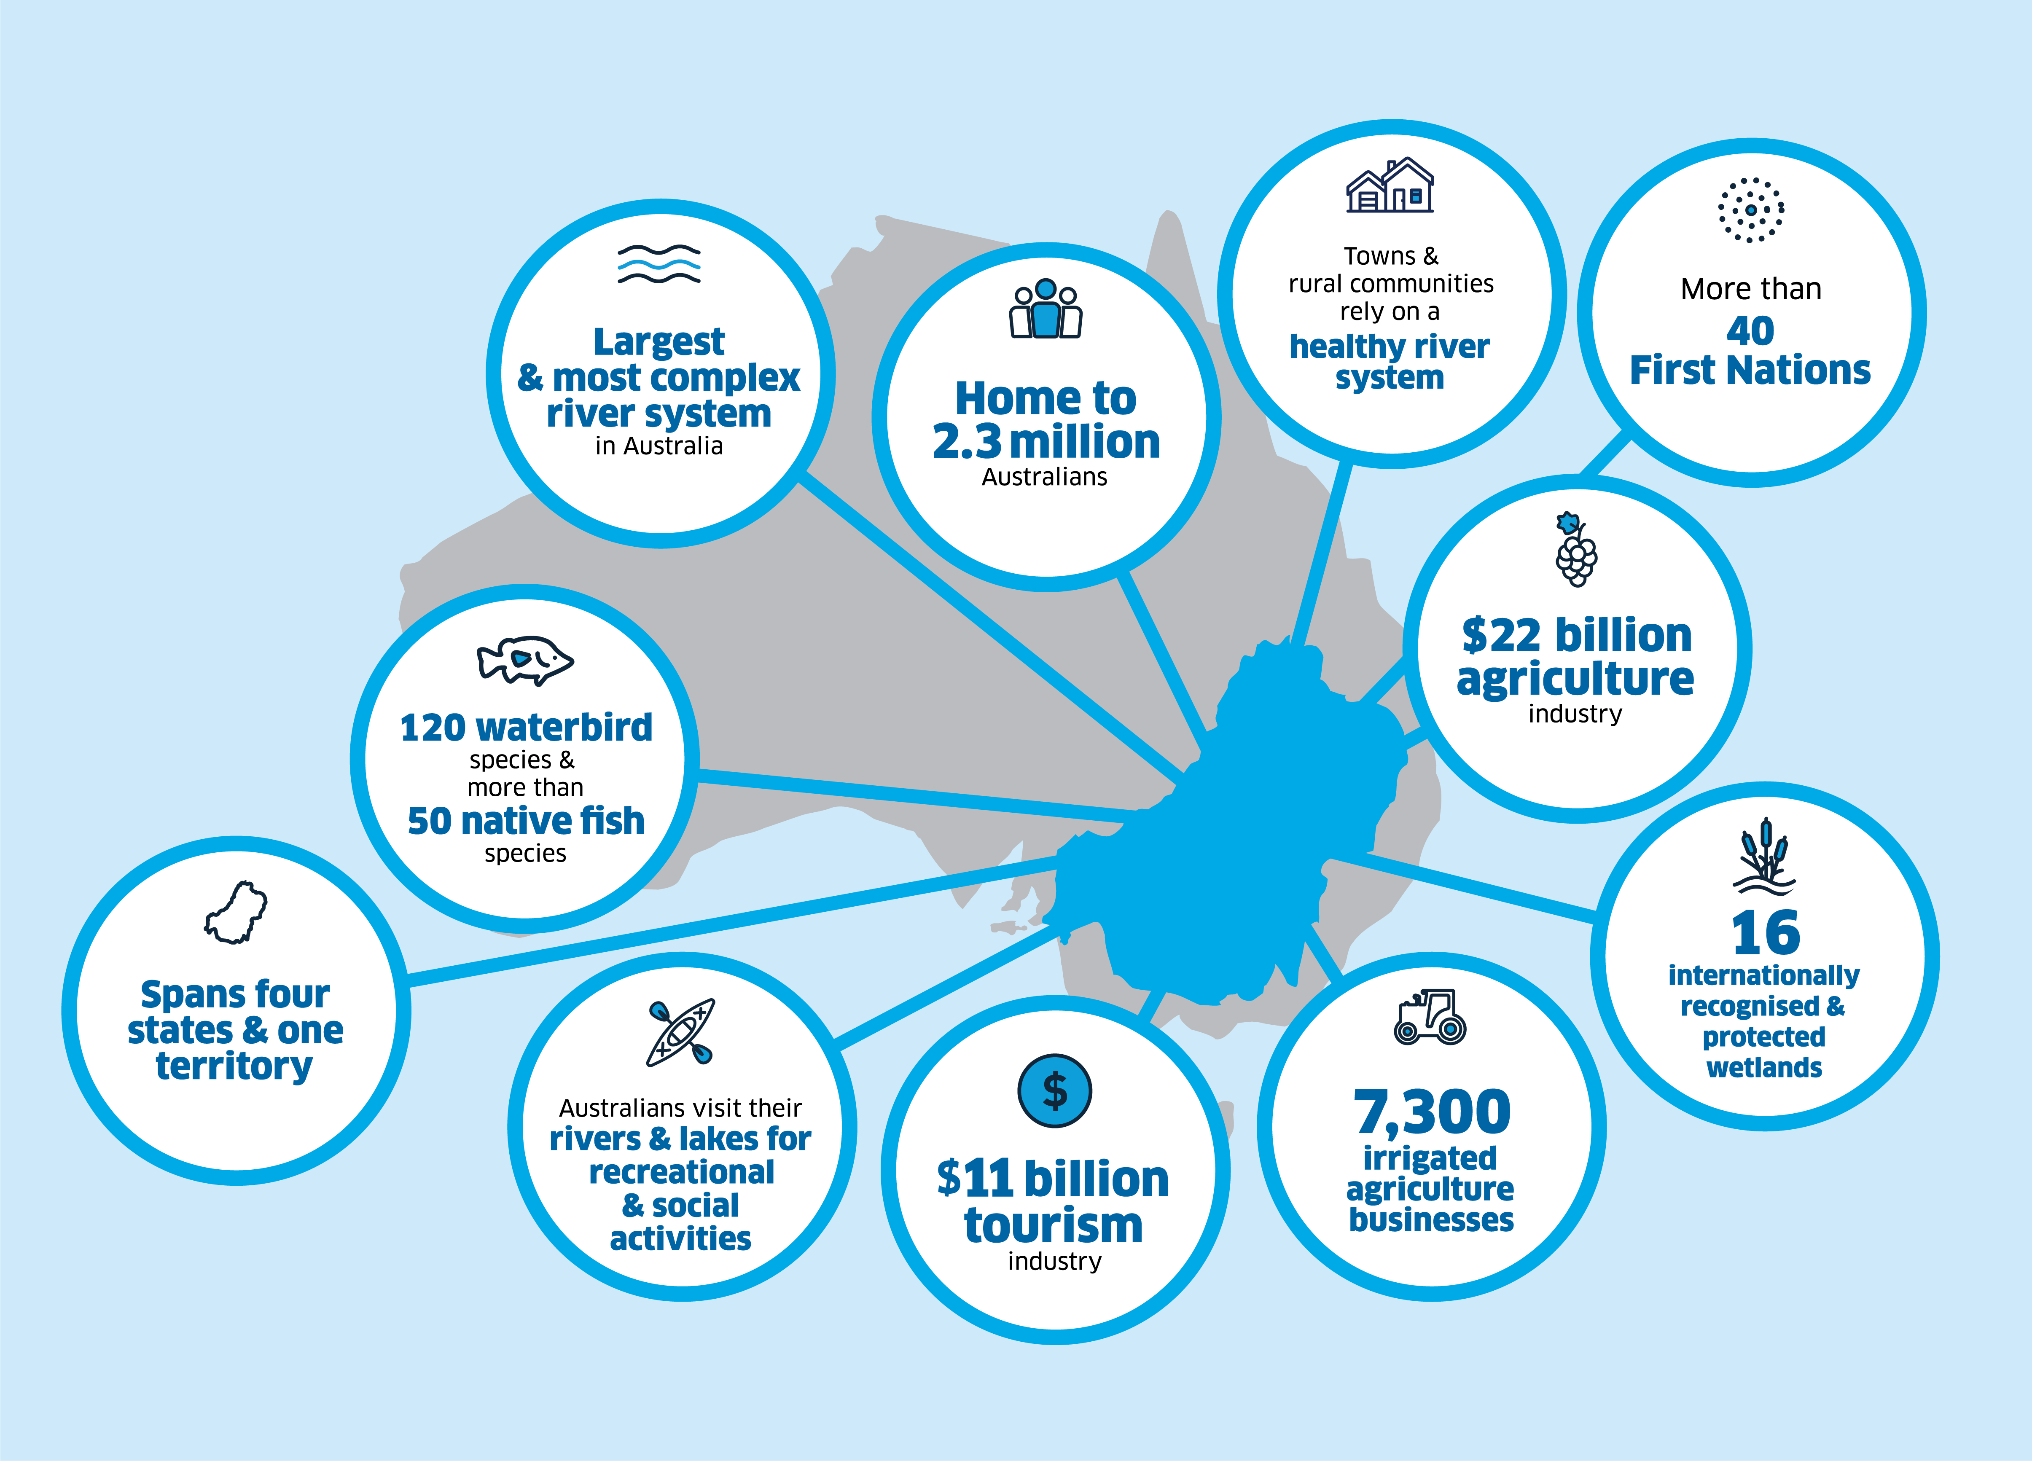

A plan for the Basin
The Water Act was enacted in response to the Millennium Drought (1997 to 2010). Basin inflows fell to the lowest on record at that time in 2007, and public pressure regarding progress on improving environmental outcomes created the impetus for national legislation that coordinated decision-making and enabled management of the Basin as a whole.
The Water Act complements state legislation by requiring Basin State governments to cooperate and align on objectives greater than those of their individual jurisdictions.
Basin governments widely agreed there was a need to develop a coordinated plan to manage Basin water resources in a sustainable way. Therefore, the Water Act also established the Murray–Darling Basin Authority (MDBA) and required it to develop the Basin Plan.
The objective of the Basin Plan is to restore and maintain the health of the Basin, while supporting essential industries such as agriculture.
Essentially, the Basin Plan establishes how much water can be taken from the Basin each year without compromising the health and sustainability of Basin waterways and ecosystems.

Figure 1.5: Murray–Darling Basin facts
Source: A plan for the Murray–Darling Basin | Murray–Darling Basin Authority (mdba.gov.au)

Roles and responsibilities of other agencies

Basin State governments are responsible for monitoring compliance with their water laws in their states and for determining the allocations between different types of water use.
The Inspector-General ensures Basin water managers and users act within the law in respect of the Water Act and Basin Plan. The Inspector-General has powers to enforce compliance with relevant laws where there is evidence to support a finding of non-compliance.
Additionally, the Inspector-General monitors state, territory and Australian Government decision-makers and holds them to account. In doing this, the Inspector-General may conduct inquiries to gather information and evidence to inform their findings.
Several Australian Government agencies have responsibilities relating to Basin Plan implementation that fall under the Inspector-General’s remit. They include:
- the Murray–Darling Basin Authority
- the Department of Climate Change, Energy, the Environment and Water
- the Commonwealth Environmental Water Holder
The Inspector-General’s powers emphasise the importance of compliance with water laws as one of the keys to maintaining the integrity of water management by all Basin governments.
Figure 1.6 shows some of the different roles of the Inspector-General, the Murray–Darling Basin Authority and Basin State agencies in managing the Basin’s water resources.

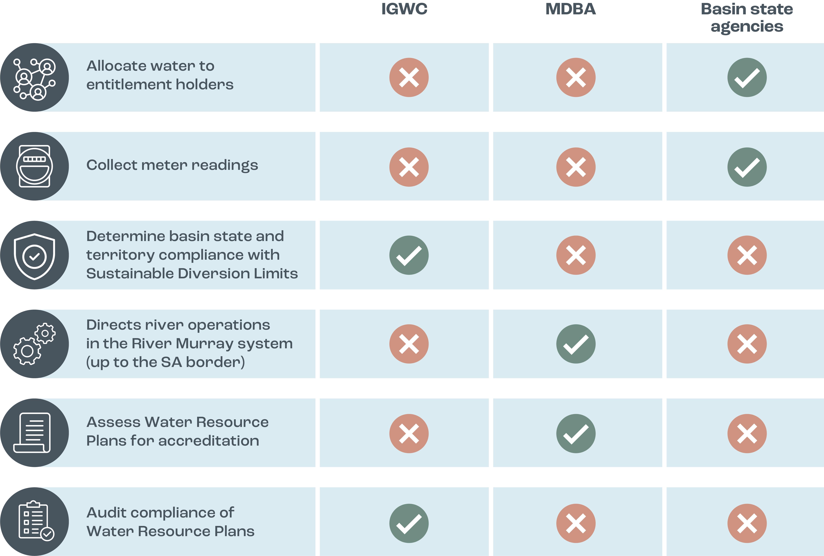

Figure 1.6: Roles and responsibilities in Basin water management

A dynamic Basin: 2022–23 in review

Following prolonged droughts across large parts of the Basin over many years, 2022–23 was another difficult year for Basin communities – for very different reasons.
Southern Queensland and northern New South Wales had already endured devastating floods in the first half of 2022 that led to thousands of people being displaced from their homes and businesses.
Then, starting in late spring 2022, severe flooding impacted large parts of regional New South Wales, Victoria and South Australia until early 2023.
Agricultural production across the Basin was significantly affected. Crops were waterlogged and harvests were delayed. Road closures affected supply chains across the regions, preventing producers from transporting stock to market, and creating bottlenecks in other industries such as manufacturing.
By early December 2022, Agriculture Victoria reported the deaths of almost 16,000 livestock, damage to 12,000 km of fencing, the loss of more than 150,000 t of hay and silage, and the loss of over 200,000 ha of field crops as a result of storm and flooding events. Flooding continued to impact Victorian communities until February 2023. In news reports, the New South Wales Department of Primary Industries estimated the on-farm damage bill across the Central West and Riverina to be more than $466 million. Downstream in the South Australian Riverland, more than 3,200 properties between the Victorian border and Murray Bridge were damaged, and communities were still cleaning up months after floodwaters receded.
Still recovering from the immediate effects of the floods, the Darling (Baaka) River experienced unprecedented mass fish deaths near Menindee in March 2023, attributed to low dissolved oxygen levels. The event was another blow for the local community, and deeply upsetting for those who live on, and care for, the Darling (Baaka).
As we move into 2023–24, Basin communities continue to demonstrate their resilience in the face of extreme events and changing conditions of water availability and use. Ongoing inflationary pressures, commodity prices, and significant labour shortages all continue to further exacerbate the pressures felt across many Basin communities and industries. Changes influenced by factors such as climate change, changing demographics and social values, new technologies and global market shifts create uncertainty about the future for Basin communities.
The complexity of water management arrangements and uncertainty about where to go for information can create frustration. Research undertaken by the Inspector-General in 2022 indicates that perceptions of water management are driven by a number of factors, including:
- feeling informed / having a good understanding of the topic
- being aware of positive outcomes
- having access to trusted sources of information
- feeling that decision-making processes meet expectations
It is therefore incumbent on governments and Basin water managers and users to demonstrate they understand the relationship between the delivery of outcomes and real-world effects for millions of people, and ensure that water is managed in a way the Australian community can be confident in.

02 Compliance and performance

Enforcing trade rules: the water market
For several years, water users have been able to trade water rights issued by Basin State governments and irrigation infrastructure operators in the Murray–Darling Basin.
As the Basin Plan is a cap-and-trade policy, water trade is an essential element of Basin Plan implementation. Water trading allows water users to make their own decisions about how to source the water they need for production.
The Basin has several different water market areas. Water markets in the Basin reflect individual water resource areas, which may be surface water resources or groundwater resources. The Basin Plan water trading rules create a consistent framework to conduct water trade in and across the Basin.

The Inspector-General’s enforcement role
The Inspector-General of Water Compliance is the enforcement agency for the Basin Plan water trading rules.
Trade enforcement was the number-one work priority of the Inspector-General for 2022–23. This included completing:
- several trade investigations and
- an audit of interstate trades in the Border Rivers area (Northern Basin).
Anyone who has specific concerns or evidence about non-compliance can report these to the Inspector-General. Visit the website for contact information: Contact us | Inspector-General of Water Compliance (igwc.gov.au)
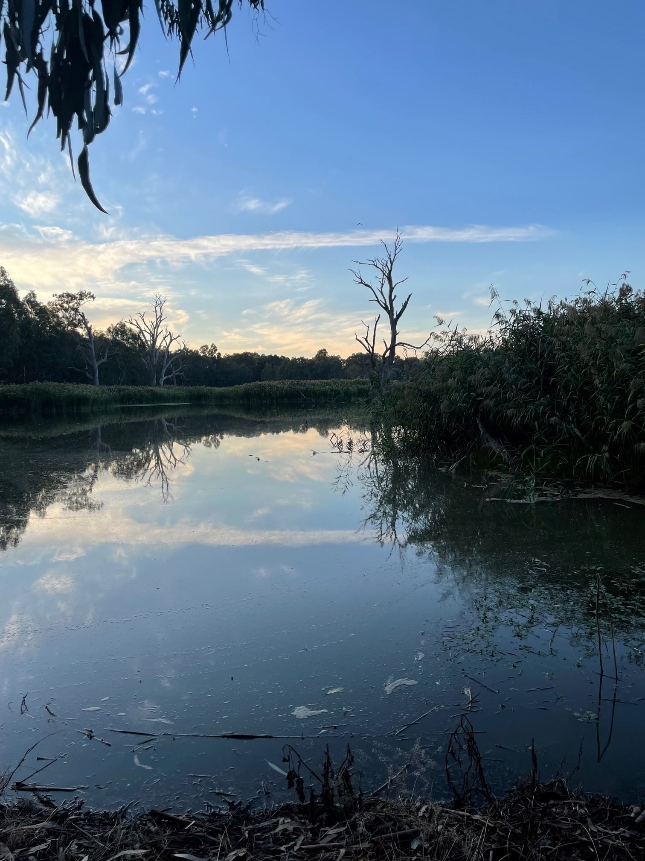

Trade investigations

What the Inspector-General investigated
In 2022–23 the Inspector-General closed 49 trade investigation matters. Another 4 remain open. The open matters include one – an inaccurately reported trade – that does not constitute non-compliance under current legislative arrangements. The Inspector-General is working with the relevant agency to have the matter rectified.

What the Inspector-General found
Through investigations undertaken in 2022–23, the Inspector-General noted a number of issues that affect enforcement of trade offences under the Water Act. The issues include:
- Deficiencies in the breadth of offences:
  - Certain types of poor behaviour do not constitute an offence
  - The investigative scope is extremely narrow
  - In certain circumstances where offending is likely, evidence is extremely difficult to collect
- Escape clauses in legislation:
  - There are more legal defences than actual offences
  - The term ‘reasonable excuse’ is explained by the word ‘excuse’
  - There is no requirement to verify claims
  - There is no maximum gift amount

- Lack of access to data:
  - It is extremely difficult for investigators to access trade data
  - Once data is provided, it lacks the robustness required to conduct further enquiries
  - There is no chain of custody attached to data
  - The quality and integrity of data cannot be guaranteed

How the Inspector-General responded
The Inspector-General used the information and insights gained from completed investigations to inform the Australian Government’s effort to improve water markets.
The Australian Competition and Consumer Commission’s water markets inquiry (2021) demonstrated the need for significant improvements to Basin water markets. The subsequent Commonwealth Water Market Reform Roadmap sets out the pathway to implementing water market reform.
During 2022–23 the Inspector-General provided extensive advice and knowledge to the Department of Climate Change, Energy, the Environment and Water taskforce coordinating implementation of the roadmap.

Border Rivers trade Audit of Accounting for Interstate Trade in the Northern Basin

In 2022–23 the Inspector-General completed an audit of accounting for interstate trade in the Northern Basin. In the Northern Basin, interstate trade of surface water between New South Wales and Queensland occurs only in the Border Rivers catchment.
The objective of the audit was to assess the arrangements for recording interstate trades in the Border Rivers catchment and ensuring that interstate trade data is accurately accounted for in annual reports provided to the MDBA on water use and availability.

Why the audit was done
The accuracy of surface water and trade data is important as it is used to determine compliance with the annual sustainable diversion limits (SDLs) under the Basin Plan, as well as in modelling for long-term annual diversion limits.
New South Wales and Queensland have different accounting processes and systems for recording and reconciling interstate water trade data.

Key facts
The Basin State governments are required to provide the MDBA with an annual report which includes details of the volume of water permitted to be taken, the actual take, and details of trading in specific water resource plan areas.
In 2018–19 (the audit sample period):
- the combined SDL for the Border Rivers catchment was 669 gigalitres (GL)
- 398 GL of water was used in the Border Rivers
- 31.6 GL was traded between New South Wales and Queensland
- 30.8 GL of this interstate trade was from New South Wales to Queensland

What the audit found
- The volume of water traded was not likely to have had any material impact on SDL compliance
- The transfer of water through works that are permanently linked is not recognised as a trade by either New South Wales or Queensland
- Inconsistencies and inaccuracies occurred in water accounting records
- No appropriate process was in place to reconcile accounting differences between the states
- Take of water occurred in Queensland before trades were approved
- New South Wales does not require a meter reading to confirm water availability before a water trade is approved

What the audit report recommended
- New South Wales and Queensland must recognise transfers of water through works that are permanently linked as trades under the Basin Plan
- System and process improvements are needed to ensure that water trade data is accurately recorded
- Regular reconciliation of water trade data should be undertaken to identify and resolve data integrity anomalies and ensure the accuracy of information reported
- Queensland must investigate and record the outcome of these investigations – all instances where water was taken before the trade was approved
- Meter reading data in New South Wales needs to be validated before a trade is approved

Water resource plans

Water resource plans are an integral part of implementing the Basin Plan.
They outline how each region of the Basin aims to achieve community, environmental, economic and cultural outcomes and ensure that state water management rules meet the Basin Plan objectives.
They establish the rules on how much water can be taken from the system and are used to ensure that SDLs are not exceeded over time.
Each water resource plan specifies the rules for water used at a local or catchment level, including limits on how much water will be made available to the environment, how water quality standards can be met and how much water can be taken from the system.
Water resource plans incorporate surface water and groundwater resources. The Basin is divided into 33 water resource plan areas in total: 14 for surface water (Figure 2.1), 14 for groundwater (Figure 2.2), and 5 that cover both.
Water resource plans reflect current arrangements and incorporate new arrangements that strengthen water management at a local level.

Development
Basin State governments are responsible for developing water resource plans.
They work closely with the MDBA to ensure that their water resource plans meet both the requirements of the Basin Plan and local requirements for water resource management.
Much of the critical work of water resource planning happens in the development stages when plans are developed in consultation with communities and with assistance from the MDBA. Getting the plans right can take time, as local communities must have confidence that the plans are robust, are high quality and adequately address local needs.

Accreditation
Basin State governments submit their completed water resource plans to the MDBA for assessment. The MDBA then advises the Australian Government Minister responsible for Water on whether the plans should be accredited.
Eighteen water resource plans have been accredited and are operational. This total comprises plans for each water resource plan area in Queensland, Victoria, the ACT and South Australia; and 5 of the 20 water resource plan areas of New South Wales (see New South Wales water resource plans, page 14).
Accredited water resource plans can be viewed on the MDBA’s website.
Water resource plans will continue to evolve and adapt over time as new and improved information becomes available.

Implementation
Once water resource plans are operational, the Basin State governments are responsible for implementing them in accordance with the Basin Plan.
Basin State governments are also responsible for ensuring irrigation infrastructure operators and water users comply with relevant water resource plan rules and licence conditions.

The Inspector-General’s compliance role
The Inspector-General is the enforcement agency for water resource plans.
When a water resource plan is in place, the Inspector-General has a full legal suite of monitoring, risk assessment and compliance tools, such as inquiries, audits and investigations, available to undertake water resource plan compliance and enforcement activities. These compliance powers are being defined through the Water Resource Plan Compliance and Enforcement Framework that the Inspector-General is currently preparing. This is expected to be finalised by March 2024.
The Water Resource Plan Compliance and Enforcement Framework will:
- describe the Inspector-General’s role and objectives to ensure compliance with water resource plans
- set out the Inspector-General’s approach to exercising statutory powers and functions
- set out the Inspector-General’s expectations and requirements regarding performance by Basin State governments and Commonwealth agencies of their functions relating to water resource plan compliance
The Water Resource Plan Compliance and Enforcement Framework will also set out processes and expectations to achieve an appropriate balance in the nature and timing of any response to a potential water resource plan non-compliance by applying best practice regulation principles. It will ensure a transparent and robust process to provide procedural fairness, and aims to build community confidence in water resource plans and the Basin Plan.
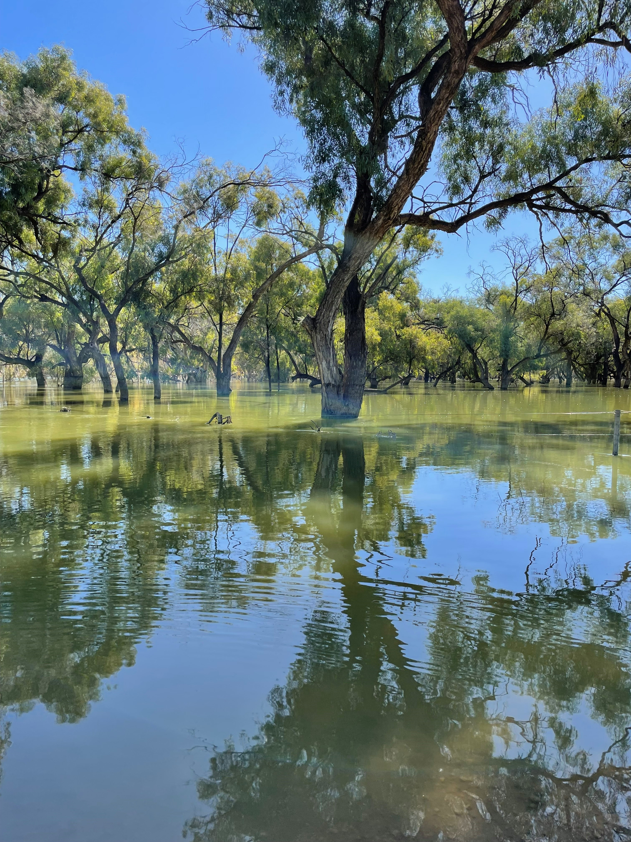

Investigating compliance with water resource plans
In 2022–23 the Inspector-General closed 18 investigations into compliance with water resource plans. As at 30 June 2023, 19 investigations remain open.
It is critical to note that, although 18 matters have been closed with no finding of non-compliance, the evidence gathered highlights areas for improvement. This information assists in informing the Inspector-General’s oversight functions.

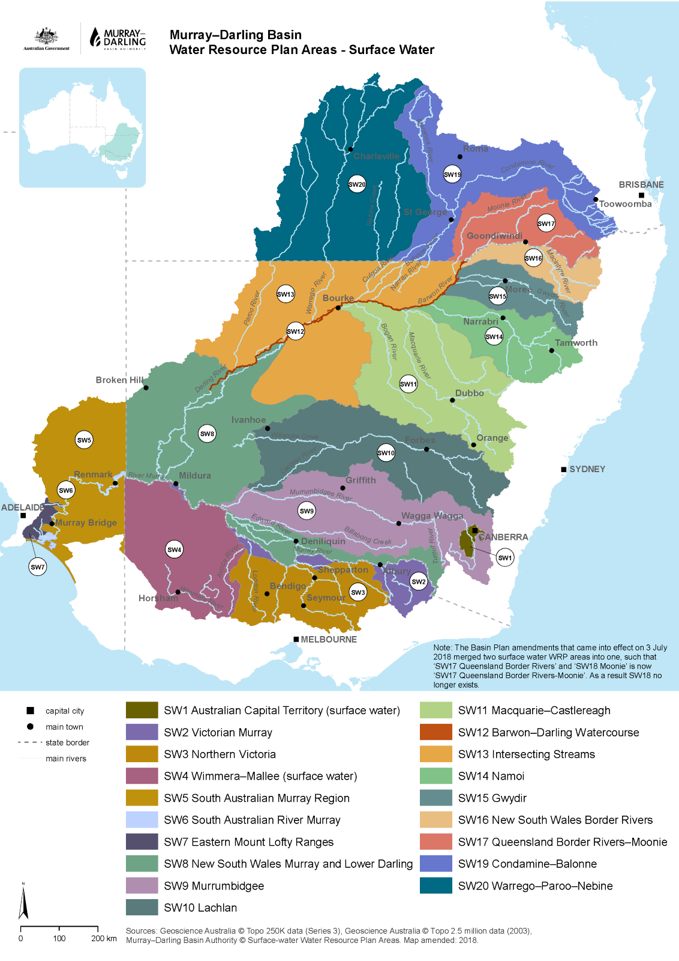
Figure 2.1: Murray–Darling Basin water resource areas – surface water

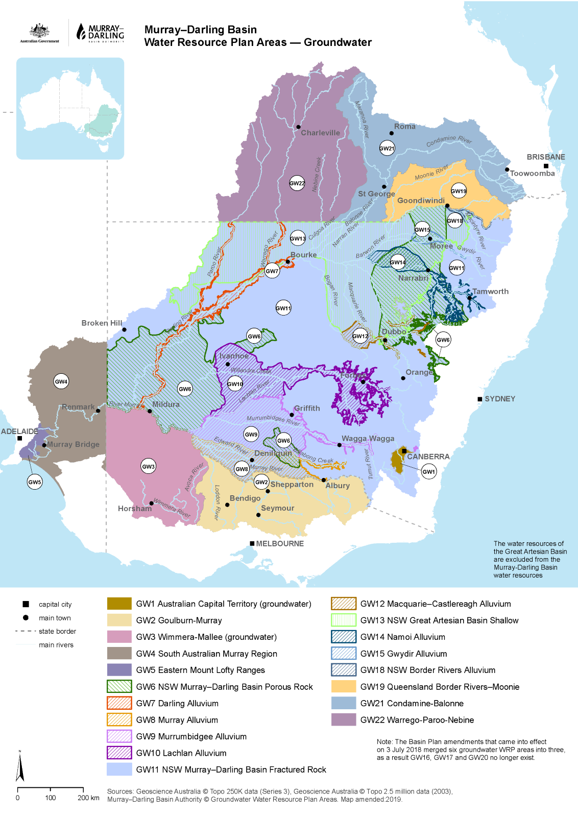
Figure 2.2: Murray–Darling Basin water resource areas – groundwater

New South Wales water resource plans
Approximately 50% of the water take in the Basin occurs in New South Wales, and 20 out of 33 water resource plan areas are within New South Wales: 11 for groundwater and 9 for surface water. Only 5 groundwater water resource plans have been accredited and are operational in New South Wales.
In April 2023 the Inspector-General briefed the incoming New South Wales Minister for Water on the regulatory risks relevant to the state government, including the absence of accredited and operational water resource plans.
The ongoing absence of operational New South Wales water resource plans poses a significant risk to the implementation of the Basin Plan. Without accredited water resource plans, significant areas of the Basin cannot be assessed for compliance, and it is not unreasonable for other Basin State governments and the broader Basin community to question the delay of New South Wales in the submission of water resource plans that meet the requirements for accreditation. The poor performance of the outgoing New South Wales Government in preparing accreditable water resource plans for MDBA assessment has contributed to the undermining of trust and confidence in the Basin Plan.

Background
In the first half of 2020, all of the New South Wales water resource plans were submitted to the MBDA for assessment. The MDBA assessed these water resource plans between May 2020 and August 2021.
Subsequently New South Wales withdrew all 20 water resource plans after receiving formal advice from the MDBA that the plans did not meet all accreditation requirements.
The main reasons why the plans did not meet these requirements were related to:
- issues around planned environmental water
- First Nations consultation
- internal and other minor referencing issues

Current status
New South Wales resubmitted all 20 of its water resource plans to the MDBA in the second half of 2022.
Five of these were accredited and are now operational.
As of July 2023, the remaining 15 are either being assessed by the MDBA (8 water resource plans) or updated by New South Wales (7 water resource plans).
The 7 water resource plans being updated by New South Wales are for:
- New South Wales Border Rivers
- Lachlan
- Gwydir
- Macquarie–Castlereagh
- New South Wales Murray and Lower Darling
- Barwon–Darling
- Namoi
The Inspector-General will continue to closely monitor and oversee all agencies that have obligations under the Water Act, the Basin Plan, and relevant intergovernmental agreements to progress the accreditation and adoption of all New South Wales water resource plans.

Lower Balonne water resource plan audit

In 2022–23 the Inspector-General completed an audit of the management of overland flow harvesting in the Lower Balonne.
The objective of the audit was to assess whether the Queensland Department of Regional Development, Manufacturing and Water (DRDMW) was meeting Basin Plan and water resource plan requirements in relation to overland flow licensing and management of flow events during an announced period. An announced period is a period of time (often a day) when water allocation holders are allowed to take water from the river system.
The water resource plan requirements for the Lower Balonne are supported by the Water Plan (Condamine and Balonne) 2019 and the Condamine and Balonne Water Management Protocol.

Why the audit was done
Overland flow water is the water that runs across land after rainfall. The Lower Balonne catchment has had full volumetric licensing of overland flow water since 2010. This means there is a limit on the volume of water that can be taken under a licence within a water year. The Lower Balonne arrangement is the model for similar licensing being rolled out in other catchments of the Basin in Queensland.
The regulation and licensing of overland flow water is critical to verifying that the take of this water is within legal and sustainable limits and by licence holders only.
Water measurement and accounting of overland flow is highly complex, and a relatively new area of water take measurement.

Key facts
There are 19 water licences that authorise the take of overland flow water from the Lower Balonne floodplain.
The take of water under the authority of an overland flow licence is permitted only during an announced period.
The audit covered 3 flow events between February 2020 and January 2022.

What the audit found
DRDMW is meeting the requirements of the Condamine–Balonne water resource plan in relation to overland flow licensing and the management of flow events during an announced period.
However, the audit report made several recommendations to improve the effectiveness of systems and processes that were reviewed.

Key areas for improvement
- DRDMW should commit to a minimum number of on-site audits before and after a flow event
- DRDMW should consider remote monitoring to ensure timely oversight where on-site audits are not feasible or are delayed
- DRDMW should consider developing a capacity for licence holders to provide measured take data to DRDMW without the risk of tampering
- The level of information provided to entitlement holders should be reviewed to reinforce notification requirements in the Water Management Protocol
- DRDMW should ensure that the requirement to report measured take within a specified period is consistent and enforceable
- DRDMW should consider developing documented guidance for key compliance activities. This would:
  - mitigate the risk of losing knowledge through staff turnover
  - promote more consistent application of rules

Measuring water take
Measuring how much water each licence holder takes from the river system is fundamental to water management. Without accurate, consistent measurement at this level, it would be impossible to be sure that water use in the Basin remains under sustainable diversion limits.
Water meters are used to measure licence holder water take throughout the Basin. The quality of water metering is therefore a critical factor in the quality of Basin water management. The Inspector-General recognises this by publishing a Murray–Darling Basin Metering and Measurement Report Card each year. In effect, the metering report card assesses the qualitative aspects of metering within each state and territory.

State of play – metering across the Basin
Fit-for-purpose metering of water take has 3 elements: coverage, accuracy and timeliness (Figure 2.3).
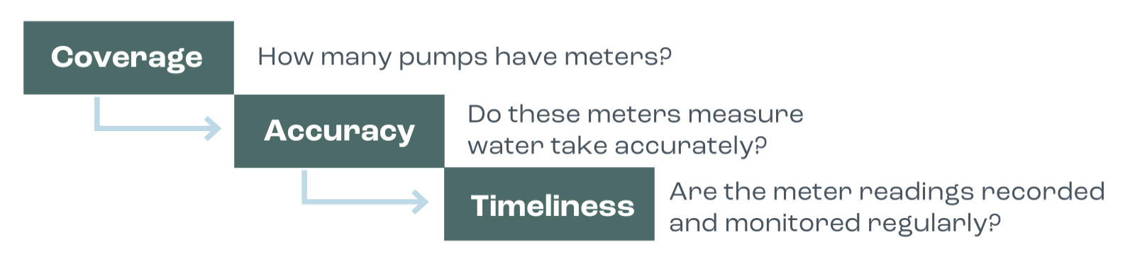
Figure 2.3: Elements of fit-for-purpose water metering
Source: Inspector-General of Water Compliance, Murray–Darling Basin Metering and Measurement Report Card 2021–22
The Inspector-General’s metering and measurement report card provides comprehensive information on all 3 elements – coverage, accuracy and timeliness – for each Basin State.
Meter coverage is the foundation of effective water measurement. While each Basin State government has generally taken a risk-based approach to deciding when a meter is required, the basis on which risk is assessed varies between jurisdictions.
Figure 2.4 demonstrates the different levels of coverage across the Basin States. These numbers are based on ‘meterable take’ from the 2021–22 water year. Table 2.1 shows the changes in meter coverage in each Basin State between years.
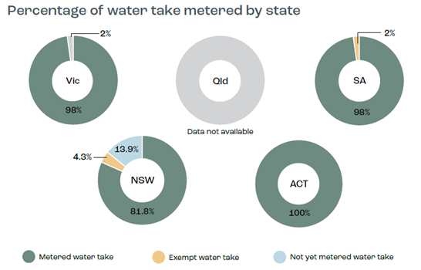
Figure 2.4: Water take metered in each Basin State
Source: Inspector-General of Water Compliance, Murray–Darling Basin Metering and Measurement Report Card 2021–22
Table 2.1: Changes between years in Basin State meter coverage

Metered water take
as reported by Basin State governments in metering report cards
 | 2020–21 | 2021–22
ACT | 100% | 100%
NSW | 78.4% | 81.8%
Qld | Data not available | Data not available
SA | 98.2% | 98%
Vic | 96% | 98%

Notes
- These figures are based on licensed water take from the 2021–22 water year. The Inspector-General has published metering report cards for both the 2020–21 and 2021–22 water years.
- This data has been provided directly by the Basin State governments. No assurance check has been undertaken by the Inspector-General to attest to the validity of these figures.
- In NSW and SA some categories of water take are exempt from the requirement to be metered.
- The 0.2% change in SA reflects water user behaviour rather than a reduction in metered coverage.
- Due to the upcoming implementation of a strengthened measurement policy, Queensland could not supply a metering figure based on water take.
Source: Inspector-General of Water Compliance, Murray–Darling Basin Metering and Measurement Report Card 2021–22

Compliance with sustainable diversion limits

Background
The Inspector-General of Water Compliance is responsible for monitoring Basin State governments’ compliance with the sustainable diversion limits (SDLs). Each year the Inspector-General releases a sustainable diversion limit compliance statement.
SDLs are a key element of the Basin Plan. Under s. 20(b) of the Water Act, the Basin Plan is to provide for ‘the establishment and enforcement of environmentally sustainable limits on the quantities of surface water and groundwater that may be taken from Basin water resources.’
In effect, SDLs limit the amount of water that can be taken from rivers and aquifers for towns, industry and farmers.
Under the Basin Plan, SDLs are set for 29 surface water areas and 80 groundwater areas across the Basin (these 109 areas are referred to as the SDL resource units). SDLs cover all forms of water take defined in the Basin Plan – including take from watercourses and regulated rivers, groundwater, floodplain harvesting, runoff dams and commercial plantations; and take under basic rights (e.g. for stock and domestic use).
The Water Act requires Basin State governments to provide an annual report to the MDBA on the volumes of water take for each SDL resource unit. The MDBA then performs a quality assurance check on the data before passing it on to the Inspector-General. This data is the official register of take for the purposes of determining SDL compliance.

Sustainable diversion limit compliance assessment 2021–22
In 2021–22, as in 2020–21, there were registers of take for 55 (19 surface water and 36 groundwater) SDL resource units. There were no SDL exceedances, and all the 55 SDL resource units were found to be compliant (Figures 2.5 and 2.6).
The 55 compliant SDL resource units are managed through the 13 water resource plans operating across Queensland, South Australia, Victoria and the Australian Capital Territory.
As no SDL resource units exceeded the SDL compliance threshold, there were no reports of a reasonable excuse or action plans provided by Basin State governments.
The 2021–22 SDL compliance assessment does not include the 54 SDL resource units (10 surface water and 44 groundwater) in New South Wales, as none of the 20 water resource plans in New South Wales were accredited or operating for the full 2021–22 water accounting year.
The situation in New South Wales is concerning, particularly as there is an indication that SDLs are being exceeded in an increasing number of areas. For example, there are indications of SDL exceedances of 40% in the Barwon–Darling watercourse and 21% in the Gwydir surface water.
There are now 5 groundwater water resource plans accredited in New South Wales. These water resource plans were accredited during 2022–23; therefore they are not included in the 2021–22 SDL compliance assessment.

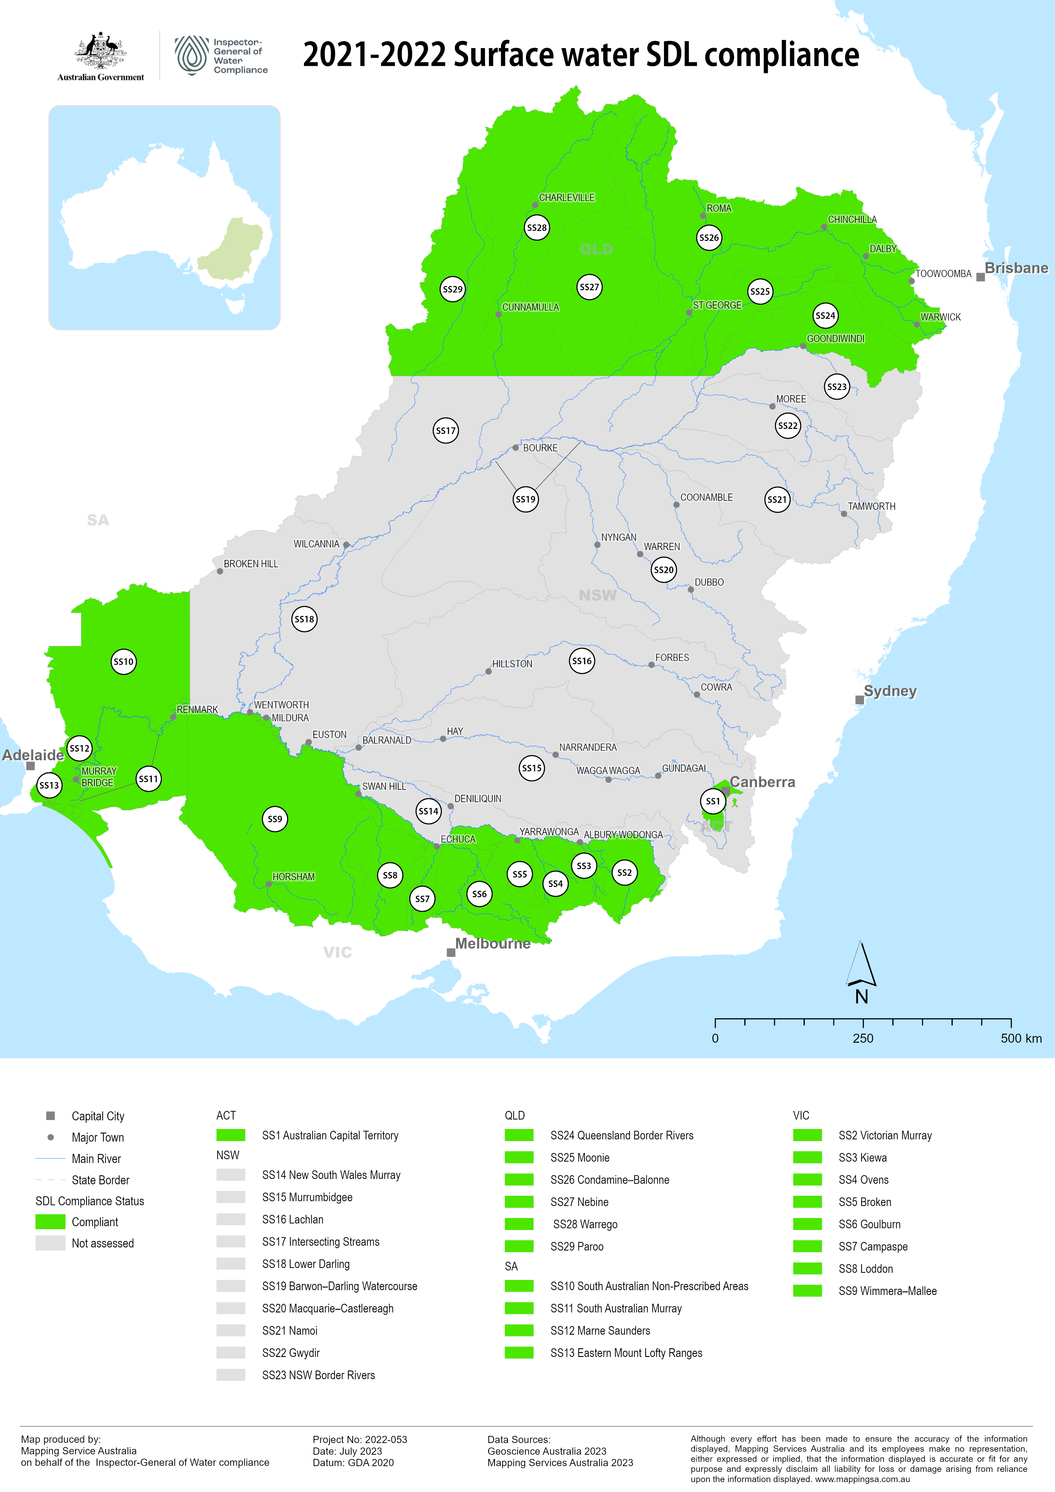
Figure 2.5: 2021–22 sustainable diversion limit compliance – surface water
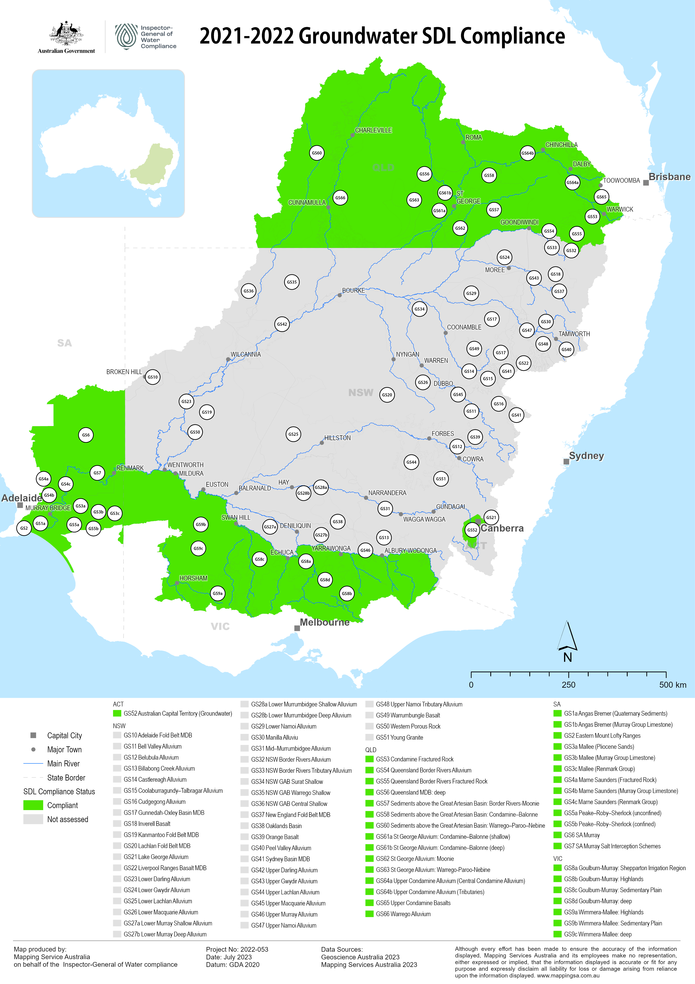
Figure 2.6: 2021–22 sustainable diversion limit compliance – groundwater

03 Oversight and confidence

Regulatory Leaders Forum
In response to the review conducted by Mr Des Pearson AO, Compliance and Enforcement across the Murray Darling Basin, the Inspector-General established the Regulatory Leaders Forum (RLF) in 2021 (see page 24 for more on this review).
The RLF is a quarterly meeting of all Basin State government chief regulatory officers. It provides the mechanism through which Basin State regulators and the Inspector-General can:
- share knowledge, insights and learnings
- work collaboratively to build community confidence in water management
- actively cooperate to increase transparency in the application of water rules across the Basin, and the outcomes they are working to achieve
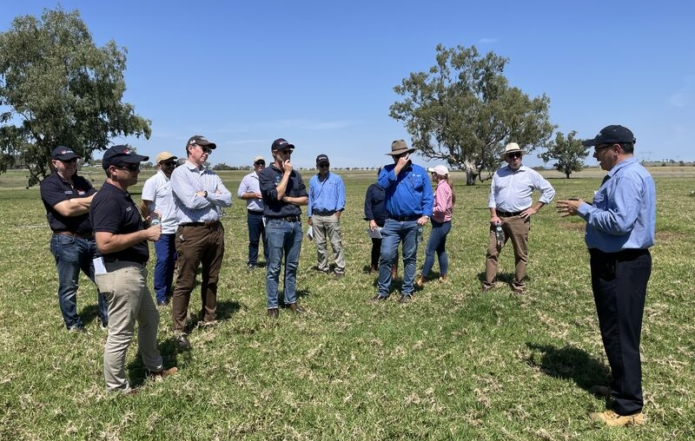

Achievements of the Regulatory Leaders Forum in 2022–23


COMPLIANCE PERFORMANCE REPORTING
The RLF reviewed and agreed the Compliance Performance Reporting Framework and performance metrics for phase one reporting. The framework intends to firstly provide activity-based reporting in each jurisdiction to provide greater transparency for the Australian public over what is being achieved at the Basin scale.

METERING REPORT CARD
A working group formed through the RLF collaborated on the development of the Inspector-General’s metering report card.
The report card is published annually and allows the public to see how Basin State governments are progressing with meter coverage, accuracy and timeliness.
For more information on the Metering Report Card, see pages 18 and 19

METERING STANDARD
The Inspector-General has commenced consultation via the RLF on a Metering Standard that will inform the minimum standards for metering. The standard is intended to provide avenues for Basin State governments to achieve greater levels of consistency in metering in the Basin.

Acting on the Des Pearson review: consistency of reporting

When the Inspector-General’s role was established in 2021, there was a critical need to review the compliance and enforcement frameworks and practices of Basin State governments. The Inspector-General engaged Mr Des Pearson AO, a former auditor-general in Victoria and Western Australia, to assist in doing so. The report of this review, Compliance and enforcement across the Murray–Darling Basin, was published in August 2022.

Background
In 2018 the Basin Compliance Compact (the Compact) was negotiated and agreed by Basin State governments and the Australian Government. Its aim was to help restore public confidence in Basin water management.
One of the agreed actions in the Compact was for Basin State governments to publicly report on compliance and enforcement actions by location.
Demonstrating compliance with water take and use obligations under legislation in the Basin is important not only for ensuring effective implementation of water reform but also for building and maintaining public confidence that water resources are being administered in accordance with the law.

Review of the Basin Compliance Compact
In 2021 a review by the MDBA of the Compact was undertaken. It found:
The Compact should evolve from an annual cycle of activity and commitment reporting by using the principles contained in the Compact as the basis for developing refined performance and outcomes reporting on the Basin’s water compliance systems. By maturing the Compact in this way, the community will be able to see where further improvement is required and have clear sight of any emerging problems. Using this information, governments will also be well-placed to target existing resources and make new investments in water compliance. This will meet community expectations initially and progressively provide more valuable information. Ideally, the performance reporting metrics will be developed collaboratively.
The Des Pearson review in 2022 reinforced these findings. It found:
… simply reporting activities does not necessarily show how effective the activities are in achieving desired outcomes. There is a need to move the focus from activities and outputs to achieving better compliance outcomes … At present there is no established Basin-wide set of key indicators that would allow systematic monitoring of how effective compliance and enforcement activities are in achieving outcomes. There is a need for a more collaborative approach to establish Basin-wide key indicators and measures showing the effectiveness of compliance activities.
In response, the Inspector-General committed to undertaking a compliance performance reporting project in collaboration with Basin State governments through the RLF.

Compliance Performance Reporting Framework
The Compliance Performance Reporting Framework is an important outcome of the collaborative performance reporting project initiated by the Inspector-General in 2022.
The Compliance Performance Reporting Framework was endorsed by Basin State governments in early 2023. It establishes consistent, outcomes-focused compliance performance reporting across the Basin that will be progressively applied by Basin governments over the next few years.
It outlines how compliance performance reporting will move from just activity-based reporting to incorporate more outcomes-focused performance reporting that will report on the success of achieving compliance outcomes in both the short term (2 to 5 years) and the long term (10 years).
Basin State governments have agreed on a set of metrics to report against for the first phase of this project, with the aim to produce a performance reporting dashboard that will be made available on the Inspector-General’s website in early 2024.
Metrics (or activities) that Basin State governments have agreed to report on in the first year include:
- Investigations
- Warnings
- Penalty Infringement Notices
- Prosecutions commenced
- Volume of detected unauthorised take
- Penalties imposed by a court
- Number of licences
This is a significant step forwards in the way the effectiveness of water compliance activities is demonstrated and reported to the Basin community. Getting this right is important to maintaining community confidence in compliance with water management rules. Therefore the Inspector-General will continue to work through the RLF to develop the compliance reporting project to achieve the goal of consistent public reporting on Basin-wide compliance outcomes by 2025.

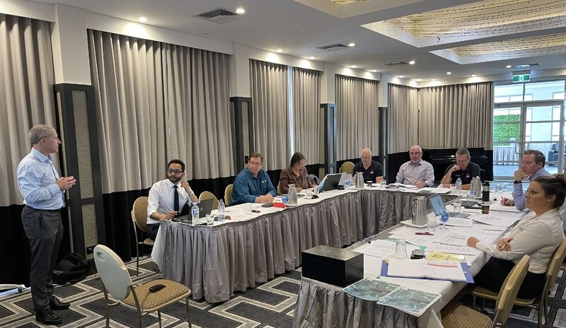

Acting on community questions: operation of irrigation infrastructure operators
During the Inspector-General’s initial tour of the Murray–Darling Basin, community members raised questions regarding the operation of irrigation infrastructure operators (IIOs). These issues primarily related to matters such as contractual arrangements, water markets and charging fees. In 2022 the Inspector-General undertook a desktop review to assist the community to understand the compliance and enforcement arrangements governing IIOs in the Basin.

Irrigation infrastructure operators
An IIO is defined under the Water Act as an infrastructure operator that owns or operates water service infrastructure for the purpose of delivering water for the primary purpose of irrigation.
The ACCC identified 20 IIOs operating in the Basin in the 2020–21 water year. It is important to note that the ACCC does not report on IIOs in the Basin that hold or service less than 10 GL of entitlements. The majority are privately owned and operated. These IIOs vary greatly in the volume of water they supply, the size of the irrigation districts they service, the number of customers they supply and the context of their operational arrangements/structures.
In privately owned IIOs, irrigators hold a delivery and irrigation right against the IIO. However, the specifics of the contractual relationships between IIOs and the irrigators vary significantly across the Basin.

The Inspector-General’s compliance role
The Inspector-General has a compliance role in relation to IIOs insofar as they are required to comply with specific obligations of the Basin Plan and water resource plans.
- The Inspector-General can use a range of specific powers in relation to IIOs contravening their obligations in the Water Act and may also use special powers for determining if an IIO has complied with a designated compliance provision
- The Inspector-General can use powers in the Water Act to compel information from an IIO if they have reason to believe that an IIO had information in its possession relating to the investigation of a designated compliance provision
- The Inspector-General has the power to conduct audits of IIOs as part of assessing their compliance with their obligations under the Basin Plan and water resource plans

Transparency review: $13 billion Basin funding

In 2022–23 the Inspector-General undertook a transparency review to gain a better understanding of what level of detail is available to the public on the $13 billion allocated to Murray–Darling Basin reform. The review also set out to demonstrate whether a member of the public could see where the $13 billion allocated to Murray–Darling Basin reform has been spent or committed.

Rationale and methodology
Underpinning the management of Basin water resources is the money spent on, or committed to, achieving Basin Plan outcomes. If the public cannot see for themselves where the money for Basin reform has gone, and what outcomes have been achieved, trust in the management of Basin water resources will quickly erode.
The transparency review used only publicly available information, such as budget statements and annual reports. The Inspector-General did not use any oversight or inquiry powers to undertake this review.

What the review found
The key observation arising from this review was that there is no simple, definitive public source of information that clearly shows a breakdown of the $13 billion figure that is generally accepted as the amount allocated to Murray–Darling Basin water reform.
The methodology underpinning this review relied solely on publicly available information. It achieved limited success in finding information. While Commonwealth budget documents provide a reasonable level of detail on the Commonwealth contribution to the Murray–Darling Basin reforms, the trail of funding was difficult, if not impossible, to follow once it left the Commonwealth’s financial reports.
Given the scale of this reform, tracking funding over many years is not an easy task, and with programs of this size and complexity, funding is quite often moved into and out of various program areas and various departments and agencies.
Varying amounts – $10 billion, $13 billion, $15 billion – have been quoted as expenditure on Basin reform, and there is no clarity on what elements of the reform package this money has been allocated to.
A lack of transparency around funding is not a new issue: it was highlighted in the Productivity Commission’s 2018 review of Basin Plan implementation.
The research undertaken did not find a clear trail of funding from the publicly available information. It was also not possible to reconcile completely the publicly available information provided by the Department of Climate Change, Energy, the Environment and Water on the total funding.
Publicly available information is incomplete or difficult to locate, and therefore additional information held only by the Commonwealth and the Basin State governments can provide complete transparency over Basin Plan funding. Table 3.1 summarises the observations and issues from this review.

How the Inspector-General will use the review findings
The findings of this review will form part of the Inspector-General’s submission to the Productivity Commission’s Five-yearly Murray–Darling Basin Plan: Implementation Review 2023. The Inspector-General’s submission will be published through this public process. To avoid duplication of effort, the Inspector-General will work with the Productivity Commission on this matter.
If any outstanding questions remain after the Productivity Commission review, further actions available will be explored under the Inspector-General’s legislated remit.

Table 3.1: Summary of observations and issues arising from the transparency review of Basin Plan funding
Focus | Observations | Issue
Overarching observations | Lack of transparency in funding flows is not unusual for a multi-agency government reform program running over a decade.  - This review did not examine accounting practices; rather it looked at whether a taxpayer could see what had been committed and spent.  - The Inspector-General cannot see an aggregated breakdown by programs and outcomes for the Basin Plan.  - The Water for the Environment Special Account provides for heightened transparency and accountability, including 2 independent reviews that produce public reports on spending and effectiveness. | There is limited transparency as to how funding is spent.  - Commonwealth entities are under no obligation to provide a higher level of public reporting transparency on funding. Commonwealth entities are currently meeting their obligations in this reporting.​  - When the public cannot see where the money has been spent in an aggregated breakdown, this reduces confidence and trust in water reform. ​
$10 billion becomes $13 billion –Investigating a generally accepted amount of funding for reform | $13 billion is generally accepted as the funding for Basin reform.  - It is not possible to reconcile from the $10 billion announced in 2007–08 to the 2008–09 funding announcement of $12.9 billion; new measures in 2008–09 did not total $2.9 billion, and identified measures did not relate to Murray–Darling Basin reform.  - It is not possible to reconcile from the $10 billion announced in 2007–08 to the current accepted figure of $13 billion.  - Some available breakdowns of the $13 billion amount include funding for water reforms not connected with the Murray–Darling Basin. | Identification of a total funding envelope for Murray–Darling Basin reform is not possible.  - After the initial announcement of the Basin Plan, and inclusion of new measures in the 2007–08 Budget, the level of information diminishes.  - The first step to identifying what has been spent on reform is typically to start with allocated expenditure. That identification of the total funding envelope is challenging and presents a significant hurdle to tracing what was spent.  - There is a risk that the $13 billion generally accepted funding amount includes funding for initiatives not connected to the Murray–Darling Basin.
Federal Financial Relations – Funding provided to the Basin State governments | There is disconnect between funding agreements and budget documents.  - Information in the Commonwealth budget documents for Federal Financial Relations arrangements is provided at the program level, making it difficult to align with milestone payments in the funding agreements.  - Accountability measures for funding provided vary across agreements; more recent funding agreements tend to include greater provision for accountability.  - It is not possible to follow funding from receipt by the state to expenditure made in connection with funding agreements. | There is limited publicly available information to determine whether payments have been made.  - Consistent with estimates documents, the final budget outcome information is at the program level. While it can be assumed that payments have been made, on the basis that total amounts are included in whole-of-government financial documents, there is no alignment.  - Limited information is made available on the assessment of milestones.  - There is limited connection between the Federation Funding Agreements and state financial information. At most, states provide high-level snapshots.
Commonwealth expenditure – Identifying what has been spent | There is an inability to identify what has been expended to date.  - There are various conflicting sources as to how much has been spent on Murray–Darling Basin reform in total.  - There is an identified trend of underspending.  - A significant amount of departmental expenditure cannot be traced to water reform programs. | Identification of amounts expended is a critical input to evaluation of reform.  - If the amount of funding applied to Murray–Darling Basin reform cannot be accurately identified, it is difficult to form views on the success or otherwise of reform.  - Assuming costings to support original funding allocations were reasonable, an underspend is an indicator that achievement of program objectives is at risk.
Program-level information – Granular information availability | Public information focuses on facilitating program delivery rather than demonstrating accountability.  - The review indicates that information is made publicly available not for accountability purposes but to enable stakeholders to engage with projects and connect with the appropriate people if they want to get involved or believe they are impacted. The information facilitates consultation and informs stakeholders about the programs being delivered.  - The level of detail provided is different depending on state and program. Funding information is limited to high-level snapshots of total funding being provided or made available. | The reporting frameworks inform reporting decisions and information that is available.  - Entities only produce accountability information when there is a legislated requirement or they are directly asked.  - The level of detail that entities provide depends on the requirements. Without clear guidance, there may be inconsistent information across the Basin.  - An example of this, related to Basin reform, is the level of information included in the different water entitlement trade registers.

Measuring community confidence

In 2022–23 the Inspector-General commissioned ORIMA Research to conduct a survey on community views about water management in the Murray–Darling Basin. Over a thousand people participated in the survey and represented water licence holders, basin community members, and First Nations People living in the Basin. The survey findings provided significant insights that further inform the work of the Inspector-General.

Top concerns
The survey identified that respondents’ top concerns about water management in the Basin related to:
- the distribution and allocation of water
- the sustainability of the system for the future, including extreme weather events
- the environment and/or perceived mismanagement of water

Unreliable information
The survey identified a number of topics on which there are myths and misperceptions circulating in the community, perpetuated by individuals seeking information from sources other than those charged with governing water management.
The research identified a range of sources for participants’ knowledge about the Murray–Darling Basin and water management. Most participants reported that they tended to receive information through word of mouth in the community, or through media channels. Many also reported that the information through these channels was more likely to be negatively skewed, with a tendency for these sources to prioritise negative over positive stories and content.
Figure 3.1 shows sources of information about the Basin identified by qualitative research participants.

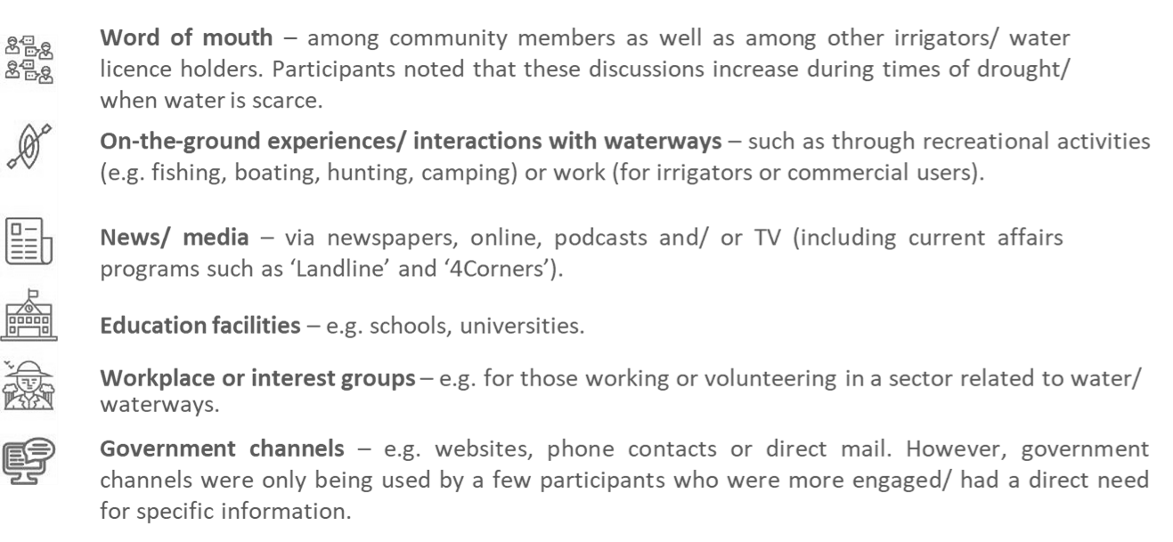
Figure 3.1: Sources of information on the Murray–Darling Basin
Source: Community sentiment survey 2022, conducted by ORIMA Research for the Inspector-General of Water Compliance

Unofficial sources of information can contribute to growing myths and misperceptions, ultimately bringing into question the management of Basin water resources.
While the data may seem alarming, the Inspector-General has already been taking steps to address any myths or misperceptions. The Inspector-General has used the insights gained from the survey to develop a comprehensive engagement and communications strategy. The strategy focuses on ‘myth busting’ through a range of engagement methods including:
- myth-busting videos
- myth-busting podcast episodes
- targeted engagement activities through the Field Officer network
- advertising in major rural and regional newspapers
- an Inspector-General of Water Compliance LinkedIn page

Views on compliance
The researchers found that there were strong emotions associated with compliance, and high levels of support for independent oversight (Figure 3.2). Most community members and water licence holders (WLHs) reported getting angry with those who do not follow the rules. There was also a perception that people often took more water than they are allowed to (Figure 3.3).

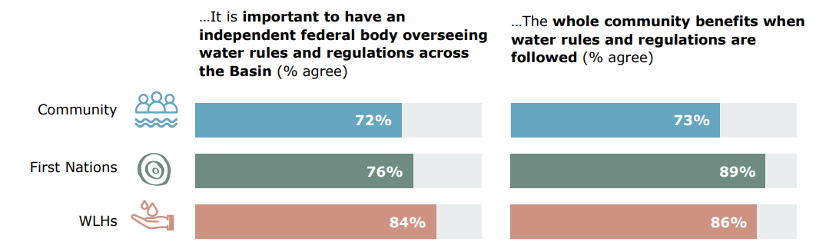
Figure 3.2: Community sentiment around independent oversight of water management in the Basin
Source: Community sentiment survey 2022, conducted by ORIMA Research for the Inspector-General of Water Compliance
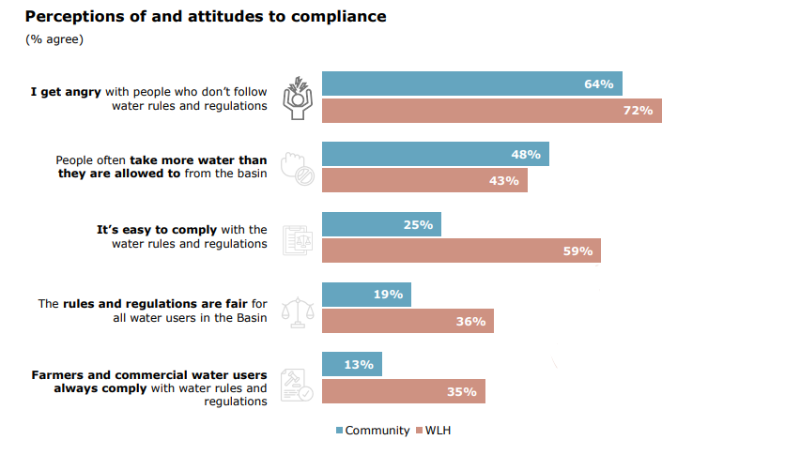
Figure 3.3: Perceptions of and attitudes towards compliance
Source: Community sentiment survey 2022, conducted by ORIMA Research for the Inspector-General of Water Compliance

Understanding of water rules
The majority of water licence holders said they wanted to know more about water rules, regulations and enforcement in the Basin, but less than half of this group said it was easy to understand the water rules and regulations. Water licence holders also said that they felt there was not enough information available about how water is managed in the Basin.

Negative perceptions about water management
The survey identified a range of negative perceptions in the community about how water is managed and decisions are made (Figure 3.4).
The survey identified 4 key drivers of perceptions about water management:
- feeling informed / having a good understanding of the topic
- being aware of positive outcomes
- having access to trusted sources of information
- decision-making processes meeting expectations
When these drivers are not present, negative perceptions, beliefs and opinions can arise. The Inspector-General has committed to communicating with audiences about how it is addressing negative perceptions. For example, they are producing a video explaining how the establishment of the Regulatory Leaders Forum helps to address the perception that governments and organisations do not work together to effectively manage water in the Basin.

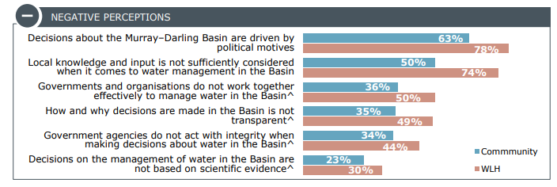
Figure 3.4: Negative perceptions of water management in the Basin
Source: Community sentiment survey 2022, conducted by ORIMA Research for the Inspector-General of Water Compliance

Engaging across the Basin
In 2022–23 the Inspector-General attended over 130 stakeholder and media engagements. These included speaking directly with farmers, peak industry bodies, community groups and local councils, as well as meetings with state and Commonwealth agencies and ministers with responsibilities for Basin water management.

Engagement by the Inspector-General
Just some of the people the Inspector-General has spoken with over the last year are:

- Farmers and businesses across the Basin
- Community groups
- Australian Floodplain Association
- Western Murray Land Improvement Group
- First Nations groups
- River Murray and Mallee Aboriginal Corporation
- Bangerang Aboriginal Corporation
- Murray Lower Darling Rivers Indigenous Nations
- Industry bodies
- New South Wales Irrigators’ Council
- Almond Board of Australia
- National Farmers’ Federation
- Local governments
- Murray Darling Association
- Wagga Wagga City Council
- Balonne Shire Council
- Bourke Shire Council
- Western Downs Regional Council
- Basin State parliamentarians
- The Hon Tara Moriarty MLC
- The Hon Jihad Dib MP
- The Hon Rose Jackson MLC
- Ms Stephanie Cooke MP
- Mr Justin Field MLC
- Parliament of Australia
- Senate estimates committee meetings
- Commonwealth parliamentarians
- Dr Helen Haines MP
- The Hon Michael McCormack MP
- Senator the Hon Jenny McAllister, Assistant Minister for Climate Change and Energy
- The Hon Tanya Plibersek MP, Minister for the Environment and Water
- Ms Rebekha Sharkie MP
- Senator David Pocock
- Senator Pauline Hanson
- Senator Fatima Payman
- Senator Perin Davey
- Senator Malcolm Roberts
- Senator Sarah Hanson-Young
- Intergovernmental meetings
- Murray–Darling Basin Ministerial Council
- Commonwealth agencies
- Productivity Commission
- Department of Climate Change, Energy, the Environment and Water
- Murray–Darling Basin Authority
- Water Reform Taskforce
- Department of Defence

Engagement by Field Officers
The Inspector-General has a network of Field Officers on the ground in Basin communities, hearing about the issues and questions that matter most at the local level.
While the Basin needs to be managed as a whole system to achieve the intended outcomes of the Water Act and Basin Plan, the Inspector-General understands that differences in rules and water availability across the Basin mean that the issues of interest at the local level can vary between Basin communities.
The Inspector-General’s Field Officers capture the issues and questions communities raise with them and feed this back to the Inspector-General to inform the agency’s work. To ensure the Inspector-General can see the Basin both at the local level and as a whole, an interactive dashboard has been developed to demonstrate topics of interest across different Basin communities. This informs the agency’s regulatory planning and assists the Inspector-General to reflect public sentiment in meetings with Commonwealth and Basin State ministers and officials, and in reporting to the Australian Parliament.
The top 5 topics of interest identified by Field Officers in 2022–23 were:
- metering
- river operations
- environmental water
- environmental damage
- confidence in Basin water management

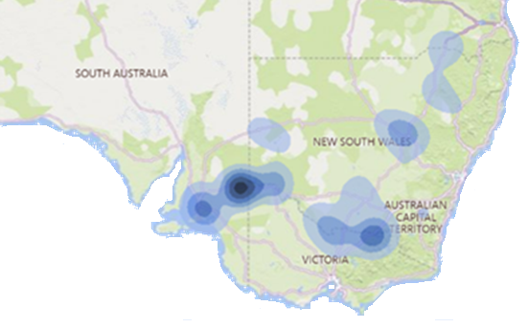
Figure 3.5: Inspector-General of Water Compliance field operations engagement dashboard

The Water’s Edge podcast

Launched in August 2022, Water’s Edge is a podcast produced by the Inspector-General of Water Compliance and hosted by staff from the Media and Engagement team. It discusses what recent reports, audits and investigations say about the implementation of the Murray–Darling Basin Plan, and aims to break down information that can be difficult for the community to understand.
The Inspector-General has also been using Water’s Edge as a platform to address myths. A myth-busting series which airs between regular episodes of the podcast is dynamically responding to myths and misperceptions in the community that are being detected through the media and the Field Officer network.
Water’s Edge has continued to grow in popularity, increasing subscribers with each episode that has been released.
Episodes include:
- Explaining the difference between the Basin Plan’s Bridging the Gap targets and its 450 GL environmental water target
- Matthew Coulton, General Manager of Agriculture and Water with the Bureau of Meteorology, explaining the role of the Bureau and its responsibilities under the Water Act
- Grant Barnes, Chief Regulatory Officer of the Natural Resources Access Regulator (NRAR), explaining the work his agency is doing in rolling out water meters, and the technology being used to detect instances of non-compliance
- The Inspector-General, the Hon Troy Grant, and the former Interim Inspector-General of Murray–Darling Basin Resources, Mick Keelty AO, discussing the establishment of the role of Inspector-General

All episodes of Water’s Edge can be found on the website: Podcast | Inspector-General of Water Compliance (igwc.gov.au)
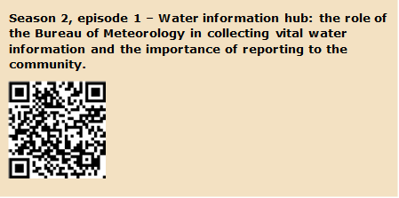
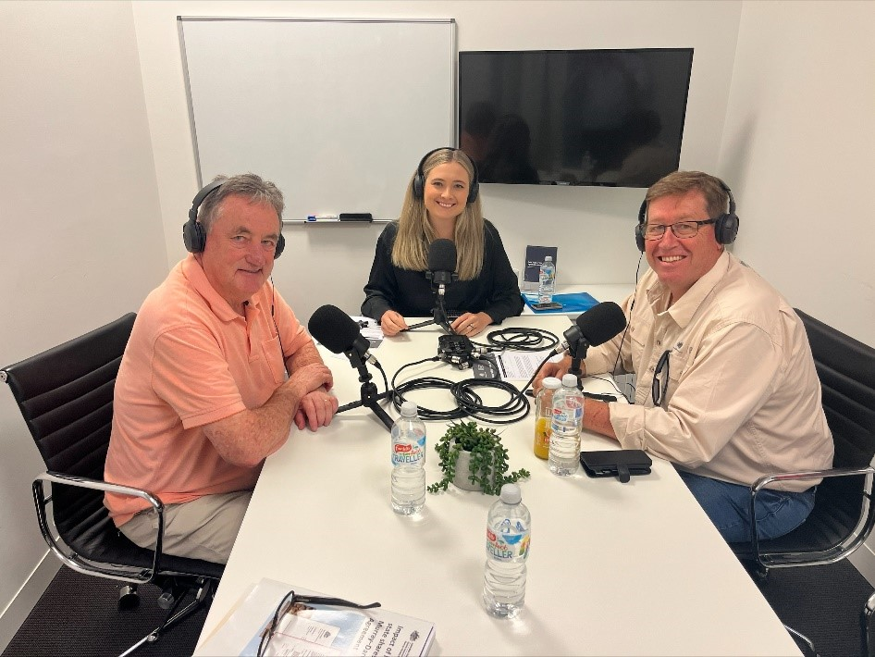
Mick Keelty AO with Water’s Edge host Annabelle Hudson and Inspector-General of Water Compliance the Hon Troy Grant

Looking forward
In the 2 years since the Inspector-General of Water Compliance was established, 2 things have become clear:
- Commonwealth and Basin state governments need to do better if they are going to achieve the outcomes of the Basin Plan
- The rules are not just complicated and confusing; they are simply not as good as they need to be to ensure governments are accountable for their decisions and transparent in the performance of their responsibilities
The Inspector-General has established 2 key priorities to address these key issues in 2023–24:
- Monitor Commonwealth and state performance
The Inspector-General will focus on creating greater visibility over the performance of the Commonwealth and Basin state and territory governments implementing the Basin Plan.
Through public reporting, the Inspector-General will create a greater level of accountability and transparency and help drive integrity in the system.
This priority helps to deliver on the Inspector-General’s strategic objective 3 – Do it better: Raise performance and drive improvements in standards of Basin Plan delivery.
- Foster Basin-wide regulatory cooperation
The Inspector-General will continue to work with Basin regulators to pursue continuous improvement in regulatory standards, with a focus on promoting a standardised approach to metering of water take.
The Inspector-General will also actively participate in significant reviews and reforms being undertaken across 2023–24, including:
- the water market law reform
- the review of Inspector-General
- the Water Act review and changes
- the 5-yearly review of the Basin Plan
This priority helps to deliver on the Inspector-General’s strategic objective 4 – Make it better: Use knowledge, evidence and insights to input into the ongoing reform of water regulation.
To read the Inspector-General’s 2023–24 Annual Workplan, please visit the website: Reviews and reports | Inspector-General of Water Compliance (igwc.gov.au)

The Basin States are New South Wales, Queensland, South Australia, Victoria and the Australian Capital Territory.
- Flood and storm impacts in late 2022 | Floods and storms | Emergency management | Farm management | Agriculture Victoria
Farmers still grappling with impact of 2022 NSW flood crisis optimistic about winter crop – ABC News
Flood response and recovery | State Budget 2023–24 | Government of South Australia
Fish kills in NSW | Threats to fish habitats | Habitat management | Fishing | NSW Department of Primary Industries

