Draft Regulatory Policy

July 2023

Document history

|  |  |  |  |
| --- | --- | --- | --- |
| Version | Date | Author | Document status |
| 0.1 | 12 July 2023 | Jodi Smith | First draft |
| 0.2 | 13 July 2023 | Peter Lyons | Reviewed draft |
| 1.0 | 26 July 2023 | Troy Grant | Approved |

**Table of Contents**

Role of the Inspector-General 1

Role as an integrity agency 3

When the Inspector–General gets involved 6

Responsive regulation approach 6

Targeted priorities 7

Ongoing regulatory focus 7

Principles–based approach 11

Principles for the management of Basin water resources 11

Regulatory principles 12

Regulated entities 14

Coordination with other Commonwealth agencies 15

Collaboration with other entities 16

Regulatory tools 19

Monitoring 19

Examinations 20

Enforcement 21

Guidelines and standards 23

Compliance approach 23

Performance approach 24

Review of policy 26

Feedback and next steps 27

Appendix 1: Inspector–General’s functions with respect to government agencies 28

Appendix 2: National water decision–making model 30

References 31

# Role of the Inspector-General

The Murray–Darling Basin (the Basin) is in eastern Australia (see Figure 1) and runs across four states: Queensland, New South Wales, Victoria and South Australia. The Australian Capital Territory is also part of the Basin and is the only state or territory that is fully within the Basin.

The Basin is a geographic region with national economic, social, cultural and ecological importance, where all of these outcomes are underpinned by the effective management of its water resources. Historically, ineffectual and disparate regulation of these water resources led to the establishment of a national framework under the *Water Act 2007* (Cth)(the Water Act) that enables the Commonwealth Government, in conjunction with Basin States, to manage the Basin water resources in the national interest.

The integrity of the national framework depends on its implementation in ways that are compliant with relevant laws and that deliver the intended outcomes for Basin communities and those dependent on Basin water resources for their livelihoods. As such, the independent Inspector–General of Water Compliance was established to enforce compliance with the national laws and to hold Commonwealth and Basin State governments to account in their management of Basin water resources.

In this context, the independent Inspector–General broadly has the roles of:

* Monitoring and overseeing the performance of functions and exercise of powers by agencies of the Commonwealth
* Monitoring and overseeing relevant Commonwealth, and Basin state and territory government agencies’ performance in the management of Basin water resources
* Enforcing compliance with Commonwealth laws that regulate the management of Basin water resources
* Engaging with the Australian community on the management of Basin water resources.

Framework for developing this policy

Inspector–General’s role within a broader institutional context

The Inspector–General is responsible for administering Commonwealth law relating to the Basin and, consequently:

* Adopts a Basin–wide and national interest focus
* Treats all jurisdictions and Commonwealth agencies equitably and without fear or favour
* Regulates consistently across all geographic regions of the Basin
* Considers long term water extraction trends
* Works together with other relevant agencies, to collectively manage Basin water resources in the national interest.

Inspector–General’s legislative framework

The Inspector–General interprets legislation in the way that best delivers the objectives of the Water Act and BasinPlan. The Inspector–General’s principal focus is on ensuring that all the enabled legislation operates and is complied with in a way that delivers the intended outcome(s) from the Water Act.

Figure Murray–Darling Basin

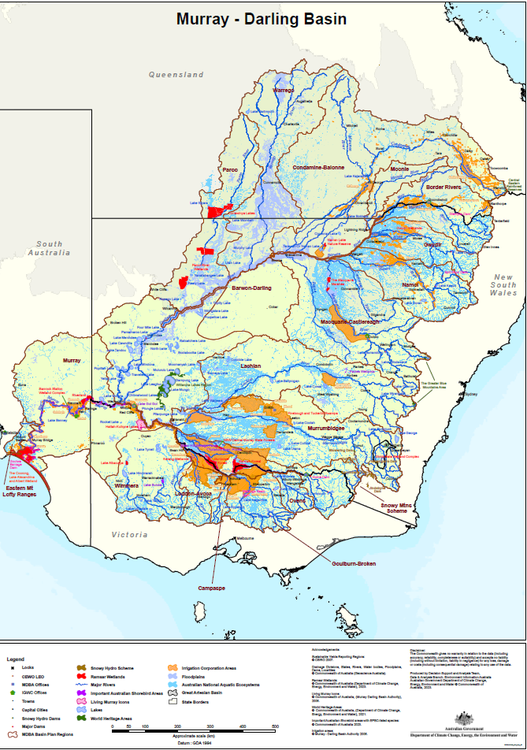

In performing the above roles, the Inspector–General is primarily responsible for:

* Assessment of compliance with long–term water extraction limits (known as sustainable diversion limits) in Basin catchments
* Compliance with water resource plans that enable the integrated management of Basin water resources by Commonwealth and Basin State governments
* Enforcement of the *Basin Plan 2012* (Basin Plan) water trading rules
* Assurance around the enforcement of water laws with respect to the theft of Basin water resources
* Oversight of the implementation of commitments in intergovernmental agreements that support the effective operation of the Water Act and delivery of the Basin Plan
* Providing accountability for the effectiveness of Commonwealth and Basin States’ performance of their obligations under Part 2 of the Water Act, relating to the management of Basin water resources
* Scrutinising and providing accountability around relevant Commonwealth agency decisions made in performing their functions or exercising powers under Part 2 of the Water Act
* Engaging with Australian communities on the management of Basin water resources and, in particular but not limited to, the matters set out above.

The Inspector–General is also responsible for enforcing Part 2A of the Water Act, relating to critical human water needs. In accordance with this Part of the Water Act, the Basin Plan sets out the triggers for and processes to follow during times of low water availability.

This *Regulatory Policy* sets out the Inspector–General’s approach to performing these roles and responsibilities. This document has been developed following consideration of feedback on the *Regulatory Policy Discussion Paper* published by the Inspector–General on 31 March 2023.[1]

## Role as an integrity agency

The Inspector–General is a Commonwealth integrity agency[2] and therefore operates within the Government’s multi–agency approach to promote integrity, transparency and accountability and to prevent corruption, fraud and misconduct. Relevantly, this means the Inspector–General applies the legislative framework they administer in a way that holds relevant agencies and other decision–makers to account. In practice, the Inspector–General provides the following:

* Integrity—the Inspector–General provides accountability for rigour in decision making and management of Basin water resources under the Water Act
* Enforcement—the Inspector–General ensures laws are complied with so that Basin water resources are being managed in the national interest.
* Assurance—the Inspector–General provides transparency around the management of Basin water resources in a way that is appropriate and equitable
* Influence—the Inspector–General builds and maintains trusted relationships with government agencies, water users and the Australian public
* Improvement—the Inspector–General drives and supports innovation and continuous improvement in the inclusive management of Basin water resources in the national interest

See below for further detail.

### Integrity

##### What it is

Integrity refers to the integrity of the regulatory frameworks; that is, are they doing what they were designed to do and, if not, why not, and then taking steps to address the underlying causes. Integrity also refers to integrity in the performance of regulatory functions; that is, are they being performed without fear and favour.

The integrity of regulatory frameworks and functions is a matter of public interest. Regulators have significant powers to grant benefits to, or impose restrictions or penalties on, their regulated entities.

##### How the Inspector–General provides it

The Inspector–General adopts an evidence and outcomes–based approach to regulation that focuses on the risks to the integrity of the regulatory framework. The Inspector–General also regulates all entities without fear or favour.

### Enforcement

##### What it is

The purpose of enforcement is to:

* Support lawful conduct
* Stop unlawful conduct
* Deter offending conduct
* Ensure future compliance with the law
* Penalise offenders, where warranted.

The Inspector–General is responsible for monitoring, investigating and enforcing compliance with water management obligations under Part 2 of the Water Act, the Basin Plan and water resource plans. The Inspector–General is also responsible for enforcing compliance with other matters, such as obligations to provide information and not interfere with authorised officers.

##### How the Inspector–General provides it

The Inspector–General assesses each case on its own merits, taking into account all the relevant facts and circumstances of the matter. The Inspector–General adopts a responsive regulatory approach (see When the Inspector–General gets involved section, below) to enforcement, where the tools applied can range from education through to legal action.

### Assurance

##### What it is

Assurance is aimed at improving transparency and quality of, and confidence in, information available for relevant decision–makers and for the general public. Providing this independent assurance increases certainty that relevant information is available, easily accessible, reliable and accurate, and therefore reduces risks with those decisions.

##### How the Inspector–General provides it

In practice, among other things, the Inspector–General provides assurance around information related to the management of Basin water resources.

### Influence

##### What it is

The Inspector–General is not responsible for government policy or for making or amending Commonwealth or state and territory water laws (except in very limited circumstances, please refer to Guidelines and standards section below). The Inspector–General is generally the regulator of government agencies’ compliance with Commonwealth water laws and, in limited circumstances, more broadly in relation to the Commonwealth’s water trading rules.

##### How the Inspector–General provides it

To support the delivery of the objectives of the Water Act the Inspector–General engages through the sharing of truth, facts and evidence with those who determine policy, make laws and enforce water compliance.

### Improvement

##### What it is

Developments around technology and regulatory practice have the potential to drive step–change improvements in regulatory approaches. For example, rolling out telemetry means water meters can be read remotely and at any time, rather than through manual readings.

##### How the Inspector–General provides it

The Inspector–General facilitates and educates on improvements to enable the innovative, flexible and inclusive management of Basin water resources by relevant agencies.

The Inspector–General also drives a continuous improvement culture across water compliance and water management in the Basin, including through opportunities such as the Regulatory Leaders Forum. The Inspector–General also promotes improvements in the clear communication of reasons for decisions, and the accessibility and understanding of relevant rules and other requirements.

# When the Inspector–General gets involved

The Inspector–General prioritises where, when and how to use their powers in performing their regulatory functions. The Inspector-General adopts an evidence and risk-based approach that leads to responsive decision–making, so that they can pivot effectively in response to evolving priorities or issues.

## Responsive regulation approach

‘Responsive Regulation’ is an approach that was formalised in 1992 by I. Ayres and J. Braithwaite.[3] Under this approach, the most effective regulatory strategy is informed by factors such as overall behaviours, patterns of contraventions and level of harm associated with contraventions, etc.

The Inspector–General uses evidence to inform problem–centric, outcomes–focused and risk–informed responsive decision–making.

Problem–centric, outcomes–focused and risk–informed decision–making

The Inspector–General adopts a problem–centric, outcomes–focused and risk–informed approach in deciding which regulatory tool is most appropriate for the relevant circumstance, where:

* A problem–centric approach involves the identification of gaps between what is expected or ideal and what happens in practice.

This means the Inspector–General focuses on outcomes rather than the means of delivery, allowing for regulated entities to adopt approaches relevant for their circumstances and to respond to emerging challenges.

* A risk–informed approach uses an assessment of the likelihood and magnitude of adverse consequences to prioritise regulatory efforts and determine a proportionate response(s).

The Inspector–General adopts a risk–informed approach that considers the harms in the context of whether the outcomes intended from the Water Act are being delivered. These harms could include economic, social, cultural or environmental harms, or a combination of these.

This responsive model is adaptive and allows versatility in managing adverse regulatory outcomes based on the identification of the best remedy for the particular situation, allowing the Inspector–General to:

* Respond in a way that is proportionate to the risk
* Respond in a way that best addresses the problem and/ or delivers the intended outcome
* Escalate regulatory action
* De–escalate regulatory action
* Minimise costs associated with a response.

Figure 2 sets out the Inspector–General’s approach to regulation.

Figure Responsive approach to regulation – escalation pyramid

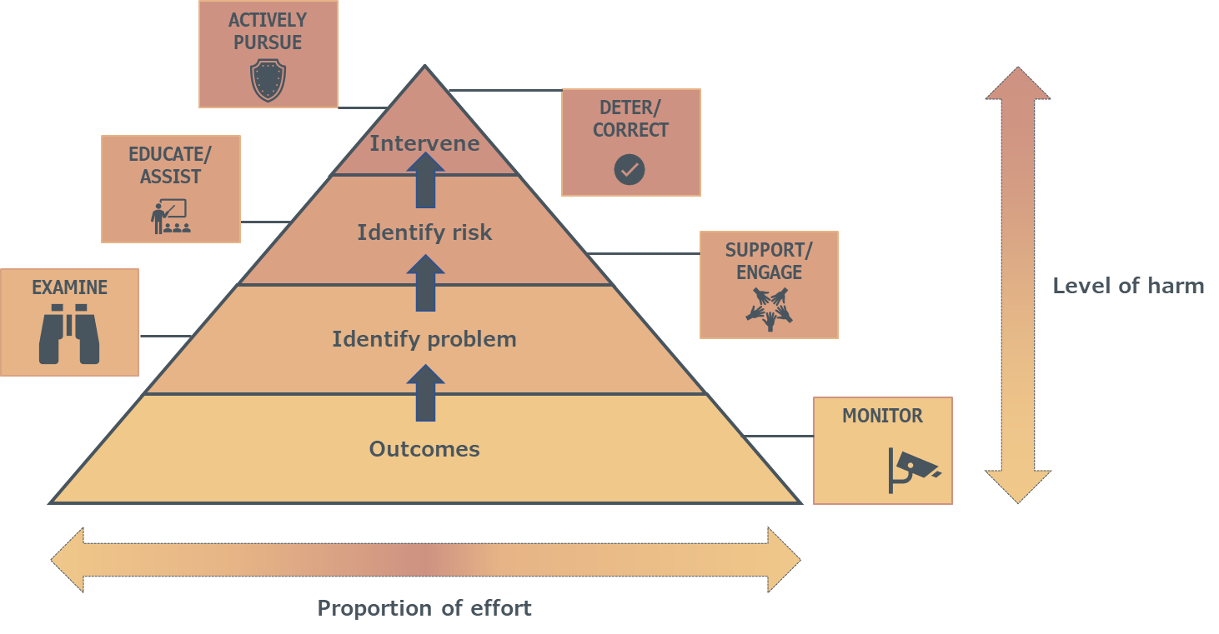

Under this approach, the type of regulatory action taken by the Inspector–General escalates in response to greater risks. The escalation level will therefore be informed by the level of harm and the proportionate effort required for the type of intervention. Relevant harms and types of interventions are set out further in the Principles–based approach and Regulatory tools sections below.

In line with the above approach, the Inspector-General recognises that most regulated entities strive to follow the law and discharge their responsibilities appropriately. The Inspector–General also recognises, with respect to government agencies, the long history of Basin governments’ commitment to the integrated, sustainable and adaptive management of Basin water resources under a national framework established by the Water Act, Basin Plan and water resource plans.

## Targeted priorities

As a relatively small agency with clear vision, purpose, and legislated remit, the Inspector–General periodically releases information on key priorities for targeted action. Details on medium to long term priorities can be found in the Inspector–General’s Strategic Plan, while details on the Inspector–General’s annual priorities are set out in annual work plans published on the Inspector–General’s website.[4]

## Ongoing regulatory focus

When deciding whether to pursue a matter, the Inspector–General prioritises those which fall within the above targeted priority areas. The Inspector–General also applies the following principles in deciding when, where and how to act.

Figure Principles for Inspector–General actions

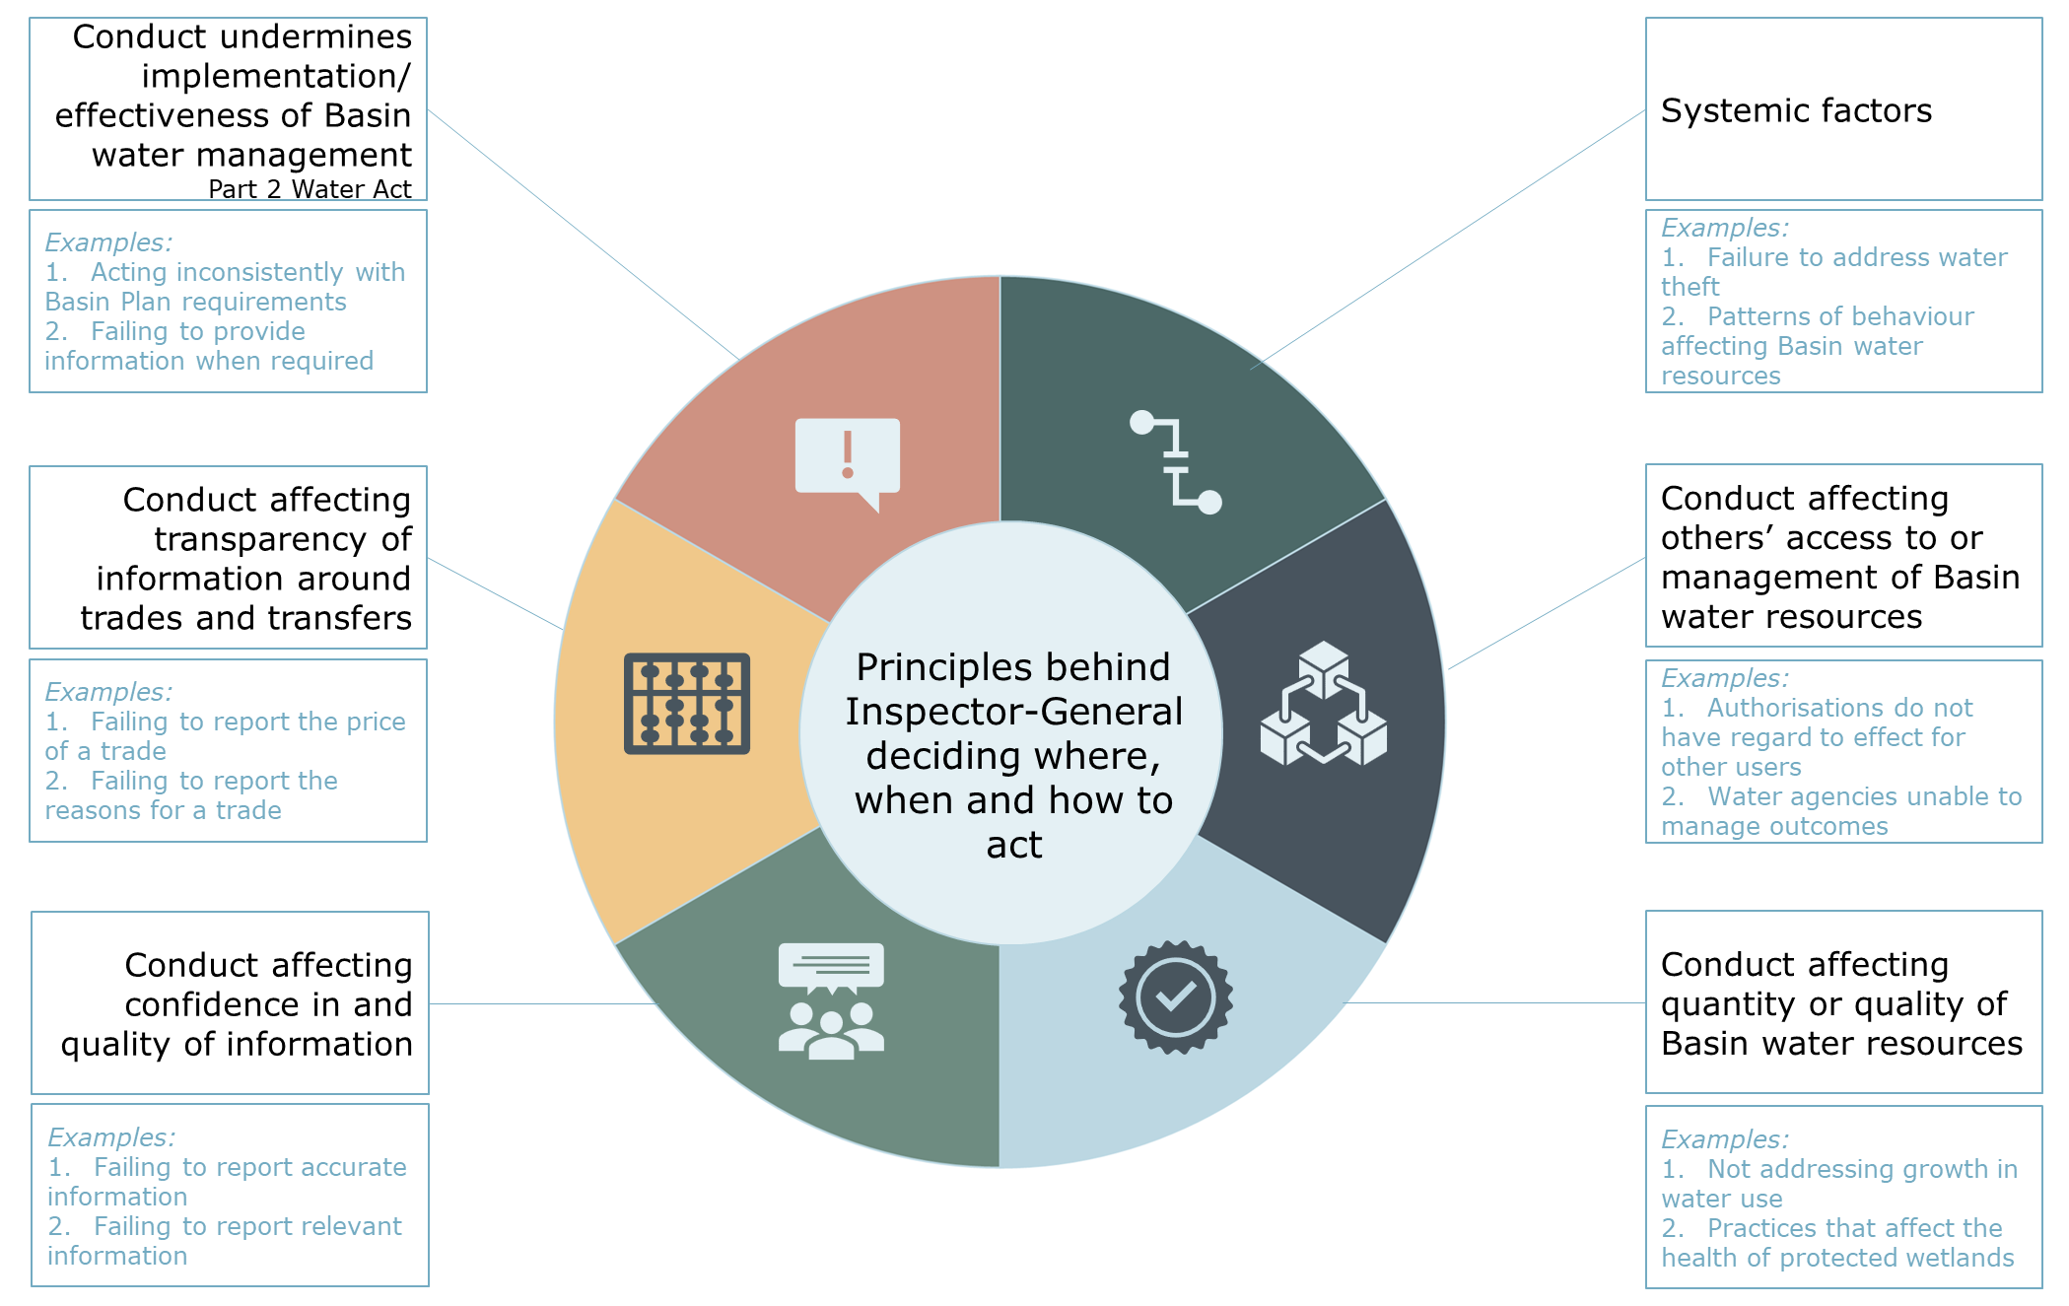

The following table sets out how these principles are applied in relation to the Inspector–General’s specific areas of responsibility and, relevantly, how these may be triggers for regulatory action.

Table 1. Specific areas of responsibility – triggers for action

| Responsibility | Triggers |
| --- | --- |
| Sustainable diversion limit compliance | Level of extraction is in exceedance of the sustainable diversion limit  Absence of acceptable reasonable excuse for non-compliance with a long-term annual diversion limit  Water resource plan has not been fully implemented or complied with  Potential major impacts from excess above a long-term annual diversion limit  Lack of adequate action(s) to address excess above a long-term annual diversion limit |
| Water resource plan compliance | Contravention of restrictive obligations set out in water resource plans (e.g., complying with licence conditions, maintaining sustainable diversion limits, no net reduction in planned environmental water, etc.)  Contraventions of operational requirements in water resource plans (e.g., register of held environmental water, implementing water quality management plans, implementing environmental watering plans, addressing risks to the water resources, etc.)  Contraventions of triggered management obligations in water resource plans (e.g., measures to preserve critical human water needs, planning for extreme events, protection of Indigenous values and Indigenous uses, etc.)  Outcomes inconsistent with the intention for water resource plans to give effect to the Basin Plan |
| Water trading rules | Restrictions are placed on trades inconsistently with the Basin Plan  Information is not provided about water delivery rights and irrigations rights  Trade approval authorities do not disclose interests in a trade  Information about water access rights is not provided, is inadequate or is not managed in accordance with the Basin Plan  Trading prices are not made available in accordance with the Basin Plan or is inadequate |
| Water theft | Systemic failure in enforcement of individual water take laws by a Basin state or territory  Delivery issues around relevant commitments in *Murray–Darling Basin Compliance Compact 2018* or other relevant intergovernmental agreement  Information is not provided to the Inspector-General to monitor relevant performance  Where water theft affects the management of Basin water resources in other jurisdictions and/ or where requested by relevant Basin State(s) |
| Commitments in intergovernmental agreements | Challenges in the implementation of commitments set out in intergovernmental agreements  Risks to giving effect to intent of intergovernmental agreements  Lack of progress that would be likely to materially compromise the implementation of relevant commitments within the agreed timeframes  Information on implementation of commitments is not provided to the Inspector-General to monitor relevant performance  Lack of robust records of decisions underpinned by Commonwealth funding |
| Commonwealth agency decisions | Significant risks to delivering the intended outcomes of the national framework  Exercising powers in a way that detrimentally affects the effectiveness of the national framework  Lack of robustness in the information provided on decision–making |
| Engaging with Australian communities | Lack of cohesive and accurate information on the outcomes from the management of Basin water resources under the national frameworks  Lack of access to Basin-wide information on the outcomes from the management of Basin water resources under the national frameworks |
| Compliance with Part 2 of Water Act (management of Basin water resources) | Significant risks to delivering the intended outcomes of the national framework  Performing obligations in a way that detrimentally affects the effectiveness of management of Basin water resources  Lack of confidence in and assurance around the quality of information provided on the management of Basin water resources |
| Compliance with Part 2A of Water Act (critical human water needs) | Not meeting the minimum amount of water required to meet critical human water needs in Basin States, except Queensland  Not meeting the minimum amount of conveyance water required to deliver water for critical human water needs  Not meeting the minimum water quality and salinity trigger points in the Basin Plan |

The Inspector–General can conduct regulatory activities to support the performance of more than one function; that is, it may not be a single function the Inspector–General performs in relation to the above responsibilities. Consequently, the above triggers may be considered separately or together by the Inspector–General and for multiple reasons.

In addition to the above, the Inspector–General may be directed to conduct an inquiry by the Commonwealth Water Minister under the Water Act. The Inspector–General is required to comply with such directions, which will then trigger an inquiry into:

* Commonwealth agencies performance of functions or exercise of powers under relevant parts of the Water Act and/ or *Water Regulations* 2008 (Regulations), the Basin Plan and/ or water resource plans
* Basin State agencies performance of obligations under relevant parts of the Water Act and/ or Regulations, the Basin Plan and/ or water resource plans
* Commonwealth and/ or Basin State agencies implementation of commitments in relevant intergovernmental agreements,

as relevant.

# Principles–based approach

The Inspector–General adopts a principles–based approach to regulation that reflects:

* Their role supporting the effective management of Basin water resources under the Water Act
* Their regulatory role primarily applying to relevant Commonwealth and Basin State agencies.

The following sets out the grounding principles behind how the Inspector–General approaches each of these roles.

## Principles for the management of Basin water resources

The Inspector–General is responsible for overseeing and enforcing compliance with a legislative framework for the collective management of Basin water resources in the national interest. Those national interest principles are:

* All authorities, whether they are Commonwealth or state governments, or private individuals or companies, are subject to, and constrained by, Commonwealth law
* Water resources of the Basin are part of Australia’s natural capital, serving a number of important productive, environmental, social and cultural objectives
* Inclusive management of Basin water resources serves past, current and future generations
* Water is allocated and used to achieve socially, culturally and economically beneficial outcomes in a manner that is environmentally sustainable
* Governments improve certainty for investment and the environment, and the capacity of Australia’s water management regimes to deal with change responsively and appropriately
* Governments provide transparency and accountability of Basin surface and groundwater management and its regulation
* Governments promote the conservation of nationally important wetlands.

### Translation of principles to relevant harms

Relevant harms arising from the above principles include:

* Environmental impacts
* Harm to the integrity of the regulatory framework from the conduct in isolation or in accumulation with other similar or related conduct
* Implications for third parties and the scale of associated impacts, prioritising impacts on water markets, and where there are wider socio-economic impacts
* Harm across jurisdictions or catchments
* Impact on other regulatory responsibilities or effectiveness of other elements of the national framework
* Harm to the effectiveness of management of Basin water resources by the relevant conduct
* Harm to trust and/or confidence in the management of Basin water resources.

## Regulatory principles

In performing their regulatory roles and responsibilities, the Inspector–General applies the following nine principles:

1. Outcomes based

Regulatory actions are not ends in themselves but rather actions to further the objectives of the Water Act and Basin Plan. As such, the Inspector–General’s activities:

* Focus on the underlying regulatory objectives to provide clarity about the long–term outcomes intended to be delivered through regulation
* Represent the course that is likely to achieve these objectives in the most effective and efficient manner
* Are integrated and aligned, that is, they work towards common purposes and objectives
* Are flexible and innovative, achieving the best regulatory outcome in the particular circumstances of each case.

The Inspector–General recognises the important practical role that inputs, outputs and activities play in delivering outcomes. As such, the Inspector–General tracks inputs, outputs and activities, including their effectiveness, as part of understanding drivers of outcomes in the management of Basin water resources.

The Inspector–General is guided by evidence from the above listed outcomes as the basis for undertaking, and reviewing the effectiveness of, their regulatory actions.

1. Proportionality and efficiency

The activities used to administer regulation should be proportionate to the problem or issue it is seeking to address. Proportionality involves ensuring that regulatory measures do not ‘overreach’ or extend beyond achieving an identified objective or addressing a specific problem.

The scope and nature of regulatory measures should match the benefits that may be achieved, by improving the management of Basin water resources, or reducing the risk of harm. The Inspector–General, therefore, prioritises effort and resources to areas or activities where, based on the available evidence, the potential benefits and risks are more significant.

1. Responsiveness and flexibility

The Inspector–General maintains their responsiveness and flexibility by:

* Considering the full range of options available to them
* Tailoring their approach to account for the circumstances of each individual case
* Focusing on consistency of outcomes
* Regularly reviewing their practice and operational policy to ensure it is evidence based, remains relevant and appropriate to changes in the sector.

In doing this, the Inspector–General has regard to the particular circumstances of each region, location and government. The Inspector–General may adopt different approaches to the same or similar issues, owing to, for example, the prevalence of that issue, compliance history, the particular importance of the issue or differences between jurisdictions, or within a jurisdiction.

1. Transparency and accountability

Regulatory actions should be open and transparent to encourage public confidence and provide certainty and assurance for regulated entities. Legislation should be fairly and consistently administered and enforced and, where relevant, regulatory authorities should explain the reasons for their decisions.

The Inspector–General seeks to provide truth–telling about the management of Basin water resources, including with respect to social, economic, cultural and ecological outcomes. This will enable relevant decision–makers to be held to account by providing scrutiny and reporting on performance information.

1. Independence

The Inspector–General ensures the integrity and objectivity of their regulatory actions by exercising operational powers and making operational decisions in the absence of actual or perceived conflicts of interest or other influences that may impinge, or be seen to impinge, upon their independence. The Inspector–General is also held to account for their performance through Parliament and other Commonwealth processes, such as under administrative law, through the National Anti–Corruption Commission, the Australian National Audit Office, etc.

1. Communication and engagement

The Inspector–General operates in a dynamic context made up of a broad range of stakeholders, including:

* Government agencies (for example, policy agencies, other regulators)
* Infrastructure operators
* Water users
* Peak bodies
* The broader community, including First Nations people.

The Inspector–General adopts an engagement approach for relevant stakeholder groups to ensure the outcomes from the management of Basin water resources are heard by and can inform relevant decision–makers.

1. Mutual responsibility

The Inspector–General acknowledges the primary roles agencies and other regulators have in the management of Basin water resources. These roles support and complement the performance of the Inspector–General’s functions and, as such, the Inspector–General and other agencies and regulators act to mutually deliver the Water Act and Basin Plan through their independent exercise of powers and performance of functions in their own legislated jurisdiction.

1. Cooperation across jurisdictions

Cooperation and coordination between jurisdictions are critical to deliver the objectives of the Water Act and ensure consistency of outcomes from, effectiveness of, and equity around the management of Basin water resources. It also ensures that scarce public resources are employed efficiently, reducing duplication of regulatory effort and improving effectiveness.

Central to achieving cooperation across government agencies and regulators is agreement on the sharing of data and information to the greatest extent possible within the limits of the law. Government agencies and regulators also share evidence, experimentation, experience and policy initiatives to facilitate the adoption of best practice across jurisdictions.

The Inspector–General facilitates the sharing of high quality, accurate information and cross–agency cooperation in the regulation of Basin water resources.

1. Awareness of the broader regulatory environment

The Inspector–General has regard to other relevant and overlapping regulatory schemes and understands the role these schemes perform in the context of their functions and powers. The Inspector–General also has regard to the obligations these schemes impose on water users and other stakeholders and how this, in turn, affects the management of Basin water resources in the national interest.

# Regulated entities

Responsibility for the management of Basin water resources is shared across a number of government agencies. Within this framework, the Inspector–General is primarily responsible for regulating Commonwealth and Basin State agencies, where those agencies come within the relevant definition in the Water Act.

Figure Regulatory responsibilities for water management in Basin

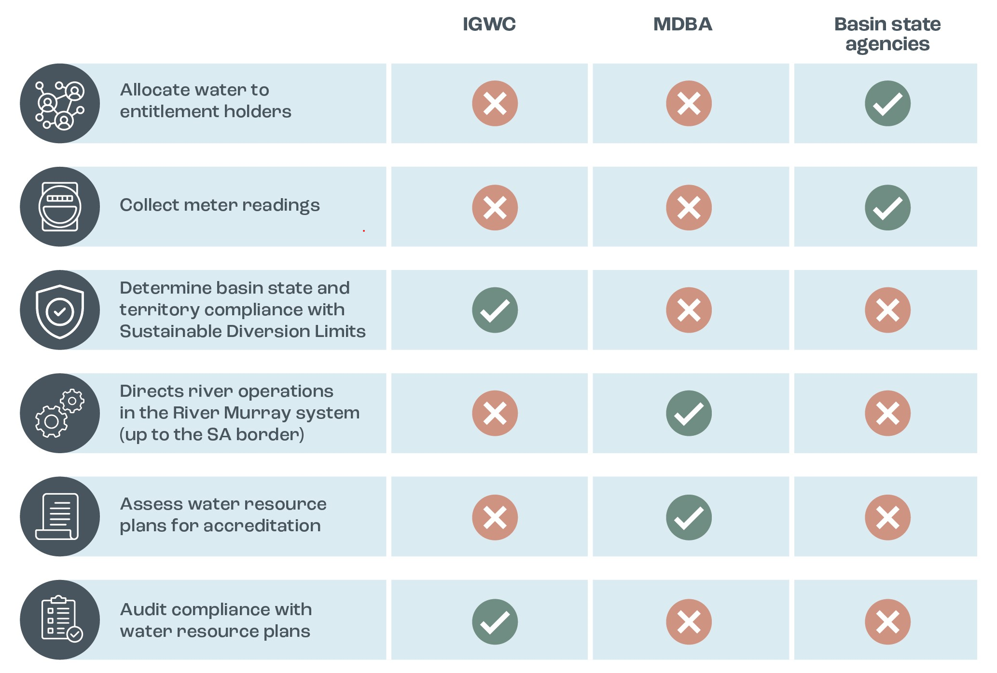

For relevant Commonwealth agencies, the Inspector–General is responsible for:

* Monitoring and independent oversight of performance of functions and exercise of powers under relevant parts of the Water Act
* Enforcing compliance with relevant parts of the Water Act, *Water Regulation 2008* (Regulations) and the Basin Plan.

For Basin State agencies, the Inspector–General is responsible for monitoring and overseeing performance of obligations under the Water Act, Basin Plan and water resource plans, as well as for enforcing compliance with the Commonwealth water laws. In doing this, the Inspector–General’s jurisdiction is restricted to the management of water resources in the Basin under the Water Act and to matters affecting the quantity and/ or quality of Basin water resources.

Basin State responsibilities

Basin States are responsible for applying, administering and enforcing relevant state laws. Among other things, this means state agencies are responsible for water access licensing and the allocation of available water to the different types of licences issued.

For clarity, the Inspector–General’s jurisdiction with respect to Commonwealth and Basin State agencies relates to only certain elements of the national frameworks. The Inspector–General is not responsible for regulating matters outside of this (for example, the Murray–Darling Basin Agreement set out in Schedule 1 of the Water Act or the administration or enforcement of Basin State laws).

However, to the extent it may be relevant, the Inspector–General is responsible for ensuring that the Commonwealth and Basin State agencies who do have responsibilities in relation to these matters comply with the Water Act when performing these roles. Specifically, performing an act that is inconsistent with the Basin Plan or water resource plans may be a contravention of Part 2 of the Water Act.

See Appendix 1: Inspector–General’s functions with respect to government agencies for a representation of the Inspector–General’s role.

In a more limited way, the Inspector–General is also responsible for monitoring and enforcing water users, infrastructure operators, water traders, brokers, etc. compliance with the Water Act, Basin Plan and water resource plans, primarily in relation to the Commonwealth’s water trading rules in the Basin Plan.

The Inspector–General is responsible for monitoring and overseeing Commonwealth and Basin State agencies’ implementation of commitments in relevant intergovernmental agreements. Intergovernmental agreements express the commitment of governments to work together on certain objectives or goals. For water, intergovernmental agreements support a federalist–type approach to the regulation of water and, relevantly, the management of Basin water resources. The goal of this federalised approach is to establish a regulatory structure that collectively functions as a single scheme operating in the national interest and where implementation of projects support delivery of the regulatory objectives (e.g., Basin State projects delivered under the [Off-Farm Efficiency Program](https://www.google.com/url?sa=t&rct=j&q=&esrc=s&source=web&cd=&cad=rja&uact=8&ved=2ahUKEwjCn6exqPn_AhV5sFYBHVEaCnYQFnoECBIQAQ&url=https%3A%2F%2Fwww.dcceew.gov.au%2Fwater%2Fpolicy%2Fprograms%2Fopen%2Foff-farm-efficiency-program&usg=AOvVaw0tTr2fX61ob10ltRwxKBlf&opi=89978449)).

See Appendix 1: Inspector–General’s functions with respect to government agencies for a representation of the Inspector–General’s role.

Intergovernmental agreements specify the intended purpose and outcomes the agreements support. In considering the implementation of commitments in intergovernmental agreements, the Inspector–General has regard to the overarching intent of the agreement, along with the specific commitments of each party. The Inspector–General also has regard to the interactions between and with other intergovernmental agreements, as these provide broader context.

In performing the above roles, the Inspector–General uses the powers and other tools set out in the Regulatory tools, **Error! Reference source not found.**, and **Error! Reference source not found.** sections below.

See Appendix 2: National water decision–making model for a representation of the national decision–making model, including the Inspector–General’s role.

## Coordination with other Commonwealth agencies

The Inspector–General shares responsibility for administering laws regulating Basin water resources with other agencies. For the Commonwealth, this means the Inspector–General currently works alongside:

* Murray–Darling Basin Authority (MDBA)
* Australian Competition and Consumer Commission (ACCC)
* Productivity Commission (PC)
* Bureau of Meteorology (BOM)
* Commonwealth Environmental Water Holder (CEWH)
* Commonwealth department with portfolio responsibility for maintaining the Water Act and national water policy.

The Inspector–General adopts a proactive approach of engaging with other relevant agencies when providing advice that does or may relate to the performance of their functions or exercise of their powers. The Inspector–General notes, however, this coordination does not affect any agencies’, including the Inspector–General’s, capacity to independently provide advice on any matter relevant to their functions or powers.

## Collaboration with other entities

To facilitate the effective management of Basin water resources by multiple parties, the Inspector–General adopts an inclusive and outcomes–based approach to facilitate mutually effective outcomes in each parties’ respective areas of responsibility. The Inspector–General has also established agreements with other agencies setting out how the Inspector–General and those agencies work together.

Inspector–General’s approach to regulation of non–water government agencies

The Inspector–General’s jurisdiction relates to the management of Basin water resources in the national interest. Actions of a non–water government agency may affect the quantity or quality of water in the Basin. Where this is the case, the Inspector–General may examine outcomes from these practices or provide assurance these actions have been undertaken consistently with the Water Act, Basin Plan or water resource plans, where relevant.

The Inspector–General is responsible for monitoring, overseeing and enforcing compliance with the Water Act and Basin Plan, where these functions apply to the MDBA. As such, the Inspector–General both sits alongside the MDBA, with separate and complementary roles, and regulates the MDBA.

To manage this relationship and administer the Water Act effectively, the MDBA and Inspector–General have entered into a Memorandum of Understanding setting out how they work together. This Memorandum does not cover nor limit the Inspector–General’s monitoring, oversight or enforcement of compliance with the Water Act and Basin Plan functions.

Figure Commonwealth water agencies

* Not subject to the Inspector–General’s jurisdiction in performing these roles

The Inspector–General has similar complexity in relationships with Basin State water compliance regulators, where the collective enforcement of all relevant water laws underpins the effective management of Basin water resources in the national interest. Under this approach, Basin States are responsible for administering and enforcing Basin State laws, while the Inspector–General is responsible for ensuring that this is done in a way that complies with the Water Act and is consistent with the Basin Plan and water resource plans.

The Inspector–General has a Memorandum of Understanding setting out how Basin State water compliance agencies and the Inspector–General work together. Consistent with the Memorandum with the MDBA, this Memorandum does not cover nor limit the Inspector–General’s monitoring, oversight or enforcement of compliance with the Water Act and Basin Plan functions.

Memorandums of understanding

The Inspector–General’s memorandums of understanding can be found on the website www.[igwc.gov.au](https://www.igwc.gov.au/).

The Inspector–General also recognises the roles of the Murray–Darling Basin Ministerial Council and Basin Officials Committee as decision–makers, and, particularly, in facilitating integrated regulatory frameworks and delivery of Basin–wide outcomes. The Inspector–General engages with and seeks engagement from those forums to drive improvement and provide assurance and accountability in the management of Basin water resources.

# Regulatory tools

The Inspector–General may use a number of tools to support the performance of their functions. In addition, the Inspector–General may exercise a number of regulatory powers set out in the Water Act. Those powers generally reflect the powers of other integrity regulators, with the addition of guideline and a limited standard–making powers.

The following sets out the Inspector–General’s approach to tools used in monitoring, examination and enforcement activities. The following also explains the Inspector–General’s guidelines and standards–making powers, which are used to support the Inspector–General’s compliance and oversight functions.

## Monitoring

Monitoring is a proactive way of assuring and influencing compliance with the Water Act, the Basin Plan and water resource plans. In addition, monitoring activities can provide a strong incentive for relevant government agencies to comply with their regulatory obligations and perform their obligations or exercise their powers in a way that is focused on managing Basin water resources in the national interest.

Monitoring is a tool the Inspector–General may apply to an individual, an agency or more generally. Outcomes from monitoring also inform the Inspector–General on whether regulatory action or interventions such as guidelines or standards are needed.

Table 2. Monitoring activities

| Type | Description | Benefits |
| --- | --- | --- |
| Engagement | Proactively engaging with Basin communities on water management outcomes | Continual tracking of developments in the Basin  Informs prioritisation of resources and efforts |
| Coordination | Proactively coordinating engaging on opportunities for coordination of different agencies’ efforts to maximise compliance across the Basin | Reflects the different jurisdictions and powers of different regulatory agencies  Drives greater efficiencies in the regulation of Basin water resources in the national interest |
| Research | Drawing together information from a range of sources | Tracks and provides context for activities and processes that have led to particular outcomes in the Basin  Provides initial analysis to determine whether there is a case to take more direct or intensive actions  Provides additional information to assess risk(s) |
| Assessment and reporting | Periodically compiling and reporting on relevant risk indicators | Encourages continuous improvement  Aids in identifying emerging risks and acts as a control mechanism for determining effectiveness of interventions |
| Targeted monitoring campaigns | Monitoring for a specific compliance issue | Encourages regulated entities to comply in specific area of concern  Focuses the Inspector–General’s resources on specific problem |
| In–depth reviews | Detailed analysis at a point in time (can be issue–specific or general) | Encourages regulated entities to engage intensely on compliance  Enables the Inspector–General to establish an evidence base on compliance |
| Opportunities to influence | Participating in government processes (such as hearings, requests for submissions, etc.) | Educates decision–makers on implications and obligations  Reflects the Inspector–General is not responsible for policy or legislative reforms |

## Examinations

Examination activities can be used proactively or reactively to provide assurance that regulated entities are complying with and performing their obligations or exercising their powers under the national frameworks. Similarly, examinations can be used as an incentive to improve the integrity of regulated entities’ compliance with and performance of their obligations or exercise their powers in a way that best delivers the intended outcomes from, the Water Act, Basin Plan and water resource plans. Examination activities provide a strong incentive for relevant government agencies to improve their effectiveness at managing Basin water resources in the national interest.

Examinations are compliance or performance tools the Inspector–General may apply to an individual, an agency or more generally. Outcomes from examination activities also inform the Inspector–General on whether regulatory action or interventions such as guidelines or standards are needed.

Table 3. Examination activities

| Type | Description | Benefits |
| --- | --- | --- |
| Inquiries (monitoring and oversight only) | Formal assessment of performance of functions, use of powers and/ or performance of obligations under Water Act  and/ or  Formal assessment of implementation of commitments in IGAs | Explores the drivers behind relevant government agencies’ activities or decision–making (as relevant)  Enables the Inspector–General to demonstrate the causes of outcomes experienced from the collective management of Basin water resource  Provides clear recommended actions for improvement |
| Audits (compliance only) | Systematic analysis of compliance with Plan and/ or water resource plans | Provides assurance that relevant government agencies are complying with their obligations  Enables the Inspector–General to develop an evidence–base for prioritising activities and interventions |
| Compel information | Using powers under the Water Act to compel the provision of information relating to compliance | Aids the Inspector–General in determining whether the Water Act is being complied with in fact or intent  Establishes evidence to inform enforcement actions |
| Inspections (compliance only) | Investigating compliance with the Water Act under a court–issued monitoring warrant | Determines whether the Water Act is being complied with  Establishes evidence to inform enforcement actions |
| Investigations (compliance only) | Conduct an inspection under an investigation warrant into compliance with the Water Act | Determines to [a standard of proof] whether there is evidence of a contravention with the Water Act |
| Site visits | With permission, reviewing matters on site relating to:   * Performance of functions or exercise of powers under Water Act (relevant Commonwealth agencies) * Performance of obligations under Water Act (Basin State agencies) * Implementation of commitments under relevant intergovernmental agreements | Enables the Inspector–General to perform oversight functions  Permits review of material where there may be disclosure or handling sensitivities |

## Enforcement

Enforcement is a reactive way of ensuring relevant persons or agencies are acting lawfully and that the Water Act, Basin Plan and water resource plans are being complied with. Enforcement activities are also used to prevent unlawful conduct.

Enforcement tools are used by the Inspector–General in respect to the activities of an individual, corporation, or government agency. Where the Inspector–General is not the primary authority with respect to a matter, the relevant conduct may be referred to the appropriate agency.

Table 4. Enforcement activities

| Type | Description | Benefits |
| --- | --- | --- |
| Declarations (compliance only) | Application for a court order about a legal conclusion on compliance with the law based on established facts | Clarifies the operation of the law where there are ambiguities, uncertainties or contested conclusions  Establishes case law about compliance with the Water Act |
| Injunctions (compliance only) | Application for a court order for person or agency to do or not do something | Prevents or deters contraventions of the Water Act  Establishes case law about compliance with the Water Act |
| Prosecutions (compliance only) | Legal proceedings against a person who has allegedly committed an offence | Punishes the offender  Encourages future compliance and deters others from committing an offence |
| Enforcement notices (compliance only) | A statutory notice which requires you to take action to remedy a contravention for which the Inspector–General is responsible for enforcing | Ensures compliance with the Water Act without instigating court processes |
| Enforceable undertakings (compliance only) | Written undertaking from a person or agency setting out what they will do or not do to comply with the Water Act | Voluntary action to encourage ongoing compliance |
| Public warning notices (compliance only) | Notification that the conduct of a person or agency is or is likely to be a contravention of the Water Act | Brings to attention the conduct of a person or agency of a possible or actual contravention of the Water Act  Timely intervention prior to unlawful conduct |
| Warning letters (compliance only) | Written guidance on contraventions of the Act and steps required to not be in contravention of the Water Act | Educates regulated entities on how to comply with the Water Act |

Where the Inspector–General is not the primary authority with respect to a matter, the matter may be referred to the appropriate agency. See **Error! Reference source not found.** for details. These referrals may relate to matters of compliance or performance.

Table 5. Referrals to other authorities

| Type | Description | Benefits |
| --- | --- | --- |
| Referrals to police | Referral of a person who has allegedly committed a crime | Person is subject to criminal sanctions that are proportionate to the offence committed |
| Referrals to another authority | Referral to relevant regulator or integrity authority (e.g., anti–corruption commissions) | Refers matters to those empowered to take action |
| Advise relevant oversight body | Referral to relevant agency (e.g., Minister, Committee, Parliament, etc.) | Refers matters to those to whom the person or agency is accountable, where relevant or appropriate |

## Guidelines and standards

Guidelines and standards may be issued by the Inspector–General under the Water Act and are tools that may be used by the Inspector–General to drive improvements in the management of Basin water resources. Guidelines and standards are regulatory tools that are used by the Inspector–General regarding actions that may be taken by relevant government agencies to better achieve the intended operation of the Water Act, rather than relating to compliance with the Water Act directly. However, a failure of relevant government agencies to have regard to relevant guidelines and standards in performing their obligations under the Water Act, may be a contravention of the Water Act and, therefore, subject to compliance tools (see below).

Table 6. Guidelines and standards

| Type | Description | Benefits |
| --- | --- | --- |
| Guidelines | Administrative documents relevant Commonwealth and Basin State agencies must consider in performing their obligations under the Water Act | Addresses impediments to achieving the objectives of the Water Act and/ or Basin Plan, where government agencies are best–placed to act |
| Standards | Legislative instruments relating to the measurement of Basin water resource or information on Basin water markets relevant Commonwealth and Basin State agencies must consider in performing their obligations under the Water Act | Sets minimum requirements where there are deficiencies in measurement or market information that are or may compromise delivering the objectives of the Water Act and/ or Basin Plan |

Guidelines and standards are regulatory interventions affecting the application of the legislative frameworks relevant government agencies administer, apply or comply with (as appropriate). As such, and in line with expectations of other national standard setting bodies, the Inspector–General’s decision to issue guidelines and standards is informed by a regulatory impact analysis proportionate to the potential implications of the intervention.[5]

## Compliance approach

The following sets out the Inspector–General’s responsive approach and the regulatory tools available to the Inspector–General in performing their compliance and enforcement functions.

The Inspector–General in deciding whether to use compliance tools and, if so, which one, has regard to the following:

* Whether the matter is within the Inspector–General’s jurisdiction or whether it should be referred to another agency
* Whether it relates to one of the Inspector–General’s targeted priorities
* Whether there are other activities or processes, conducted by the Inspector–General or other agencies, that could be leveraged off or that duplicate the activity
* The prospects of successful intervention on the matter
* The most appropriate pathway of escalations for dealing with the specific matter
* The attitude of the regulated entity to compliance
* The capacity of the Inspector–General to undertake the action in light of their resourcing and other priorities.

The Inspector–General notes that consideration of the above will be driven by the circumstances relating to the particular matter of concern. This may mean that some or all of the above factors may be relevant considerations in determining their specific regulatory response.

In line with the Inspector–General’s broader responsive regulatory approach, the appropriate action is based on a compliance pyramid (see Figure 6 below).

Figure Compliance pyramid

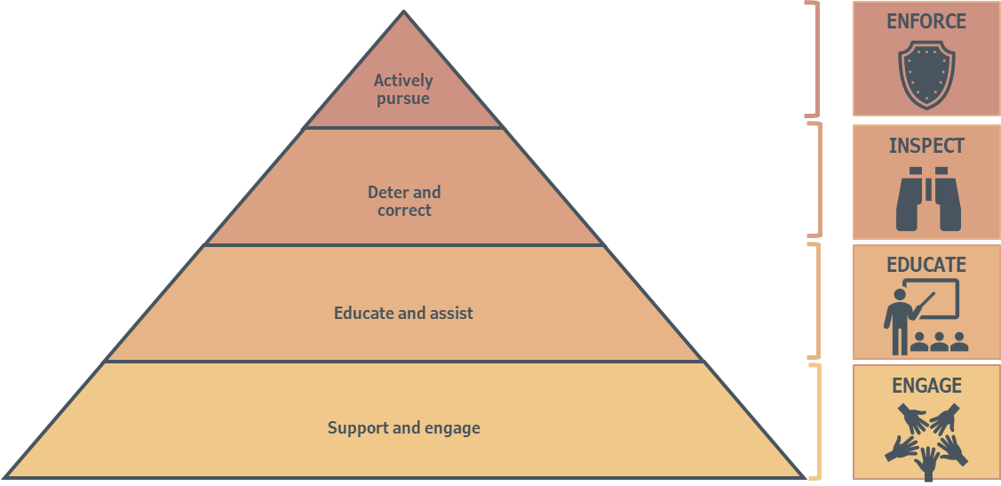

## Performance approach

The following sets out the Inspector–General’s responsive approach and the regulatory tools available to the Inspector–General in performing their monitoring and independent oversight functions.

The Inspector–General in deciding whether to use performance tools and, if so, which one, has regard to the following:

* Whether the matter relates to the management of Basin water resources under the national frameworks and is, therefore, within the Inspector–General’s jurisdiction
* Whether it relates to one of the Inspector–General’s targeted priorities
* Whether there are other activities or processes, conducted by the Inspector–General or other agencies, that could be leveraged off or that duplicate the activity
* The prospects of successful intervention on the matter
* The maturity of the relevant entity(ies)
* The attitude of the relevant entity(ies) to giving effect to the national frameworks and/ or relevant intergovernmental agreements
* The capacity of the Inspector–General to undertake the action in light of their resourcing and other priorities.

The Inspector–General notes that consideration of the above will be driven by the circumstances relating to the particular matter of concern. This may mean that some or all of the above factors may be relevant considerations in determining their specific regulatory response.

In line with the Inspector–General’s broader responsive regulatory approach, the appropriate action is based on a pyramid of regulatory responses (see Figure 7 below).

Figure Performance pyramid

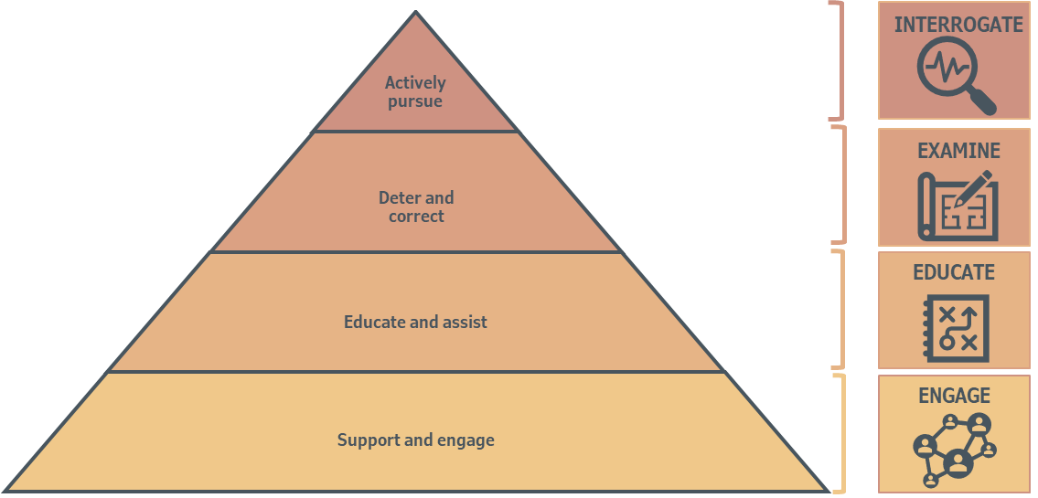

# Review of policy

The Inspector–General intends for this policy to be reviewed following legislative reforms to the Water Act or Basin Plan or, in any case, in 5 years of its publication.

# Feedback and next steps

Submissions in response to this discussion paper may be lodged with [igwc@agriculture.gov.au](mailto:igwc@agriculture.gov.au) or sent to:

Inspector–General of Water Compliance  
Department of Climate Change, Energy, the Environment and Water  
GPO Box 3090  
Canberra ACT 2601

Please provide submissions before close of business 8 September 2023. Submissions received after this date may not be considered.

It is the Inspector–General’s intention to publish submissions in full, unless otherwise prevented from doing so.

Once the Inspector–General has considered submissions on this draft regulatory policy, they intend to publish the final policy in the last quarter of 2023.

# Appendix 1: Inspector–General’s functions with respect to government agencies

##### Commonwealth agencies

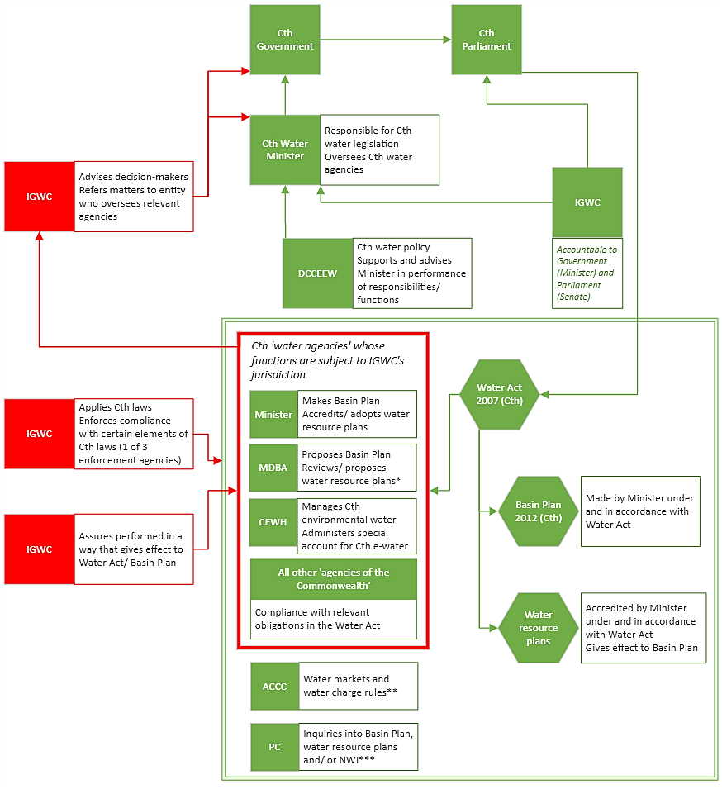

##### Basin State agencies

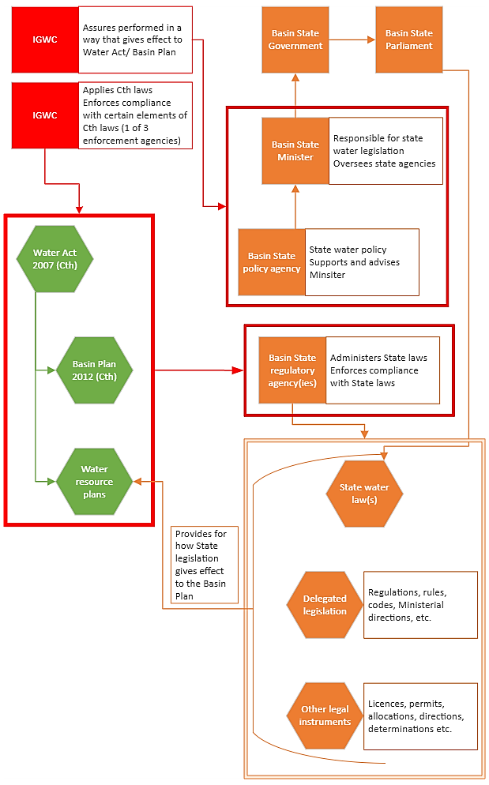

# Appendix 2: National water decision–making model

A diagram of a government policy-making, where the Murray-Darling Basin Ministerial Council is responsible for making national water policy and entering into intergovernmental agreements, which are then implemented by the Basin Officials Committee and infrastructure (that is funded by the Commonwealth under an intergovernmental agreement) is delivered by Basin State agencies. The Inspector-General advises Commonwealth agencies involved in these processes and oversees implementation of national water policy, intergovernmental agreement and the delivery of infrastructure.

Please note, the above diagram reflects the Inspector-General’s roles with respect to national water decision-making and does not include the roles of other Commonwealth water agencies, such as the ACCC or Productivity Commission, in the decision-making model. These agencies are not included as they are not subject to the Inspector-General’s oversight in those roles.

# References

1. Inspector–General of Water Compliance, *Regulatory Policy Discussion Paper*, March 2023, <https://www.igwc.gov.au/consultations>, accessed 23 May 2023.
2. Section 15, *National Anti Corruption Commission Act 2022* (Cth) (<https://www.legislation.gov.au/Details/C2022A00088>, accessed 3 July 2023).
3. I. Ayres and J. Braithwaite, *Responsive Regulation: Transcending the Deregulation Debate,* Oxford University Press, Oxford, 1992.
4. Inspector–General of Water Compliance, *Work Plans* (<https://www.igwc.gov.au/governance>).
5. Office of Impact Analysis, May 2021. *Regulatory Impact Analysis Guide for Ministers’ Meetings and National Standard Setting Bodies*, [https://oia.pmc.gov.au/sites/default/files/2021–06/regulator–analysis–guide.pdf](https://oia.pmc.gov.au/sites/default/files/2021-06/regulator-analysis-guide.pdf), accessed 15 February 2023.