

Annual Work Plan

2023–24

© Commonwealth of Australia 2023

Ownership of intellectual property rights

Unless otherwise noted, copyright (and any other intellectual property rights) in this publication is owned by the Commonwealth of Australia (referred to as the Commonwealth).

Creative Commons licence

All material in this publication is licensed under a Creative Commons Attribution 4.0 International Licence, except for content supplied by third parties, logos and the Commonwealth Coat of Arms.

Inquiries about the licence and any use of this document should be emailed to [copyright@dcceew.gov.au](mailto:copyright@dcceew.gov.au).

Creative Commons icon

Cataloguing data

This publication (and any material sourced from it) should be attributed as: Inspector-General of Water Compliance 2023, Inspector-General of Water Compliance, Annual Work Plan 2023-2024, the Australian Government, Canberra, August. CC BY 4.0.

This publication is available at https://www.igwc.gov.au/publications/annual-work-plans  
Inspector-General of Water Compliance  
GPO Box 3090 Canberra ACT 2601

Disclaimer

The Australian Government represented by the Inspector-General of Water Compliance, has exercised due care and skill in preparing and compiling the information and data in this publication. Notwithstanding, the Inspector-General of Water Compliance, the Australian Government’s employees disclaim all liability, including liability for negligence and for any loss, damage, injury, expense or cost incurred by any person as a result of accessing, using or relying on any of the information or data in this publication to the maximum extent permitted by law.

**Acknowledgement of all Traditional Owners**

The Author pays respect to the Traditional Owners and their Nations of the Murray−Darling Basin. We acknowledge their deep cultural, social, environmental, spiritual and economic connection to their lands and waters.

Aboriginal people should be aware that this publication may contain images, names or quotations of deceased persons.

**Accessibility**

The document and information is available in accessible formats. On some occasions the highly technical nature of the document means that we cannot make some sections fully accessible. If you encounter accessibility problems or the document is in a format that you cannot access, please contact us on 13 44 92.

## Picture of Inspector-General Troy GrantForeword by the Inspector-General

Once again, I am delighted to deliver the annual work plan for the Inspector-General of Water Compliance (IGWC). The 2023-24 IGWC work plan continues to develop on the year-on-year growth and achievements of the teams who support me in my role as an independent regulator performing an oversight, compliance, enforcement and engagement role across the 1 million square kilometres of the Murray-Darling Basin, or roughly 14 per cent of Australia’s land area.

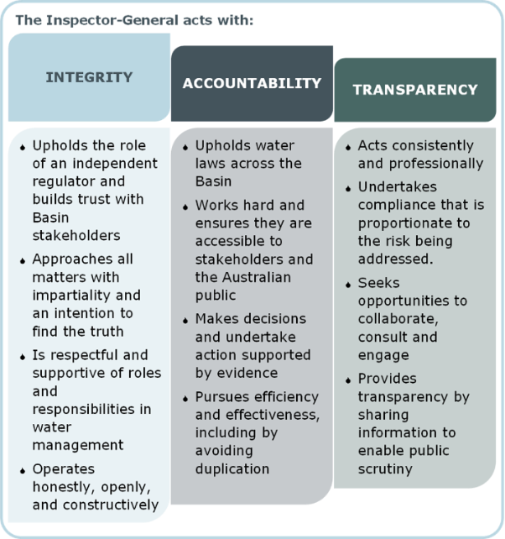When developing the previous work plan, we did so during a time of continuous wet weather events that culminated to well and truly break the longest drought in recorded European settlement of Australia. At the time of publishing this year’s work plan, global and national weather forecasters have announced a return to drier (El Niño) conditions across Australia by the end of the 2023 calendar year. While water storage levels and river operations across the Basin may appear plentiful now, history has shown, time and time again, our great and challenging country can change quickly, leaving many to wonder, ‘where did all the water go?’ and, ‘how did we let things get so bad?’

As the Inspector-General of Water Compliance enters a third year of operation, we’re approaching the 2023-24 period having listened to and understood the concerns, feedback, and ideas from communities across the Basin. We’ve undertaken research into community sentiment and understanding of issues which has informed our approach to how we plan for projects and why we do them against the backdrop of what is important to the community, what does the community need and what do they expect from the Inspector-General? We are working across Basin states and with state operators and regulators to improve monitoring and oversight; working closely with regulatory leaders in a highly cooperative forum that I lead to share ideas, concerns and important information that directly affects the Basin. The coming work year will see a review into the role of the Inspector-General, its powers, and what is needed to ensure the integrity and compliance of Basin water management is overseen by a fit for purpose entity that is equipped with the right legislation to independently oversee the performance of governments in delivering their obligations under the Water Act 2007 and the Basin Plan 2012. And we continue to engage with people face to face, at field days, at the farm gate, and at events across the cities, towns and villages that are home to the 2.2 million people who live, work, and play across the Murray-Darling Basin.

This year’s work plan supports our ‘business as usual’ work, clearly setting our outcome, goals and objectives, while allowing me and the staff who support me to shift my focus and exercise my powers to hold an inquiry into matters of significance where and if required. The IGWC operates a highly agile, flexible and adaptive work model – a credit to the professional and specialist teams who support me.

# The Work Plan

## As an independent regulator, the Inspector-General has discretion in performing oversight, compliance and enforcement functions, and at any time may use their powers and choose to change the priorities beyond those published in the work plan.

## Developing the 2023-24 Work Plan

## The work plan is designed to work towards strategic outcomes by responding to current and emerging risks and challenges affecting water management and compliance in the Murray-Darling Basin. A range of factors are considered to set the work program, including:

* what community groups and stakeholders have told the Inspector-General and their office
* analysis of data and information demonstrating the level of compliance with the Basin Plan and water management arrangements in each state
* monitoring and oversight of governments meeting their commitments to the public and each other
* the current state of water reforms and potential future scenarios and likely challenges.

## The Operating Context in 2023-24

The Inspector-General recognises there are challenges that affect the Basin’s communities and resources. Climate, changing demographics, new technologies and changing social values all influence and shape the industries and communities in the Basin.

Considerations in developing this work plan included:

* An extremely high likelihood of an El Niño developing later in the year across Eastern Australia, raising the risk of drought, heatwaves and bushfires across the Basin. Research conducted by the Inspector-General in 2022 found community concerns around the transparency and accountability of water management decisions are understandably heightened when water becomes scarce. Naturally, water scarcity negatively impacts social, economic and environmental outcomes.
* Ongoing uncertainty in Basin communities about the delivery of key Basin Plan initiatives including, among others;
  + 2024 delivery of Sustainable Diversion Limit Adjustment Mechanism supply and constraint measures that are intended to return an extra 605GL of water to the productive use; and
  + recovery of remaining water required for “Bridging the Gap” target to complete the recovery of 2,075GL of water.
  + outstanding NSW WRP submission and accreditation
  + transparency in the lead up to Basin Plan review in 2026.
* A review of the Inspector-General of Water Compliance will be undertaken in late 2023, and will explore whether the position has adequate powers to effectively perform the role and deliver the outcomes intended. The review is an important and welcome process that provides opportunities to further improve the Inspector-General's ability to ensure accountability, transparency and integrity in Basin water management.

## Delivering against the Work Plan

## The Inspector-General will undertake inquiries (if planned or required) and publish reviews and audits to keep the community informed. The Inspector-General will publish the outcomes of key areas of work to support transparency and ensure compliance with legislation.

## Please consult the website at: www.igwc.gov.au for all publications.

## Review of the Work Plan

## Section 215F of the Water Act 2007 requires the Inspector-General to undertake a mid-year review of the work plan.

## Following the review, the Inspector-General may amend the work plan to respond to emerging areas of risk. Where the work plan is amended, it will be published on the website at www.igwc.gov.au

# 2023-24 Priorities

| Priority 1: Monitor Commonwealth and state performance | |
| --- | --- |
| Why it’s a priority | The Inspector-General's powers allow for independent oversight and monitoring of Commonwealth and state water management agency performance. Monitoring performance provides assurance, and together with compliance powers and public reporting, creates accountability and transparency. Performance monitoring brings together validated, consistent and comparable data to see how different parties are tracking in their commitments. This allows the Inspector-General to work together with agencies charged with water responsibilities to set targets for improvement, track towards better outcomes, and ensure commitments are met in a way that is lawful and transparent. |
| The Inspector-General's desired outcomes | **Do it better:** Raise performance, and drive improvements in standards of Basin Plan delivery.  To provide transparency to the Australian community and stakeholders on the operations, activities and outcomes of the Commonwealth, and state water managers in the delivery and achievement of Basin Plan 2012 outcomes. Where appropriate, the Inspector-General will enforce compliance with respective laws. |
| What the Inspector-General will do | * Examine performance and outcomes to date of major commitments being delivered by the Commonwealth under the Basin Plan 2012. * Undertake audits on compliance with water resource plan obligations. * Reconcile compliance performance reporting differences between Basin states and territories and publish reports that demonstrate whole of Basin outcomes. |

| Priority 2: Foster Basin-wide regulatory cooperation | |
| --- | --- |
| Why it’s a priority | The community understands that the Murray-Darling Basin is a connected system, and impacts of water use don't constrain themselves to state borders. Differences in the way Basin states manage water resources make it difficult for the Australian community to compare like for like and to see and understand the impacts of water management on the whole system. Public confidence in the Basin Plan 2012 relies on the progress, issues, and risks in delivering Basin Plan outcomes being visible and understandable. |
| The Inspector-General's desired outcomes | **Make it better:** Use knowledge, evidence and insights to input into the ongoing reform of water regulation.  Basin water managers and regulators work together to enable the community to be able to see and understand what is being achieved at the Basin scale, and be confident in the delivery of outcomes. |
| What the Inspector-General will do | * Work with Basin regulators to promote continuous improvement in regulatory standards. * Publish a metering standard to provide a consistent, standardised approach to the measurement of water take across the Basin. * Undertake research, and use evidence, knowledge and insight to input into significant regulatory review, inquiry and reform processes undertaken by other oversight, policy and regulatory bodies. |