**Telemetry** Involves automatically recording data and sending it electronically from the meter to

another place for monitoring and analysis.

**Open-Channel meters** Meters intended for the metering of water in open channels and partially filled pipes.

**Closed Conduit meters** Meters intended for the metering of water in full flowing pipes.



**Glossary**

**Accurate** Up to +/-5% maximum permissible error in-situ operation as per Compliance Compact and MAF2 requirements.

**AS4747-compliant meter** A non-urban water meter that has met the requirements of AS4747 and has been issued with a Pattern Approval certificate.

**Basin state or state** Each of New South Wales, Victoria, Queensland, South Australia and the Australian Capital Territory.

**Australian Standard 4747 (AS4747)**

**Certified Person; Certified Meter Installer; Duly Qualified Person**

The Australian standard which covers meters for non-urban water supply, and by which said meters are tested and Pattern Approved.

A person certified by an accredited organisation to undertake meter installation, maintenance and validation activities in accordance with codified industry practices and Australian Standards.

**Grandfathered or Contemporary meter**

An installed water meter is likely to meet the ±5% accuracy range and which has a manufacturer’s certificate of accuracy of ±2.5% and has been installed to manufacturer’s specifications.

The 2018 agreement between the Australian Government and the Murray–Darling Basin States, setting priorities and obligations on the governments for water compliance effort and for the integrity of Murray–Darling Basin water management.

Rules and guidance for the use and regulation of non-urban water meters <https://www.agriculture.gov.au/sites/default/files/documents/metrological-assurance-framework-2.pdf>



**Murray–Darling Basin   
Compliance Compact   
(Compliance Compact)**

**Metrological Assurance Framework 2 (MAF2)**

**Meterable take** Licensed water take, as defined at clause 7 of the best practice guidelines for minimum metering thresholds as agreed by Basin jurisdictions. Note – exemptions are defined in Clause 8. See: [https://www.agriculture.gov.au/sites/default/files/ documents/mdb-best-practice-guidelines.pdf](https://www.agriculture.gov.au/sites/default/files/documents/mdb-best-practice-guidelines.pdf)

The National Measurement Institute (NMI) is Australia’s peak measurement body responsible for biological, chemical, legal and physical measurement.

**National Measurement Institute (NMI)**

**Pattern Approval** Evaluation of a design of a measuring instrument (such as a water meter) by an impartial body which examines the pattern of an instrument against a set of national or international metrological specifications, which determine whether an instrument manufactured in accordance with that design is capable of retaining its calibration over a range of conditions.

**Pattern approval certificate** A certificate, published by the NMI, which describes the design (including type and size) of the meter, which is Pattern Approved, and any conditions for the installation, maintenance and use of the meter.



Murray-Darling Basin – Metering and Measurement Report Card

01 Jul 2020 – 30 Jun 2021. Data as at 30 June 2021. Work has commenced on gathering data for the 2021–22 Report Card.

Percentage of water take metered by state Metering accuracy by state Telemetry coverage

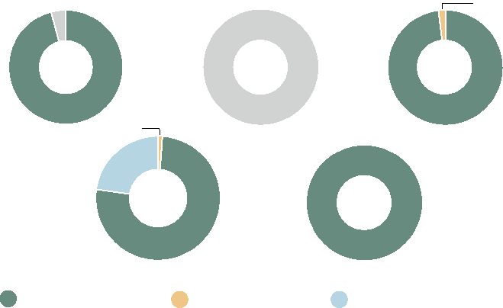

1.8%

OLD SA

98.2%

Data not available

ACT

100%

19%

NSW

78.4%

VIC

96%

2.6%

Metered water take Exempt water take Not yet metered water take

This measure is reported to highlight percentage of meterable water take across the Murray‑ Darling Basin by each State that is metered.

Refer to individual State Report Cards for detailed explanation.   
Data owner/sources: State regulators

Pattern approved meters

|  |  |  |  |  |  |  |  |
| --- | --- | --- | --- | --- | --- | --- | --- |
|  | | |  |  | |  | Siemens |
|  | Arad | |  |  | | Closed conduit |
|  | Arad | |  |  | |  |
|  | Zenner | |  |  | |  |
|  | | | Endress | & Hauser | |  |
| Elster | | |  |  | |  |
|  | | |  | | | |
|  | | |  | | Siemens |  |
|  | | |  |  | ABB |  |
| ABB | | |  |  | |  |
|  | | |  | Euromag | |  |
|  | | Sensus |  |  | |  |
|  | | |  |  | | Aquamonix |
|  | | |  |  | | Krohne |
|  | | |  |  | | Krohne |
| Rubicon |  | |  |

**0 500mm 1000mm 1500mm 2000mm**

This measure is reported by the National Measurement Institute as at 30 June 2021. The objective of the measure is to signal the market availability of pattern approved meters and models by manufacturer and pump size. The number of pattern approved meters has gone up by 7 meters between July 2019 and June 2021 (end of this reporting period) predominantly due to the NSW Government signalling the market in December 2018 when it introduced its new non‑urban water metering framework.

Data owner/sources: National Measurement Institute

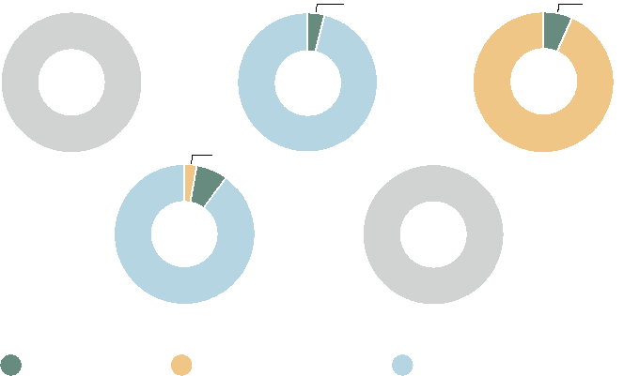

6174 Meters

316 Meters

VIC

OLD

96%

4%

93.10%

SA

6.90%

3%

ACT

3449 Meters

Data not available

1893 Meters

7%

NSW

90%

AS4747 meters Grandfathered meters

Percentage of meter type not available

All other meters

0.001%



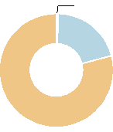

0.8%

20.3%

NSW

78.9%



ACT

100%

|  |  |  |  |  |  |
| --- | --- | --- | --- | --- | --- |
|  | Meter % with telemetry connected to the regulator’s data collection system |  | Meter % required to have telemetry connected to the regulator’s data collection system, but which are not connected |  | Meter % with telemetry not required |

This measure is reported to identify the percentage of meters with telemetry connected to the regulator’s data system across the Murray‑Darling Basin.

Refer to individual State Report Cards for detailed explanation.   
Data owner/sources: State regulators

Floodplain water take

This measure is reported to understand the volume of floodplain harvesting (called overland flow in QLD) take and how progressed states are in licensing that volume.

In the QLD portion of the Murray‑Darling Basin, high risk overland flow take is subject to water licensing. The total volume of overland flow water taken in QLD is 608 GL, 41% of which is licensed by the regulator (Lower Balonne high priority overland flow take). Due to a licensing process underway in the Border Rivers and Moonie WRP area, the total licensable volume for overland flow is changing and will not be available until the process has been completed. QLD is also developing an approach for measuring and accounting for the take of overland flow water.

Full implementation of the NSW Floodplain Harvesting Policy including licensing and commencement of measurement was due in June 2021, however delays in implementing the legislative reform have meant that licensing and measurement of floodplain harvesting have not yet taken place in NSW.

Data owner/sources: State regulators

Data not available 608 GL



Floodplain water take licensed by the regulator

41%

NSW OLD

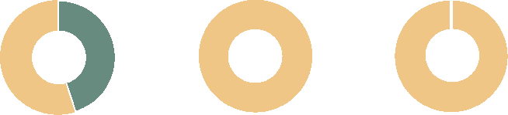

SA

99.99%

55%

100%

VIC 45% OLD

This measure is reported to identify the percentages of meters that comply with the State’s metering policy and are therefore deemed accurate (including AS4747 and grandfathered meters).

Refer to individual State Report Cards for detailed explanation.   
Data owner/sources: State regulators

Count of qualified meter installers

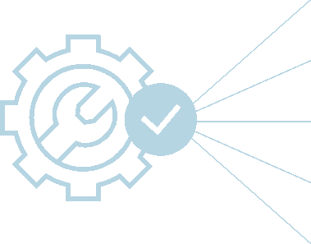

This measure is reported by State in order to highlight the availability of active certified meter installers (CMI’s) that are qualified to install, certify and validate compliant meter installations, as at 30 June 2021.

Data owner/source: Irrigation Australia

VIC 151   
SA 39   
OLD 142   
NSW 161

ACT 0

The IGWC makes no claim as to the accuracy of the data shown on this page. Data is collated and supplied directly from the states.

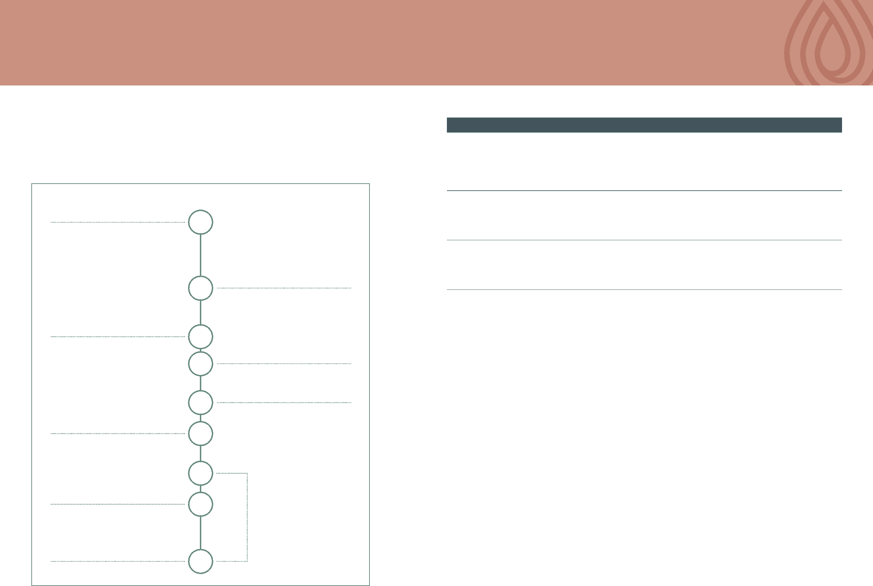

Yes but do not require new and replacement meters above 600mm size to be Pattern Approved

AS4747 compliant metering policy published including implementation plans

Yes No Yes Yes

Currently no published commitment to full AS4747 compliance

New installations or in life

replacement

Full AS4747 implementation compliance due date by jurisdiction

2023 2025 New installations

or in life replacement

No

Telemetry policy published by jurisdiction, including strategic targets for deployment

No Yes No Yes (Water

Authority dependent)

Murray-Darling Basin – Metering and Measurement Report Card

01 Jul 2020 – 30 Jun 2021

**Metering and measurement in the Murray-Darling Basin**

Metering is fundamental to trust in water accounting and compliance. Metering standards need to be consistent to make sure water take is fair for everyone across the Basin. The timeline below demonstrates the commitments to better metering.

**Metering reform timeline**

Each Basin State must have compliant meters based on the AS4747 standard by July 2025, or have relevant exemptions or grandfathering in place.

**State progress on meter accuracy, coverage and timeliness of data capture**

**Requirement OLD NSW ACT VIC SA**

**Metering reform timeline**

**2004**

National Water Initiative (NWI)

**2009**

National Framework for Non-Urban Water Metering

**2012**

The Basin Plan

**2013**

Australian Standard 4747 (AS4747) Meters for non-urban water supply

**2017**

Murray–Darling Basin Water Compliance Review

**2018**

The Basin Compact

**2020**

Floodplain harvesting

measurement (NSW and OLD)

**2021**

MAF2

AS4747 Implementation Period

**2025**

Reform Implementation Date







**Murray-Darling Basin – Australian Capital Territory Metering Report Card**

**01 Jul 2020 – 30 Jun 2021**

**Metering accuracy in the ACT**

AS4747 meters Data not available

Grandfathered meters

Data not available

All other meters



ACT

Accuracy data   
not available

**Percentage of water take metered in the ACT**

This measure is reported to highlight percentage of meterable water take across the Murray-Darling Basin by each State that is metered.

Data owner/sources: State regulators

**State overview**

The contribution of ACT non-urban water use within the Murray-Darling Basin context is relatively small and of low risk to the Basin Plan outcomes. One water user (ICON Water) accounts for most of that water take.

The ACT has achieved 100% compliance with its current policy for water metering and grandfathering arrangements as all water take is measured.

All licensed water extraction points in the ACT are metered. A total of 316

water meters measure water use of the 185 active individual ACT Licenses

To Take Water. The ACT reports the number of inspections of meters to

determine compliance with AS4747 has been affected by the impacts of Covid-19

and staff movements.

Future development and implementation of the ACT water metering policy in line with AS4747 and MAF2 requirements will inform progress towards AS4747 meters in the ACT in the short to medium term, as the policy will apply to future replacement or new installation of water meters.

The ACT does not require telemetry to be fitted to any meters. The volume of water used by each licence holder is analysed annually via an accounting process and compliance with licence conditions (supply of data, amount of water used) is checked during the accounting process. Information provided by licence holders is validated by an inspection program that aims to check water meters at least once every three years and more frequently for higher risk water users.



Metered water take

Exempt water take

Not yet metered water take

ACT

100%

This measure is reported to understand the percentages of meters that comply with the State’s metering policy and are therefore deemed accurate (including AS4747 and grandfathered meters). The percentage of AS4747 meters in the measure is intended to show progress basin states are making in the roll-out of AS4747 metering. The percentages of meter types are not currently available in the ACT.

Data owner/sources: State regulators

**How is meter data collected where telemetry is not used**

**Telemetry coverage**

Meter % with telemetry connected to the regulator’s data collection system

Meter % required to have telemetry connected to the regulator’s data collection system, but which are not connected

Meter % with telemetry not required



ACT

100%

Data provided by licence holder as per frequency set in licence conditions



This measure is reported to identify the percentage of meters with telemetry connected to the regulator’s data system.

Data owner/sources: State regulators

This measure is reported to identify how meter data is collected and how often when telemetry is not being used.

Data owner/sources: State regulators

The IGWC makes no claim as to the accuracy of the data shown on this page. Data is collated and supplied directly from the states.



**Murray-Darling Basin – New South Wales Metering Report Card**

**01 Jul 2020 – 30 Jun 2021**

**Percentage of water take metered in New South Wales**

Exempt water take

Metered water take

Not yet metered water take

This measure is reported to highlight percentage of meterable water take across the Murray-Darling Basin by each State that is metered.

Data owner/sources: State regulators

**Telemetry coverage**

This measure is reported to identify the percentage of meters with telemetry connected to the regulator’s data system.

Data owner/sources: State regulators

Meters

This measure is reported to understand the percentages of meters that comply with the State’s metering policy and are therefore deemed accurate (including AS4747 and grandfathered meters). The percentage of AS4747 meters in the measure is intended to show progress basin states are making in the roll-out of AS4747 metering.

Data owner/sources: State regulators

**How is meter data collected where telemetry is not used**

Approval holders submit meter reads to WaterNSW as per the schedule below. When submitting meter reads, if no water is taken that also needs to be declared. Non-telemetered meters have their data loggers annually downloaded by WaterNSW. Logbooks with meter records must also be kept for five years.

**Recording frequency Report Report annually**

**monthly**

|  |  |  |
| --- | --- | --- |
| Works required to meter before the metering reform compliance date (Stage One – 1 December 2020) | Licensed water take is manually recorded by the water user in a logbook each time water is taken. Some exemptions apply in some areas where an operational meter and data logger is installed. | N/A WaterNSW reads the meter at least annually (and in some cases meters are read quarterly, such as for regulated rivers) |

Works required Licensed water take is Approval WaterNSW downloads

to meter after the automatically recorded by holder Local Intelligence Device

metering reform Local Intelligence Device (logged submits data annually

compliance date (Stage hourly) a meter

One – 1 December 2020) read

This measure is reported to identify how meter data is collected and how often when telemetry is not being used.

Data owner/sources: State regulators

**State overview**

Metering requirements were first introduced in NSW in the early 1980s for regulated rivers and 2003 for major inland alluvial groundwater sources.

In December 2018, the NSW Government introduced a new non-urban water metering framework to ensure robust and fair water management across the state. The framework requires all water supply works to have metering equipment that complies with the Australian Standard (AS4747), unless an exemption applies. Existing meters can be retained provided they are validated as accurate to AS4747 requirements (+/-5% field accuracy).

The new water metering framework is being rolled out in 4 stages, with each stage occurring annually between 2020 and 2023. The purpose of these stages is to ensure all water users have enough time to comply with the new rules and the focus is on the highest risk categories first. As the annual rollout date is 1 December, these report card metrics are derived at the halfway point for each stage. On 1 December 2020, Stage 1 commenced which applies to surface water pumps 500mm and greater.

The uptake of water metering equipment for works in Stage 1 in this Report Card period (July 2020 - June 2021) was impacted by the infancy of the metering reforms and the availability at the time of suitable metering equipment for large works. Despite a comprehensive and active engagement campaign for these water users, metering uptake was slow.

NSW reports that compliance rates increased considerably into the next reporting period (July 2021 – June 2022), following the Natural Resources Access Regulator’s (NRAR) compliance program of monitoring and investigative activities, supported by further engagement and communication undertaken by the Department with WaterNSW and NRAR. The NRAR compliance program found that 90% of meters for works in Stage 1 were compliant by the end of the reporting period.

In August 2021, it was announced that the Australian and NSW Governments launched a $36.1 million suite of programs to support uptake of telemetry and metering across NSW. NSW is continuing to implement its non-urban metering reforms and the 2021/2022 Report Card will demonstrate an improvement in meter coverage as each stage is being rolled out across the state.

The IGWC makes no claim as to the accuracy of the data shown on this page. Data is collated and supplied directly from the states.

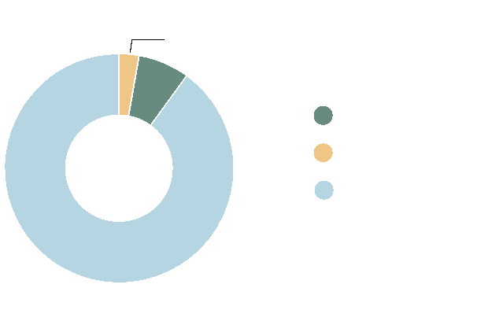

**Metering accuracy in New South Wales**

3%

7%

AS4747 meters

Grandfathered meters

All other meters

NSW

90%

6174

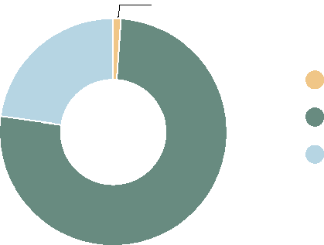

2.6%

19%

NSW

78.4%

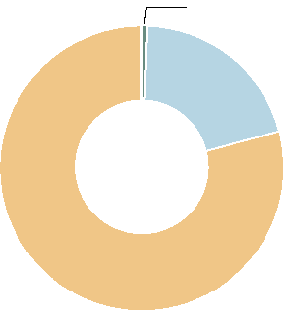

0.8%

20.3%

NSW

78.9%

Meter % with telemetry connected to the regulator’s data collection system

Meter % required to have telemetry connected to the regulator’s data collection system, but which are not connected

Meter % with telemetry not required









**Murray-Darling Basin – Queensland Metering Report Card**

**01 Jul 2020 – 30 Jun 2021**

Data not available

This measure is reported to highlight percentage of meterable water take across the Murray-Darling Basin by each State that is metered.

Data owner/sources: State regulators

**How is meter data collected where telemetry is not used**

Self meter reads provided to the department at the following intervals for identified take:

* Groundwater (21% of meters/14% of volume) read six monthly;
* Supplemented water meters (36% of meters/18% of volume) read monthly or quarterly
* Unsupplemented water meters (22% of meters/12% of volume) read annually
* Overland flow and water harvesting (21%/56% of volume) measured throughout take events

**State overview**

In October 2022, QLD released a strengthened water measurement policy to increase the standard and coverage of water meters across the state. The strengthened policy replaces OLD’s former ‘Non-urban Water Metering Policy for Unsupplemented Water Extractions’ (2019). At present, best available data indicates that approximately 74% of the total volume of water entitlements in the OLD portion of the Murray-Darling Basin is metered. When the strengthened water measurement policy and implementation plan take effect, estimates of numbers of new meters to be installed can be determined.

All take required to be metered under the former OLD policy and Water Act (OLD) (2000) as at 30 June 2021 is metered. Data is not currently recorded in departmental systems for exempt take.

A strengthened water measurement standard aligned with the National Metrological Assurance Framework 2 (MAF2) is already in place. Existing meters undergoing revalidation, and new and replacement metering, are adhering to this strengthened standard.

Under this new policy, telemetry on meters will be required for the taking of water under high-risk water entitlements in the highest risk areas. This means that as a priority, telemetry will be required for surface water entitlements in the Queensland portion of the Murray-Darling Basin. Queensland is completing work to develop a telemetry standard and during 2023, with the support of a telemetry subsidy, will commence the requirement for the installation of telemetry devices in the Queensland portion of the Murray-Darling Basin.

As work to strengthen water measurement in OLD proceeds, it is anticipated that OLD will be able to more effectively report against the metrics in future iterations of this Report Card.

**Percentage of water take metered in Queensland**



Metered water take

Data not available

Exempt water take Data not available

Not yet metered water take

Data not available

**OLD**

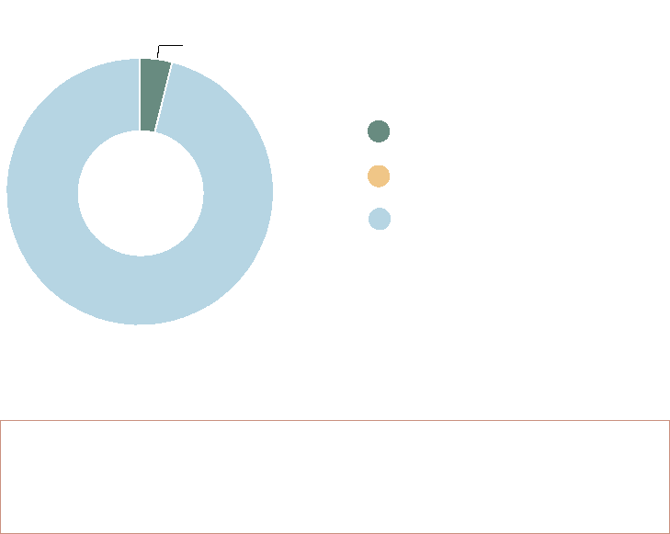

**Metering accuracy in Queensland**

4%

AS4747 meters

Grandfathered meters

All other meters

OLD

96%

1893

Meters

This measure is reported to understand the percentages of meters that comply with the State’s metering policy and are therefore deemed accurate (including AS4747 and grandfathered meters). The percentage of AS4747 meters in the measure is intended to show progress basin states are making in the roll-out of AS4747 metering.

Data owner/sources: State regulators

**Telemetry coverage**



OLD

100%

Meter % with telemetry connected to the regulator’s data collection system

Meter % required to have telemetry connected to the regulator’s data collection system, but which are not connected

Meter % with telemetry not required







This measure is reported to identify the percentage of meters with telemetry connected to the regulator’s data system.

Data owner/sources: State regulators

This measure is reported to identify how meter data is collected and how often when telemetry is not being used.

Data owner/sources: State regulators

The IGWC makes no claim as to the accuracy of the data shown on this page. Data is collated and supplied directly from the states.



**Murray-Darling Basin – South Australia Metering Report Card**

**01 Jul 2020 – 30 Jun 2021**

This measure is reported to highlight percentage of meterable water take across the Murray-Darling Basin by each State that is metered.

Data owner/sources: State regulators

Meters

This measure is reported to understand the percentages of meters that comply with the State’s metering policy and are therefore deemed accurate (including AS4747 and grandfathered meters). The percentage of AS4747 meters in the measure is intended to show progress basin states are making in the roll-out of AS4747 metering.

Data owner/sources: State regulators

**State overview**

South Australia was an early adopter of metering approximately 50 years ago, which has since been expanded to all prescribed resources in the State.

Mandatory metering of all licensed water take is required in South Australia, with the exception of low risk water use (e.g. stock and domestic and as outlined in regional Metering Implementation Plans). This means that 98.2% of the volume of water taken from the South Australian portion of Murray-Darling Basin is currently metered.

All licensed water use within the South Australian portion of Murray-Darling Basin required metering prior to the National Metering Standards (AS4747) being introduced in 2013. In response to the obligations in the Murray- Darling Basin Compliance Compact, South Australia introduced legislation in 2019 to require that all replacement meters are compliant with AS4747. The percentage of meters currently AS4747 compliant is 6.9% and this will continue to grow as meters are replaced.

SA acknowledges that telemetry may also play a supporting role in compliance and are trialling the suitability of retrofitted telemetry technologies and on-farm water usage analytics during 2022–23.

The effectiveness of SA’s compliance strategies is demonstrated through

high compliance rates, which reach 98–99% across the State, underpinned

by mandatory financial penalties for any use in excess of, or without, allocation.

In addition, as part of South Australia’s compliance program, a minimum of

10% of licensed sites are visited each year which includes meter inspections.

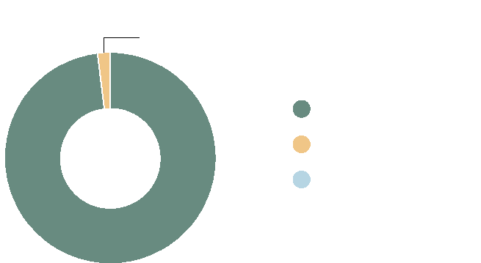

**Percentage of water take metered in South Australia**

1.8%

Metered water take

Exempt water take

Not yet metered water take

SA

98.2%

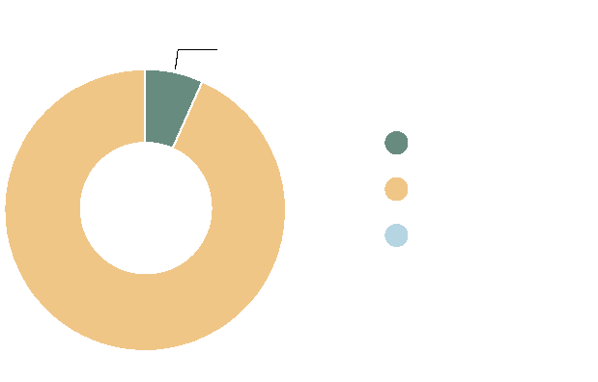

**Metering accuracy in South Australia**

6.90%

AS4747 meters

Grandfathered meters

All other meters

SA

93.10%

3449

**Telemetry coverage How is meter data collected where telemetry is not used**

Meter % with telemetry connected to the regulator’s data collection system

Meter % required to have telemetry connected to the regulator’s data collection system, but which are not connected

Meter % with telemetry not required



0.001%

SA

99.99%

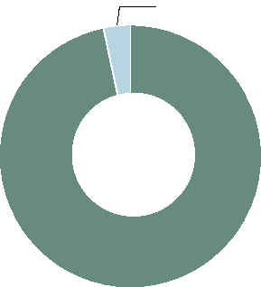

3.26%

SA

96.74%



Quarterly licensee self read (with validation by regulator)

Annual licensee self-read (with validation by regulator)







This measure is reported to identify the percentage of meters with telemetry connected to the regulator’s data system.

Data owner/sources: State regulators

This measure is reported to identify how meter data is collected and how often when telemetry is not being used.

Data owner/sources: State regulators

The IGWC makes no claim as to the accuracy of the data shown on this page. Data is collated and supplied directly from the states.

**VIC**



**Murray-Darling Basin – Victoria Metering Report Card**

**01 Jul 2020 – 30 Jun 2021**

**Metering accuracy in Victoria**







Data not available

AS4747 meters   
Data not available

Grandfathered meters Data not available

All other meters

This measure is reported to highlight percentage of meterable water take across the Murray-Darling Basin by each State that is metered.

Data owner/sources: State regulators

**State overview**

Victoria has had a high coverage of meters across the state for some time. 84% of meters in Victoria were installed prior to 2013 when the Australian Standard for non-urban Water Metering (AS4747) came into being. 96% of take in the Victorian part of the Murray-Darling Basin is metered.

Victoria does not currently have data available for the number of meters that are accurate (AS4747 compliant and grandfathered). However from an outcomes perspective, Victoria reports 87% of total take in the Victorian portion of the Murray-Darling Basin is through AS4747 compliant meters and contemporary (grandfathered) meters accurate to +/-5% in accordance with Victorian policy.

Victoria has been an early adopter of telemetry and automated control systems. In Victoria 45% of meters have telemetry and this accounts for 71% of total meterable water take.

The Victorian Government’s Non-Urban metering policy (2020) is consistent with the Compliance Compact (2018). The policy is being updated to reflect MAF2 (2021) requirements.

**Percentage of water take metered in Victoria**

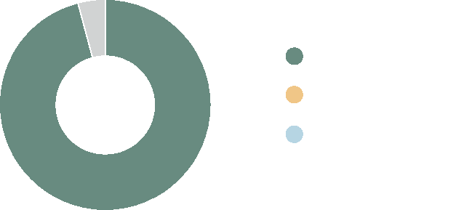

Metered water take

Exempt water take Data not available

Not yet metered water take

Data not available

VIC

96%

This measure is reported to understand the percentages of meters that comply with the State’s metering policy and are therefore deemed accurate (including AS4747 and grandfathered meters). The percentage of AS4747 meters in the measure is intended to show progress basin states are making in the roll-out of AS4747 metering.

Data owner/sources: State regulators

**How is meter data collected where telemetry is not used**

The Victorian Government’s Non-urban Metering Policy (2020) requires water   
corporations to read meters at least once a year for low volume low risk   
meters, more frequently for higher volumes, and at least twice a year for   
surface water winter-fill licences or where there is a history of usage breaches.   
Victoria’s Water Corporations own meter assets and are responsible for   
manually reading meters where telemetry is not available.

**Telemetry coverage**

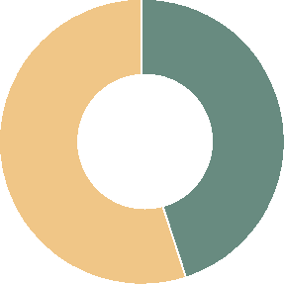

55%

VIC

45%

Meter % with telemetry connected to the regulator’s data collection system

Meter % required to have telemetry connected to the regulator’s data collection system, but which are not connected

Meter % with telemetry not required







This measure is reported to identify the percentage of meters with telemetry connected to the regulator’s data system.

Data owner/sources: State regulators

This measure is reported to identify how meter data is collected and how often when telemetry is not being used.

Data owner/sources: State regulators

The IGWC makes no claim as to the accuracy of the data shown on this page. Data is collated and supplied directly from the states.